SPECIAL PROGRAMME FOR REFUGEE AFFECTED AREAS (SPRAA)
7 ACP TA 098 - TANZANIA

FINAL EVALUATION

FINDINGS OF THE EVALUATION TEAM
14th June 2004

CARL BRO INTERNATIONAL,
Denmark EU LOC No: Hanna4-TA-deltza
Table of Contents
List of Photos iii
List of Abbreviations v
Executive Summary 7
1. Introduction 19
1.1 Study approach and methodology 19
2. Evaluation of various components of the programme 21
2.1 Project I. SPRAA Management Unit 21
2.2 Project II. Kagera Kigoma Game Reserve Rehabilitation Project (KKGRRP) 23
2.3 Project III. Kagera Environmental Project (KEP) 26
2.4 Project IV. Palm Oil Production and Improvement of Local Processing Techniques 29
2.5 Project V. Small to Medium Social and Economic Projects for Kagera and Kigoma 31
2.5.1 Activity 1. Revitalisation of Markets in Kasanda, Mabamba and Makere Villages 32
2.5.2 Activity 2. Provision of solar refrigeration and communication equipment 34
2.5.3 Activity 3. Construction of Kigoma Health Management Team offices and Store 35
2.5.4 Activity 4. Construction of Classrooms in Kibondo and Nyarugusu Primary Schools 36
2.5.5 Activity 5. Extension and Equipment of Maternity Ward in Kibondo District Hospital 38
2.5.6 Activity 6. Support to the Youth Centres in Kibondo and Kigoma Towns 39
2.6 Project VI. Lake Tanganyika Catchment Reforestation and Education Project 41
2.7 Transport Rehabilitation 43
2.7.1 Activity 1. Improvement of Mwanza Airport 44
2.7.2 Activity 2. Kagera Road Maintenance Programme 47
2.7.3 Activity 3. Nyakanazi – Kigoma Road 49
2.8 Project VIII. Review of Refugee Policies 52
3. Conclusions and Recommendations 55
4. References 58
5. Photos 60
6. Appendices 76
6.1 Terms of Reference - Final Evaluation 76
6.2 List of persons consulted 82
6.3 Brief CVs of Evaluation Team 87
6.4 Mwanza Airport Traffic Record from 1994 to 2003 88
6.5 Deliveries and Maternal Deaths for Burundians and Tanzanians - 2001 and 2002. 89

List of Photos
Photo 1. Track in Moyowosi Game Reserve 60
Photo 2. Lions in Moyhowosi Game Reserve 60
Photo 3. Rangers at Nkonje, Burigi Game Reserve 61
Photo 4. Rangers in Murongo Wildlife Division office, near Ibanda Game Reserve 61
Photo 5. Snares collected by rangers from Ibanda and Rumanyika Game Reserves 62
Photo 6. Project housing in Nkonje, Burigi Game Reserve 62
Photo 7. Individual cooking stove in use at household level 63
Photo 8. Refugees carrying firewood 63
Photo 9. Institutional cooking stove at Baramba Girls School near Ngara 64
Photo 10. Traditional cooking stove 64
Photo 11. Woodlots at Baramba Girls School near Ngara 65
Photo 12. Incomplete market at Mabamba Village 65
Photo 13. District Medical Officer's office, Kigoma 66
Photo 14. Classrooms built under the SPRAA project 66
Photo 15. Inside view of completed hospital ward 67
Photo 16. Completed and equipped labour ward 67
Photo 17. Children assisting in cracking open oil palm nuts, Bugamba Village 68
Photo 18. Tree nursery at Bugamba Village, Lake Tanganyika 68
Photo 19. Mwanza Airport runway 69
Photo 20. Mwanza Airport drainage system 69
Photo 21. Damage to runway caused by turning aircraft 70
Photo 22. Deterioration of taxiway and apron, Mwanza Airport 70
Photo 23. Unpaved apron at Mwanza Airport 71
Photo 24. Road section rehabilitated by the project 71
Photo 25. Narrow bridge that restricts traffic 72
Photo 26. Road surface with gullies 72
Photo 27. Road surface with potholes 73
Photo 28. Bridge with guard rails missing 73
Photo 29. Signboard indicating construction of Muyobozi Bridge 74
Photo 30. Ongoing work to repair culverts 74
Photo 31. Narrow bridge on sharp curve; note absence of handrails 75

List of Abbreviations
ADB African Development Bank
AIDS Acquired Immune Deficiency Syndrome
B 737 Boeing 737
CBOs Community Based Organizations
CSFM Centre for the Study of Forced Migration
DE District Engineer
DED District Executive Director
DMO District Medical Officer
DRA Disaster Relief Agency
DRC Democratic Republic of Congo
EU European Union
FES Fuel Efficient Stoves
FGD Focus Group Discussion
GTZ Deutsche Gesellschaft fÜr Technische Zusammenarbeit
HIV Human Immunodeficiency Virus
IRC International Rescue Committee
LGAs Local Government Authorities
NGOs Non Governmental Organisations
NOTAM Notice To Air Men
OAU Organization of African Union
OC Other Charges
PEDP Primary Schools Education Program
RAS Regional Administrative Secretary
REF Refugee Education Fund
RFB Road Fund Board
SACCOS Savings and Credit Cooperative Societies
SPRAA Special Program for Refugee Affected Areas
TACARE Lake Tanganyika Catchment Reforestation and Education
TANROADS Tanzania Roads Agency
TCCIA Tanzania Chamber of Commerce, Industry and Agriculture
TCRS Tanganyika Christian Refugee Services
Tshs Tanzania Shillings
UN United Nations
UNHCR United Nations High Commission for Refugees
UNDP United Nations Development Programmme
UNICEF United Nations Children’s Fund
UPS Uninterrupted Power Supply
URT United Republic of Tanzania
USA United States of America
USD United States Dollar
VCT Voluntary Counseling and Testing

Executive Summary
The Special Programme for Refugee Affected Areas of Tanzania (SPRAA) was aimed at improving Tanzania's ability to cope with the refugee movements generated by the continuous crisis in the Great Lakes region. The purpose of the project was to maintain Tanzania's capacity to accommodate refugees from the Great Lakes region and to improve her readiness for future influxes. It was a joint venture between the European Commission and the Government of the United Republic of Tanzania.
SPRAA follows on from the Special Rehabilitation Programme (SRP) for countries neighbouring Rwanda that was scheduled to end in March 1997. It was designed to continue with the rehabilitation programme in Kagera region and extend activities to the Kigoma region in recognition of a new wave of refugees crossing the border into Tanzania from Burundi and DR Congo. It was a three-year programme managed by the Prime Minister's Office (PMO) with a sectoral focus on transport infrastructure, environmental protection and assistance to the Tanzanian administration. The programme was launched in September 1997 with a Euro 22 million Financing Agreement but only became fully operational in April 1999 with the establishment of the Management Unit by the PMO. One subproject, the Kagera Kigoma Game Reserves Rehabilitation Project (KKGRRP), was reviewed in September 2001. Further monitoring of KKGRRP and of interventions made under transport infrastructure took place in November 2002. SPRAA ended in August 2003. This evaluation was conducted on site from 11th May - 1st June 2004 by a team of four consultants supplied by Carl Bro International.
SPRAA is a diverse programme with interventions divided amongst eight sub-projects that were implemented separately in the most part by different agencies, as described in the Logical Framework Planning Matrix in Annex 1 of the Financing Agreement. In responding to an evolving emergency these projects were subject to some initial revision. The final eight sub-projects were all assessed by the evaluation team and their findings are summarised on a project by project basis finishing with an overview of the SPRAA intervention. The evaluation team rated the overall quality of each sub-project or significant activity accordingly to the following rankings:
A Excellent
B⁺ Very Good
B Good
C Satisfactory
D Poor
E Failure.
Project I. SPRAA Management Unit - Prime Minister's Office
Implementation of the overall SPRAA programme and the coordination of donor rehabilitation efforts were the responsibility of the Prime Minister's Office. A Management Unit which comprised a coordinator, technical advisor, accountant and contracted local staff was established in 1999 after a two-year delay; it disbanded in 2002. The choice of PMO for implementation was appropriate given the cross-cutting nature of the programme, involving eight separate ministries and regional and district authorities, and given also the sensitive nature of the issues being addressed by SPRAA. Aspects of project planning, monitoring and reporting were weak. Nevertheless, the project enjoyed high priority at District and Regional levels through its association with the PMO and overall the support provided by the SPRAA Management Unit was adequate for effective implementation. The project is rated B.

Project II. Kagera Kigoma Game Reserve Rehabilitation Project - Wildlife Department
The establishment of refugee camps close to the boundaries of game reserves in Kagera and Kigoma Regions led to an escalation of illegal entry and the uncontrolled utilisation of natural resources within protected areas. In response to this critical problem the KKGRRP was initiated to assist the Wildlife Division in strengthening its management, improving its capacity for law enforcement and encouraging community-based conservation of surrounding wildlife resources. The project has been successful in demarcating boundaries and clearing reserves of encroachment. Also a new reserve (Kimisi GR) has been gazetted. The project has provided equipment and funds to increase the activity and effectiveness of ranger patrols and this has led to a reduction in the level of illegal hunting and in the extraction of timber. Animal populations are now increasing although they still have some way to go before reaching full recovery. With the help of the project, a 50% retention scheme of revenue was approved by the Wildlife Division. Although it is not sufficient by itself, it will significantly assist in the long-term implementation of reserve management plans. It is recommended that the Wildlife Division review its revenue collection scheme for the use of hunting blocks and trophy animals within reserves so that it can recover fees closer to the real market value.
Conservation programmes in the surrounding areas have been less successful. The main thrust of the Wildlife Division's plans for community-based conservation in the region was to be through the establishment of a new category of protected area known as Wildlife Management Areas. Yet so far no WMAs have been established in the KKGRRP regions. A community programme has not yet been implemented. There is also a need for cross-border initiatives by reserve authorities to address incursions of people and livestock from Uganda, Burundi and Rwanda. Overall the project has been well implemented. It has been fortunate in obtaining excellent technical assistance and in securing a higher than anticipated level of funding from the EC which it has used to good effect. The project is rated A.

Project III. Kagera Environment Project - Regional Forestry Office and GTZ
The KEP project was designed to reduce the environmental disturbance caused by the influx of refugees into western Tanzania and to strengthen the natural regeneration of areas left by refugees on their return to home countries. Despite the emergency nature of the project and its short duration, some significant milestones were achieved, in particular the introduction of fuel-efficient stoves in the districts which were aimed at reducing wood utilisation and consequently deforestation.
KEP's training of 1-2 technicians at each Ward level facilitated the introduction of improved cooking stoves. The response by communities was good. For instance in Biharamulo district, there was a 50 % take-up; wood consumption by the large institutional stoves was reduced from 75 to 15 head loads per month.
The afforestation programme has made moderate progress. Planted trees are today evident on the ground. The project has also had some modest success in cultivating a culture of tree planting and conservation. These achievements are the result of a combined effort by many benefactors including UNHCR and CARE, making it difficult to ascertain individual contributions. Overall some 0.82 million trees were planted in Ngara district which constitutes 88% of the target number.
Some shortcomings in the project undermine the sustainability of inputs: insufficient awareness of the project's goals amongst local stakeholders, poor affordability of inputs for plant nurseries by farmers, lack of a proper exit strategy, and limited resources in Districts and NGOs. The intervention of KEP has been of short duration and some refugees are still in the area. As such the project could not be expected to provide a full environmental correction. Accordingly, the evaluation team has rated has the project as B/C.

Project IV. Palm Oil Production and Improvement of Local Processing Techniques - Jane Goodall Institute
The objectives of the Palm Oil project were to provide farmers with a more productive variety and to improve crop husbandry. In addition, farmers were exposed to better markets and given access to improved processing techniques. The design and implementation of the project was based on a participatory approach involving farmers and cooperatives. Free hybrid seedlings were produced and distributed to refugee affected areas as planned. The hybrids are renowned for their quick maturity and high yield which is about 4 times that of the indigenous variety. The project has increased local capacity through training of beneficiaries on seedlings production and crop husbandry. New crops have started production but have not yet reached the economic production stage. Access to markets in Dar es Salaam and abroad is envisaged in the near future. The introduction and propagation of the hybrid variety has been a success. The project has received a good response from communities and local administration.
The use of local NGOs and grass root groups together with the application of social approaches in the implementation was successful. Target beneficiaries received sufficient technical training. 1600 farmers were trained on crop husbandry. Additionally, local plants were used for hybridisation instead of importing seeds which has made the project sustainable. Other development partners have continued the project following the end of EC support.
The reluctance of farmers to clear old plants to give way to the hybrid crops was seen as a constraint, instead they are integrating them with the hybrid crop. Nevertheless it is envisaged that the increased oil production will improve the socio-economic conditions of people and the region and consequently help them to cope with future refugee influxes. The evaluation team has given the project an achievement rating of A.

Project V. Small to Medium Social and Economic Projects for Kagera and Kigoma Regions - IRC
Activity 1. Revitalisation of Markets in Kasanda, Mabamba and Makere Villages
Kasanda and Mabamba villages are located in Kibondo district and Makere village is located in Kasulu district. The markets projects were planned in these villages in order to provide a clean trading environment as well as creating an atmosphere more conducive to interactions between refugees and local communities. This project was the last one amongst those being implemented by IRC. It suffered a number of setbacks such as limited funds, increase of prices of various items, poor participation of the communities and heavy rainfall that caused difficulties in the haulage of materials.
The project when completed would help to reduce poverty by increasing the volume of trade in the community. This would in turn improve the income of the people living in those communities. Additionally, trade would be conducted in a clean environment so minimising the impact of disease outbreaks. However the planned size of the markets has been reduced and for various reasons work has not been completed to date. Project funds are now exhausted but IRC has undertaken to complete the projects using its own resources. Kasanda and Mabamba markets are scheduled to open on 4th July 2004. Ongoing construction of market stalls has encouraged the owners of stall around the market to improve them.
For the reasons stated above this project is rated a borderline case between C and D.
Activity 2. Provision of Solar Refrigeration and Communication Equipment
This project was selected from a list of priority projects that were planned for implementation by the Biharamulo District Council. It involved installation of five radio stations and the supply of two solar run refrigerators. An ambulance was also fitted with a radio call. The two-fold objective of the project was to improve service delivery by ensuring timely referral to hospitals, and to provide for the safe-keeping of drugs.
The project was implemented effectively and the service was provided to the intended community. It was reported during the evaluation that sometimes it was difficult to get a clear radio signal. Discussions with the district authorities revealed that they were not provided with manuals and that they were not even aware of sources of perishable items like batteries. This was an important omission and it is the opinion of the evaluation team that this need should be addressed.
This project was rated as Grade B⁺.
Activity 3. Construction of Kigoma Health Management Team Offices and Store
The District Medical Officer (DMO) had been going without an office for sometime. The small place that was rented for him had been broken into by thieves twice. At the influx of refugees, the DMO was expected to give even services that would be extended to refugees. The SPRAA mission accepted to finance the office project in order to alleviate that critical problem.
The office was designed by the district Engineer’s office with ideas from the DMO. It has now been completed and has a number of advantages. Now the DMO is housed in an office that is spacious. He can attend more customers; he can participate in meetings with other heads of department because they are now in the same compound. As a spill over effect, the District Executive Director (DED) is now temporarily housed in this office pending completion of his office currently under construction. The project is lined for both maintenance and further improvement using Health Basket Funding and Other Charges (OC) vote of the district council.
The project was properly implemented, and has delivered the intended services. Its sustainability is also assured. It is therefore given Grade A.
Activity 4. Construction of Classrooms in Kibondo and Nyarugusu Schools
The classrooms project was conceived by the government in order to strengthen the social infrastructure, mitigate the effect of the influx of refugees, and to improve relationships between the local communities and refugees. Parents were asked to contribute materials and labour to create a sense of ownership. In total seven classrooms, three teachers’ houses and 18 pit latrines were constructed and completed as planned. As a result of this improvement, enrolment in Kibondo primary school rose from 440 to 1096 pupils between 2000 and 2004. In Nyarugusu there was an increase in enrolment of 330 pupils.
In Kibondo this development led to the founding of a new school (Mapinduzi Primary School) which is using classrooms borrowed from Kibondo primary school. Parents are so motivated that they are now thinking of establishing a secondary school. This is in addition to two more classrooms they constructed following directly from the SPRAA project.
The increase in enrolment will have a long-term effect on reducing poverty. The fact that parents have started new schools indicates that there is a shortage of schools in rural areas. This project is given Grade A
Activity 5. Extension and Equipment of Maternity Ward in Kibondo District Hospital
The main objective of this project was to redress the congestion in the labour ward. The hospital attends 400-650 deliveries per month. Before construction of this ward, up to three patients used to share a bed. The situation was further affected by the influx of the refugees who would be referred to the hospital in case of delivery complications. About 20-30 percent of expectant mothers from the refugee camps used to be referred to this hospital per month. It was therefore proposed to build an extension of thirty beds to the maternity ward and improve the delivery room by building an extension and supplying three more delivery beds. The hospital and community leaders participated in the selection of the project and participated during implementation as well.
After completion of the ward, the admission environment has significantly improved. The hospital is also capable of handling more patients and more complicated cases than it was before. There is satisfaction amongst the mothers and general public who visit the hospital. Safe motherhood is an attribute for improved productivity in all sectors of the economy where mothers are involved. This can be regarded as a significant contribution to poverty reduction.
Staffing in hospital is in short supply with one nurse sometimes being forced to work double shifts. Efforts are underway to get permission from the government of Tanzania to employ more staff. The project was successfully completed and is delivering the intended services. It is rated Grade A.
Activity 6. Support to the Youth Centres in Kibondo and Kigoma Towns
The International Rescue Committee implemented this project. The main motives behind establishing these centres were to minimize idleness among youth by providing training that aimed to increase income earning opportunities, and imparting adolescent reproductive heath knowledge about sexually transmitted infections including HIV/AIDS. The training given included tailoring, carpentry, typewriting, gardening, cookery, and catering. Tuition in language and other subjects was also provided. Much of the training was delivered by volunteers. The construction of the Ndela Youth Centre was completed successfully but some items were not procured for Kibondo Youth Centre. Further, Kibondo Youth Centre has not been able to pay trainers and this has resulted to a temporary halt of some activities.

Both centres have been operational for about one and a half years serving different groups of youth. Graduates from both centres have been self-employed especially those graduating from tailoring, carpentry and catering courses. Reduced idleness among the youth is an indirect poverty reduction indicator as youths participating in the Centre’s activities have a smaller possibility of contracting sexually transmitted infections. For females, the reproductive health knowledge imparted is instrumental in safe motherhood. Both Centres are generating some income from leasing their premises for functions, and they have been receiving support from Local Government Authorities. Sustainability of the Centre's activities will depend on their charging a moderate fee, as sometimes volunteers are not forthcoming. The Ndela and Kibondo projects are rated A and B respectively.

Project VI. Lake Tanganyika Catchment and Reforestation and Education Project (TACARE) - Jane Goodall Institute
The TACARE project had two components: the introduction of environmental and sustainable farming techniques; and village-based savings and credit schemes together with community development through village grants. In implementing the latter, establishment of Savings and Credit Cooperative Societies (SACCOS) was proposed. The main objective of SACCOS was to respond to the needs of the community to secure capital for off-farm income generating activities, and to promote the culture of saving. Villagers were first asked to contribute before they could receive a loan from TACARE. This has instilled a sense of saving amongst members and contributed to the sustainability of the project.
TACARE staff imparted entrepreneurial and business skills to the villagers. Women were strongly encouraged to join SACCOS and about 80 percent of members are in fact women. The beneficiaries have participated in food procurement activities such as selling cassava flour, palm oil, rice/paddy, sardines, and food vending. Accordingly, the beneficiaries have improved their wellbeing through acquisition of different assets such as land and livestock, and accessing social services such as education and health. The most cherished outcome has been the “empowerment of women.” Notwithstanding these achievements, a review of the business loan interest rate by TACARE, and more educational and sensitisation programmes are needed if the project is to realise its main objective of poverty reduction.
TACARE has also supported community-based forest conservation. Institutional arrangements that support environmental improvements have been encouraged and 13 villages have now established environmental by-laws. The participation of villagers in dealing with environmental defaulters has increased. Afforestation and agroforestry activities have been supported by the project. Production of seedlings is taking place in local plant nurseries and farmers have started harvesting and selling products. The introduction of fuel-efficient stoves has received a good response from communities as a means of alleviating deforestation. For example 20% of households in Bugamba village have adopted them. In addition, awareness raising and education on the environment have been provided by the project through seminars and films. The TACARE III project has been successfully implemented and it is rated B+.

Project VII. Transport Rehabilitation
Activity 1. Improvement of Mwanza Airport
The airport was selected for improvement because it was one of the largest facilities near the refugee affected areas making it the logical choice for development as a transport hub for receiving airlifted goods and service personnel and sending them on by road. Activities undertaken included, strengthening of the runway, airport surface and subsurface drainage, 10 kilometres of fencing and installation of a standby generator. Important activities that were left out included the strengthening of taxiways and aprons.
The project as planned was effective in the sense that the target groups were provided with the intended benefit. The project was completed in time, goods and services passed through the airport and UNHCR offices that cater for refugees in Ngara, Kibondo, Kasulu and Kigoma are located within the airport premises. The airport maintenance program is good and at the time of this evaluation there were plans for an upgrade.
The airport has contributed significantly to poverty reduction in the area. It is considered that its effect has been felt in the entire region. Apart from facilitating movements of goods and services for the refugees, the airport has contributed in a number of other ways:-
- More passengers use the airport;
- The fishing industry has improved because more fish are now airlifted through the airport;
- There has been an increase in personnel employed at the airport;
- The airport authority is utilising facilities left by the project contractor;
- The fire engines stationed at the airport are also utilised in Mwanza.
The project has had a significant impact in the region and has been rated as Grade A.
Activity 2. Kagera Road Maintenance Programme
Kagera region was severely affected by the influx of refugees with direct impacts at the refugee camps and indirect effects arising from the increased thoroughfare of goods and services moving from Mwanza to the camps. Kagera region was also the source of many refugee food items and in particular fish from Lake Victoria were transported to Ngara, Biharamulo, Kibondo and Kasulu. Roads selected for rehabilitation aimed to address these needs.
A total of 258 km of road network was rehabilitated in the region. All the money that was planned for gravel roads was spent but only 50% of the money earmarked for paved roads was disbursed. The reason advanced for this was that the funds for engaging a consultant road supervisor came from another donor. They were exhausted before the project had completed the release of funds for paved roads. The donor sponsoring the supervising consultant did not extend their funding, and work on the paved roads could not continue without supervision. The road sections that were implemented are in good condition and because of that they are entitled to the full routine and recurrent maintenance fund supplied by Government through the Road Fund Board.
The project roads are in good condition and maintenance activities are on going. The project has been given Grade A.
Activity 3. Nyakanazi - Kigoma Road
Kibondo, Kasulu and Kigoma areas all received refugees. This led to the need for an efficient means of transporting goods and services from the Isaka dry port and Mwanza airport through the rehabilitated roads in Kagera regions. It was therefore decided to rehabilitate the Nyakanazi to Kigoma road in order to complete the link between the ports and the refugee camps. This would also assist in the transport of fish from Nganza village to the camps.
A number of suggestions were made by engineers on the ground during the road project's design phase but these were not taken into consideration. The project was divided into three lots which were tendered separately. It happened that one contractor had the lowest bid in all three packages. Instead of awarding tenders to three contractors as earlier envisaged, all three lots were awarded to this one contractor without verifying whether he could mobilise three equal groups of personnel, plant and equipment. The contractor could not manage this scale of work and as a result he was unable to finish the project on time. Furthermore, the resulting product was not up to standard because of design shortcomings that were contained in the tender documents.
The main impact of this component of the road project was to provide good road access into Kigoma region. In the past the main access road was almost impassable. Despite the project's shortcomings this improved road has been a great relief to the people of Kigoma. The road is now undergoing various maintenance interventions but the length of road being treated per year is not adequate. This component of the road project is rated at Grade C.

Project VIII. Review of Refugee Policies - University of Dar es Salaam
The study team at the University of Dar es Salaam was assigned the task of reviewing the refugee-related policies and practices that might provide the basis for developing a concrete policy on refugees. Five themes were identified covering refugee admission and eligibility procedures, durable solutions, educational and employment facilities for refugees, and refugee impact on the local administration - specifically on police, law enforcement and the judiciary.

The project was successfully implemented and the outputs were used to formulate the National Refugee Policy of September 2003, through consultative meetings conducted at national and regional levels. The policy outlines the responsibilities and obligations of various actors at local and international levels in order to share the refugee burden. In implementing the policy, Tanzania has continued to admit refugees and to provide them with asylum and protection. In addition, the Government has continued to call upon the international community to take measures to improve conditions in the respective countries of origin. Legislation of the policy clauses and the development of an implementation strategy are still needed. Future review of the policy should include clauses on how to address cross cutting issues such as gender, the environment and HIV/AIDS, and should also consider aligning the Employment Policy and Lands Acts with the spirit of the Refugee Policy. The project was successfully implemented and is rated A.

Overview
SPRAA was an emergency programme of assistance put together rapidly to address problems created by the refugee crisis and hence some areas of weakness in design, difficulties in coordination and delays in implementation were to be expected. These are reflected in the ratings given to each of the subprojects in the table below.
As can be seen, three subprojects or major activities were rated C or below indicating some weakness in the intervention. In most cases the implementation process was at fault either in project administration (Projects I; Project III; Project V, Activity 1; Project V, Activity 6) community participation (Project V, Activity 1) or capacity of implementing agency (Project I; Project VII, Activity 3). There was also a problem with sustainability of inputs that arises from the lack of properly formulated exit strategies (Project III; Project V, Activity 6).
One lesson that can be learned is the importance of selecting agencies with sufficient capacity to undertake the required tasks. In this regard, the tendering procedures used in awarding contracts for transport infrastructure should incorporate safeguards to ensure that firms have the required capacity. Similarly where external technical expertise is brought in to assist agencies with implementation, great care should be taken to ensure they have the requisite experience. In particular, the Management Unit should be put in place at the outset of the intervention and its members should have clear and detailed terms of reference.
It is also important in any future project that Local Government Authorities are involved in problem identification and implementation as collaborators, and that their role and extent of involvement is made clear from the beginning.

Subproject or Major Activity | Rating
Project I. SPRAA Management Unit | B
Project II. Kagera Kigoma Game Reserve Rehbilitation Project | A
Project III. Kagera Environment Project | B/C
Project IV. Palm Oil Production and Improvement of Processing Techniques | A
Project V. Small to Medium Social and Economic Projects
Activity 1. Revitalisation of Markets in Kasanda, Mabamba & Makere Villages | C/D
Activity 2. Provision of Solar Refrigeration and Communication Equipment | B⁺
Activity 3. Construction of Kigoma Health Management Team Offices & Store | A
Activity 4. Construction of Classrooms in Kibondo & Narugusu Schools | A
Activity 5. Extension & Equipment of Maternity Ward, Kibondo District Hospital | A
Activity 6. Support to the Youth Centres in Kibondo and Kigoma Towns | A, B
Project VI. Lake Tanganyika Catchment and Reforestation and Education Project | B⁺
Project VII. Transport Rehabilitation
Activity 1. Improvement of Mwanza Airport | A
Activity 2. Kagera Road Maintenance Programme | A
Activity 3. Nyakanazi - Kigoma Road | C
Project VIII. Review of Refugee Policies | A

The majority of interventions were correctly targeted and most subprojects and activities were warmly received at the local, District and Regional levels. Many of the subprojects were rated as A and SPRAA is commended for achieving the highest rating for so many of its activities under such difficult conditions. The programme has demonstrated that effective longer-term rural development is possible in a crisis and may even be enhanced to some extent by the added attention given to the area by key decision-makers.
Whilst it would have been impossible to fully compensate for the environmental, infrastructural and social costs of the refugee crisis, SPRAA has helped to alleviate many problems. It is not possible to judge how Tanzania would view the prospect of future refugee influxes in the absence of SPRAA, however the indications are that the project has made significant progress in achieving its overall goal of preparing the nation for further movements across its borders.

Introduction
The three-year programme of assistance for refugee affected areas known as SPRAA was launched in September 1997 with a Euro 22 million Financing Agreement between the Government of Tanzania and the European Commission, in the framework of the 7th European Development Fund. The overall objective of the programme was to "maintain Tanzania's capacity to accommodate refugees from the Great Lakes region and to improve her readiness for future influxes". SPRAA is a programme of differing interventions covering four areas of intervention: transport, environment, socio-economics and programme management. The overall programme was grouped into eight discrete sub-projects that were implemented independently of one-another. SPRAA commenced on 1st April 1999 and ended on 31st August 2003.
A mid-term review of the Kagera Kigoma Game Reserve Rehabilitation Project (KKGRRP) was undertaken in September 2001 by an independent consultant, Dr. Malte Sommerlatte. Further monitoring of KKGRRP and of interventions made under transport infrastructure was undertaken in November 2002 by Richard Platt.
The final evaluation is being undertaken by Carl Bro International. The evaluation team consisted of:
Dr. Martyn Murray, Team Leader and Natural Resources Expert;
Eng. Exaud Mushi, Civil/Highway Engineer;
Mr. Richard Minja, Forestry and Environmental Expert;
Dr. Flora Kessy, Socio-economist.

Study approach and methodology
This evaluation has been carried our by inspection of project sites, meetings and one-to-one interviews. The latter were held with project officers, senior and junior staff of beneficiary organisations, representatives of local communities, and government and district officials who were handed over the project at completion. Where possible, interviews were conducted in the absence of project staff, and in the case of junior staff of beneficiary organisations also in the absence of senior staff.
The evaluation commenced on 11th May 2004 with the assembly of the team in Dar es Salaam and subsequent meetings with representatives of the EC Delegation, Ministry of Finance and Prime Minister's Office. Further meetings took place in Dar es Salaam during the course of the first week between members of the team and representatives of the Ministry of Works, the Tanzania Airports Authority, TANROADS, the Wildlife Department (WD), the University of Dar es Salaam and UNHCR. The team flew to Mwanza on 15th May to hold meetings with the Airport Manager and technical staff, and to inspect the runway, drainage system and related inputs. From there the team flew to Bukhoba where it held meetings with the Regional Administrative Secretary and the Regional Manager of TANROADS.
The team next proceeded by road to visit project sites in Kagera and Kigoma Regions. In Kayanga, the team met up with Wildlife Department officers from Kagera Region. They also met the TA assigned to the KKGRRP who accompanied them during much of the following week, providing valuable technical information, support and back-up. The team proceeded to Rumanyika and Ibanda GRs where they examined project infrastructure, viewed the reserves and held meetings with park staff and representatives of the local community in Murongo. In Biharamulo the team held meetings with the District Executive Director, the Roads Inspector of TANROADS and representatives of the District Medical Office. They next visited Burigi GR where the team discussed law enforcement with the field force at Nkonje and viewed wildlife populations in the vicinity of Lake Burigi. They continued to Ngara for meetings with the District Executive Director and to visit sites where improved charcoal-burning stoves had been installed and woodlots planted. A large vacated refugee camp was inspected to assess the level of rehabilitation of woodlands. The team next traveled to Kibondo for meetings with IRC and to inspect infrastructure and assess technical inputs by the Small to Medium Social and Economic Project. Members of the team also inspected infrastructure at the WD headquarters at Kifura and visited the Moyowosi GR where they viewed three hunting blocks and held discussions with a safari operator. They proceeded to Kigoma continuing to inspect the project's trunk road rehabilitation, en route. In Kigoma they held meetings with TACARE and visited the site of the Palm Oil Production project and the Regional Manager of TANROADS. The team arranged a boat trip to Bugamba village on the shores of Lake Tanganyika to the north of Gombe Stream NP in the company of TACARE staff. In the village, team members held meetings with the village school headmaster, the chairman and other members of the local committee working with TACARE. Finally the team flew back from Kigoma to Dar es Salaam on 28th May.
In assessing the diverse interventions of SPRAA the team has found it helpful to rate the overall quality of each sub-project or significant activity accordingly to the following rankings:
A Excellent
B⁺ Very Good
B Good
C Satisfactory
D Poor
E Failure.

Evaluation of various components of the programme

Project I. SPRAA Management Unit

Implemented by: the Prime Minister's Office
Amount: TZS 100,958,187

Relevance and quality of design of the project
Under SPRAA II, the Prime Minister's Office was responsible for the implementation of the overall programme and the coordination of donor rehabilitation efforts. The choice of PMO for implementation would appear to have been appropriate given the cross-cutting nature of the programme, involving eight separate ministries, and the sensitive nature of the issues being addressed by SPRAA. The evaluation team noted that the project enjoyed high priority at District and Regional levels through its close association with the PMO.

Effectiveness of the project
The unit comprised a coordinator, accountant, technical advisor and contracted local staff. The Management Unit was established in 1999 and disbanded in 2002. In administering SPRAA, the unit made 15 monitoring field trips to Kagera and Kigoma Regions, held five Task Force meetings to enable strategic decision-making on relief, rehabilitation and development in Kigoma and Kagera Regions, and produced three progress reports covering the period 1st August 1999 to 30th June 2002. Some training was provided at programme level.
Reporting was of mixed quality. For instance, the last progress report (1st November 2001 to 30th June 2002) comprises little more than a listing of individual activities. Similarly the financial reporting comprises many pages of detailed information, mainly extracts from bank payment books, but lacks information even as to which sub-project the accounts refer. There is no summary of accounts for the individual projects and little comment on the quality of the financial administration of the separate implementing agencies. There is no attempt to evaluate the overall progress of SPRAA and its effectiveness in addressing the problems associated with refugee influxes. No explanation is forthcoming as regards the absence of a mid-term review of SPRAA as called for in the Financing Agreement.
Despite these shortcomings, the evaluation team is aware that SPRAA has been a complex project involving eight discrete sub-projects with operations in the transport, environment, agriculture, forestry, wildlife and policy sectors. The Management Unit has coordinated activities between eight Ministries, liased successfully with Regional and District Authorities, and overcome many challenges and difficulties associated with the volatile nature of repeated refugee influxes. The overall project was successfully implemented and is well understood and appreciated at Regional, District and local levels.

Efficiency of the Project

Due to various administrative difficulties, the establishment of the SPRAA management unit was delayed until August 1999. The cause of the delay was reported to be the lead time required for advertising the posts and the time required to arrange meetings between the principal stakeholders: PMO, Programme Support Unit (i.e. the Unit in the Ministry of Finance responsible for project implementation), and the European Commission. The delay was to some extent mitigated by the early start of several infrastructural projects (including the Mwanza runway) and environmental projects.
Planning and administration appear to have been weak as reflected in the slow start and multiple field missions, each tackling only a single issue. Considering also the standard of reporting (see above), some doubt arises about the adequacy of support received from the technical advisor.

Contribution of the project to poverty reduction
The Management Unit made its contribution to poverty reduction indirectly through the successful implementation of the other sub-projects.

Sustainability of the project
The Project Management Unit disbanded in 2002. Subsequently, activities have continued with the support of the PMO.

Lessons learned
Complex emergency projects require the appointment of a technical advisor with exceptional capacity in project management, administration, monitoring and reporting.

Conclusion
Some aspects of project management have been weak. This can only partly be attributed to the complex nature of SPRAA with its requirement for coordination at Central, Regional and District levels. Nevertheless, the overall project performed reasonably well and was adequately supported by the SPRAA Management Unit. Overall rating is B.

Project II. Kagera Kigoma Game Reserve Rehabilitation Project (KKGRRP)

Implemented by: the Wildlife Department
Amount: TZS 1,188,000,000 (€1,500,000)

Relevance and quality of design of the project
A number of large refugee camps were placed close to the boundaries of some of the Game Reserves in Kagera and Kigoma Regions leading to a dramatic escalation of illegal entry and uncontrolled resource utilisation within protected areas. Wildlife populations declined as a result of poaching, and woodlands suffered from illegal logging and burning. In response to this critical problem, the KKGRRP was initiated to assist the Wildlife Division in strengthening its management and reinforcing the protection of game reserves affected by refugees. The 1994 influx of refugees was from Rwanda, but in 1996 and subsequently the refugees came from Burundi and DR Congo. Consequently the focus of the associated problems shifted from the Ibanda and Rumanyika Game Reserves in the north Kagera Region to Burigi and Biharamulo GRs in south Kagera Region and to Moyowosi and Kigosi GRs in Kigoma Region.

The six reserves, together with the newly gazetted Kimisi Game Reserve, cover an area of over 24,000 km², representing approximately 20% of the total game reserve area controlled by the Wildlife Division. They provide for a profitable safari hunting business that constitutes a valuable source of employment for local communities, and are the source of traditional wild harvests of honey, fish, fungi and medicinal plants (photos 1&2). The reserves are also used illegally by Tanzania nationals for grazing cattle, to procure meat and as a source of building materials. Consequently the reserves have significant socio-economic importance in western Tanzania.

The KKGRRP project was directed towards enhancing the Wildlife Division's capacity for law enforcement, developing effective reserve management and encouraging community-based conservation of the surrounding wildlife resources. These are key elements of successful protected area conservation, but beyond this the Intervention Logic outlined in the Financing Agreement provides little guidance. Inputs are ill defined, activities lack any budget and there are no guidelines on methodology. In the case of community conservation which is identified as a major component of conservation strategy, the lack of guidelines and budget contributed to underperformance at implementation. In short, whilst KKGRRP's purpose was highly relevant to the overall objective of SPRAA, the project design failed to provide adequate direction or to detail the resources needed for inputs.

Effectiveness of the project
The project has been successful in lobbying Government for a 50% retention scheme whereby half the income generated from the reserves can be retained for their management. The project has also secured increasing sums of money from the Wildlife Division to support anti-poaching and other operational activities. In addition, the project has facilitated the gazettement of the Kimisi Game Reserve which lies between the border with Rwanda and the western boundary of the Burigi Game Reserve. These are significant accomplishments for the project. They will help to secure the future of the reserves which have been largely unrecognised and in long-term decline over many years.
Wildlife populations are reported to be increasing within the reserves, but the lack of a regular census programme, or even occasional surveys, by the Wildlife Division makes it difficult to assess the real level of progress. The evaluation team observed plentiful herds of impala, zebra and giraffe in northern Burigi GR. The paucity of animals observed in Ibanda GR and southern Burigi may partly reflect the difficult viewing conditions in May with tall grass in many areas. However the overall impression gained was that wildlife is patchily distributed and that full recovery is still some way off. Further improvements may be difficult to achieve due to recruitment constraints by the Wildlife Division which means that staffing levels of the reserves remain well below those required for fully effective conservation. Equally important is the need for more effective training of the field force in security operations and law enforcement (Photos 3 & 4). This should include an overall assessment of illegal activities and training in tracking, combat, first aid, night operations, patrolling, ambush, reaction and operational roles. The evaluation team noted a disparity in staff motivation between remote and more accessible areas.
The potential effectiveness of the project is being undermined by the weakness of its external programmes. The lack of a community-based conservation programme is now placing additional pressure on the ranger patrols. Similarly the failure of other Ministries to protect grazing lands around Ibanda is increasing pressure on the reserve from pastoralists both from neighbouring countries and from within Tanzania. To deal with the non-refugee incursions of people and livestock from Uganda, Burundi and Rwanda, the Phase II Project will nee to encourage an increased level of cross-border initiatives by reserve authorities.
Efficiency of the Project
KKGRRP has made good use of the funding opportunities associated with SPRAA. The original allocations of funds was TZS 1,188,000,000 (€1,500,000) for a period of three years but the project also obtained funding from unutilised amounts remaining from other SPRAA projects, so that it actually received TZS 2,427,621,888 over a period of 4.5 years. Following the recommendations of a mid-term review, a second phase of funding (Support to Tanzania Game Reserves) was agreed in a February 2004 Financing Agreement to support follow-up activities.

The efficiency of law enforcement operations has been substantially improved. Farmers that were encroaching in Rumanyika have been dealt with swiftly following demarcation of the boundary and nomadic pastoralists around Biharamulo have also been removed. Anti-poaching activities have been improved by the supply of eight Land Rovers, field equipment and running costs and through training and technical advice. The project also improved and developed road networks and rehabilitated two airstrips to facilitate safari hunting and the anti-poaching effort, and to enable rapid responses in the case of an emergency. Results have been positive with a significant reduction in illegal activities being reported. During the influx of refugees in the mid-nineties approximately 80% of the poachers caught were refugees. By 2001 this proportion had reportedly declined to 30%. Large quantities of snares have been collected (Photo 5). Reserve wardens do not summarise data on snare recoveries or arrests, making it difficult to monitor the effectiveness of their patrolling.
Management plans have been compiled jointly for Ibanda and Rumanyika Game Reserves and for Burigi and Biharamulo Game Reserves. A management plan for Moyowosi and Kigosi Game Reserves is pending. The first two plans were prepared by an external consultant to a high standard and according to the Wildlife Division's own format. The project is commended for the quality and timeliness of this output. The plans are ambitious and contain many operational activities. Sustaining this level of management will require extensive support from the Wildlife Division headquarters and a substantially increased revenue to meet the budgeted costs of each Reserve. In the meantime, the project in its second phase will need to draw up annual work plans that recognise budgetary limitations and prioritise activities according to available resources.
Other measures taken by the project to enhance game reserve management include improvement and establishment of staff housing, office accommodation and workshops, supply of office equipment, and technical assistance in reserve management and project administration. The infrastructure programme has been completed with commendable efficiency and the quality of housing at Rumanyika and Kifura was found to be of a high standard (Photo 6). Roads within reserves were being maintained to an acceptable standard. The quality of equipment was also good except for the Land Rovers which have required frequent and costly maintenance. The technical assistance obtained from external experts in wildlife management and natural resources conservation was of high quality and represented good value for money.
Contribution of the project to poverty reduction
The overall objective of KKGRRP is to strengthen the management of game reserves through law enforcement, management planning and community-based conservation. Baseline socio-economic data have been collected from a few villages in surrounding areas but no activity has taken place that could support improvements in community livelihoods. Local communities were represented in consultative workshops involving all stakeholders that took place as part of the process of compiling management plans. Some traditional community activities such as bee-keeping and fishing have been allowed to continue in Burigi GR under the new management plan. There is also some temporary employment provided to local villagers as part of road improvement and camp development in reserves. None of these activities amount to a significant community-based conservation programme.
The main thrust of the Wildlife Department's plans for community-based conservation in the region is through the establishment of a new category of protected area known as Wildlife Management Areas (WMAs), where local people will have a full mandate to manage and benefit from their conservation efforts, through community based conservation programmes. So far the Wildlife Division has failed to publish guidelines for wildlife management areas and no WMAs have been established in the KKGRRP regions. It is to be hoped that this activity will be initiated soon under the second phase STFGR Financing Agreement which continues to emphasise community-based conservation as a major expected output of the intervention.
Sustainability of the project
To ensure their long-term success and sustainability, the game reserves need a secure source of finance on which to base management plans. The 50% retention scheme is an important step in the right direction but the revenue currently obtained is insufficient to meet projected management costs, especially for those reserves where little income is generated from hunting fees. The returns currently obtained by the Wildlife Division for sport hunting are below the market rates. The Wildlife Division should therefore be encouraged to review its revenue collection system for hunting.

Wildlife conservation is most likely to succeed in the long-term where an effective law enforcement programme is supplemented by activities that serve to increase the value of wildlife resources when utilised within a legal framework by local communities. It is recommended that the Phase II Project increase the level of revenue integration between the main stakeholders, i.e. professional hunting organisations, local villagers and the Wildlife Division.

Lessons learned
The project has achieved a large amount in a relatively short space of time. This is partly attributable to the high quality of technical assistance and the satisfactory level of funding secured by the project. Ironically, the emergency conditions may have assisted by focussing attention on the area, so facilitating decision-making by the major project stakeholders. On the other hand, the need for rapid implementation in the face of emergency conditions meant that the planning and design phases were weak and this has contributed to the poor performance of the community programme.

Project III. Kagera Environmental Project (KEP)

Implemented by: Regional Forestry Office and GTZ
Amount: TSHS 304,667,600

Relevance and Quality of the Design
The objectives of KEP were to minimise the environmental damage in areas sheltering refugees and to strengthen the regeneration of flora in the areas that had been vacated by refugees. The design and implementation of KEP utilized a participatory approach, for example the needs-assessment used PRA methods. Stakeholders such as villagers, districts, NGOs and regional authorities participated fully in the project cycles (other than in awareness raising).
KEP was implemented through GTZ and several local NGOs. The cooperation of GTZ and the NGOs was based on contracts for implementation of activities such as nursery establishment and afforestation. Funds were advanced and accounted for at the end of the activities. Karagwe Development Association (KARADEA) implemented activities in Karagwe in collaboration with the district. UNHCR also supported afforestation activities. CARE Tanzania supervised activities in Ngara and Biharamulo districts in collaboration with the District Authorities.
Efficiency of the Project
A major focus of the project was on the introduction of fuel-efficient stoves (FES); a more modest effort was put into other environmental conservation programmes. This could be viewed as an important decision because of the project’s short life span.
There was insufficient awareness amongst stakeholders about the project's goals or its expected outputs. In Karagwe district, funds for conservation activities were occasionally received late and sometimes when the appropriate season was over. In some areas, funding of activities apparently took place without proper planning. NGOs received cash and villagers received materials such as polythene tubes, seeds and wheelbarrows.
Afforestation and conservation activities have not fully countered the level of destruction brought on by refugees. Around refugee camps such as Benaco, the price of firewood has gone up many times (now reaching Tshs 400/head load), whilst the distance traveled by women has increased.
A follow-up programme of support, which had been expected for some time was ruled out at a late stage. Perhaps partly for this reason, there was no official hand over of project activities or equipment. In effect, follow-up has been left to the District which has limited resources.
Effectiveness of the project
KEP successfully managed to introduce FES to the households, refugee camps, restaurants, and religious/government institutions in urban and rural areas. Each ward had 1-2 trained technicians who could manufacture FES. For example, 28 ward technicians were trained in Karagwe district and 2 for each ward in Biharamulo. Photo 7 shows a household fuel-efficient stove in use.
There stoves proved to be popular with a 50% take-up in Biharamulo district. However, the life span of the stoves was only 2-3 years. Users agreed that wood consumption had declined significantly. For instance, the users of one institutional stove claimed that fuel wood consumption was reduced from 75 to 15 head loads per month (photo 8). The improved institutional stove is contrasted with a traditional one in photos 9 & 10.
Twenty-five CBOs were established for Fuel Efficient Stoves and conservation activities in Karagwe district and 24 in Biharamulo. Some 5000 and 2000 stoves were prepared and put into use in Ngara and Biharamulo districts respectively. In Karagwe district, NGOs were supported to undertake pilot land-use planning projects at Kayanga through organised workshops. As KEP was approaching its end, community-based forest management was initiated at Bujuruga and Mabira in which boundary demarcation by tree planting was implemented. In Karagwe district, the number of tree nurseries increased from 4 to 30 as a result of EC funding and today poles are being harvested from trees planted out from the nurseries. The poles are commonly used to support banana plants and for construction of houses. Some rudimentary education on the management of water sources was also provided to stakeholders.
Afforestation was initiated around refugee settlements using fast-growing species that can be harvested for fuel wood and poles, for example Grevillea robusta, Acrocarpus sp, Leucaena leucocephala and Eucalyptus were planted around Kagenyi and Benaco camps. Other organisations such as the European Union, UNHCR, Norwegian Peoples Aid (NPA) and the Dutch Government (which funded the District Rural Development Program) all contributed to the joint afforestation/conservation work. This makes it hard to accurately assess individual achievements. In Ngara district, KEP planted 820,000 trees out of a target of 935,000 between 1996 and 2001, reaching 88% of its target. Some trees have already reached a mature size and harvesting has taken place for poles and firewood (photo 11). The expectation is that the distance traveled by women to collect firewood will be reduced when the trees are fully matured. Few of the refugees still in the area are now extracting wood from the remaining natural woodlands. However, according to local authorities, herds of cattle left behind by returning refugees are grazing inside protected areas; it is thought that they are in some way linked to the occurrence of frequent bush fires and subsequent deforestation.
Contribution of the project to poverty reduction
The afforestation and FES programmes should engender a positive change in peoples’ livelihoods in terms of an increased access to fuel wood, which will in turn save time and money spent on walking long distances to collect and purchase the same. Also, in future, farmers will be able to increase their income from the sale of timber, charcoal and poles.
Sustainability
Today there is a good spirit of conservation in the areas where project activities have been implemented. A modest amount of capacity building was delivered through training in FES and by organised visits to environmental projects that enhanced environmental sustainability. District Environmental Committees and NGOs such as KARADEA and Community Habitat Environment Management (CHEMA) were involved. On the other hand, some major implementing NGOs have now closed their conservation activities in Kagera region and this is jeopardizing the sustainability of the programme. In Biharamulo district 17% of the CBOs have ceased to function. Practical conservation activities have almost halted due to the paucity of resources (especially in relation to funds and transport) and there is a general lack of motivation at the local level, except for some continuing efforts in awareness raising. The ownership of woodlots and trees left behind by refugees is being taken up at the District level.
The intervention of KEP was over a short period so that full environmental correction could not have been expected. Full sustainability of KEP activities is questionable because there was no exit strategy to ensure that stakeholders were in a position to continue the programme. Nevertheless, the efforts made by KEP have had a moderate environmental and socio-economic impact, and have gone some way towards achieving the programme's main goal.
Lessons learnt
The use of expensive material that is not available locally should be avoided. KEP used imported polytubing materials (US$3-4 per kg) which could have been replaced by the use of Swaziland beds or direct sowing. On the other hand, by concentrating on a few promising activities, particularly FES, KEP was able to achieve some useful results during a short project period. The project is therefore rated between B and C in terms of its overall achievement.

Project IV. Palm Oil Production and Improvement of Local Processing Techniques
Implemented by: Jane Goodall Institute
Amount: TSHS 100,958,187

Relevance and Quality of the Design
The objectives of the Palm Oil project were as follows: 1) to provide farmers with a productive palm oil variety; 2) to enable farmers to practice improved crop husbandry. 3) to expose farmers to better markets; and 4) to provide farmers with good access to processing techniques.
The European Commission supported the Palm Oil Project in Kigoma Region as part of the SPRAA program. In an earlier phase, the project had received funding from UNDP. The design and implementation of the EC-funded project was based on a participatory approach involving stakeholders from village to the ministry level.
Effectiveness of the project
The project has been successful promoting the introduction, production and distribution of hybrid seedlings. Local communities have responded rapidly to this opportunity by planting the palm Oil hybrid and at the same time by adopting environmental conservation practices. The project was also successful in raising the capacity of villagers and district staff in the production of hybrid seedlings and crop husbandry methodology. The project provided technical training to 10 district staff. In addition, 1600 farmers were trained on better crop husbandry methods. Use of local plants in the hybridisation programme avoided the need to import seeds at as cost of US$290/kg.
The project produced and distributed free some 128,000 hybrid seedlings in the refugee- affected areas, exceeding the set target of 100,000. The project thereby benefited 22 villages and 1 cooperative union. Early maturing hybrid crops produce 4500 kg/ha/year of oil compared to 800 kg/ha/year from indigenous varieties. Crops planted under SPRAA are now being harvested for oil production.
Poverty Reduction
As oil palm are the number one cash crop, the Regional Authority has acknowledged that the project has a high potential for improving the economy of the region and consequently peoples’ livelihoods. Palm oil is today finding its way to Dar es Salaam Oil Mills for further refining before it is sold on to local markets or exported.
Efficiency of the Project
The supply of improved Palm Oil processing equipment was stalled before the end of EC funding. However, the district has continued working on the design of this equipment. Funding sources such as from USAID are now available for a limited period and some activities have continued without interruption. As with KEP, the lack of a smooth exit strategy by the project left many stakeholders still requiring further support. Some money expected under EC funding was not released compelling the project to scale down some activities. At the field level, farmers have shown reluctance to clear old plants and instead they are integrating them with the hybrid crop until the hybrids are ready for economic production.
Sustainability
The participatory approach used by the project provided a strong force for sustainability of its activities. The use of local NGOs and grass root Community Based Organisations in the implementation was beneficial.
SPRAA's overall goal was: Tanzania's ability to cope with the refugee movements generated by the continuing crisis in the Great Lakes Regions improved. The Palm Oil project will make a useful contribution towards achieving this goal if the present funding sources continue to lend support up to the point at which the crop reaches economic production levels. It is envisaged that oil production can improve socio-economic conditions in the area and consequently help the local population to cope with future refugee influxes.
Lessons learnt
The original objectives of this subproject were many and probably overly ambitious, and therefore the project made the right decision to narrow its focus to a few achievable interventions. Following the ending of SPRAA, the project acted promptly in seeking alternative funds from other development partners to cover a bridging period. Overall, the project has been a success and the programme is now moving towards sustainability. The project is givne an achievement rating of A.

Project V. Small to Medium Social and Economic Projects for Kagera and Kigoma

Implemented by: IRC
Amount: TSHS 312,136,000

The Small to Medium Social and Economic Projects in Kagera and Kigoma Regions were planned by the SPRAA team in collaboration with Local Government Authorities (LGAs). Just before the start of the programme, it was decided that the project should be implemented by an international NGO. The International Rescue Committee was appointed to take up the assignment. The same documents that were used for planning by the LGA were handed over to IRC for implementation. The time given for implementation was very short and IRC did not carry out any significant refinement of the planning.
The projects implemented by IRC were as follows: three markets in Mabamba and Kasanda (Kibondo District) and Makere (Kasulu District); provision of solar refrigeration and communication equipment in Biharamulo; construction of an office and store for the Kigoma District Health Management Team; construction of classrooms in Kibondo and Nyarugusu primary schools in Kibondo and Kasulu respectively; extension and equipping of a maternity ward in Kibondo District Hospital; and support to the youth centres in Kibondo and Kigoma towns. These projects are diverse in nature and consequently their evaluation was carried out separately.

Activity 1. Revitalisation of Markets in Kasanda, Mabamba and Makere Villages

Relevance and quality of design of the project
Kasanda and Mabamba are villages located in Kibondo District while Makere is located in Kasulu District. These villages are near the refugee camps. Mabamba is about four kilometres from the border with Burundi. The main objective of refurbishing the markets was two folds: first, they were designed to create a better trading environment, and secondly, the markets were intended to facilitate interaction between the local communities and refugees. A standard design was adopted for all the markets and implementation was expected to be participatory whereby communities would contribute labour and bricks and the SPRAA project would contribute the rest of the items such as cement, sand, iron sheets and ironmongery.
Effectiveness of the project
This was the last project to be implemented by IRC and it suffered a number of setbacks. Up to now none of the markets are operational. None of them is completed fully either. IRC has undertaken to use its own resources to make the markets operational. Consequently, the communities are yet to enjoy the benefits that were intended from the construction of these markets.
Efficiency of the project
By the time this project was being implemented, programme funds were almost depleted as some reallocation had taken place while implementing the other projects. It was therefore necessary to scale down construction. In addition to limited funds, there was an increase in the price of cement. The price of one bag of cement was about 20 percent higher than the amount budgeted. In addition, the Primary Schools Education Programme (PEDP) was being implemented at the same time as this project, and unlike SPRAA where communities were required to contribute bricks, PEDP was paying cash for bricks supplied. This changed matters and the project ended up having to buy bricks as well. This aggravated the financial situation even further. To make matters worse, some local vendors refused to supply the required materials because they were being paid by cheque which incurred a levy of one percent by the bank on the payment. Rainfall also caused significant problems with trucks taking a long time to haul sand over a distance of about 50 km.
In some areas, especially in the surroundings of Makere, participation by the community was not forthcoming as earlier envisaged. This caused both delay and an increase in the cost of implementing the project. Since IRC came in only at the implementation stage, they were not sure of the cause of such reluctance. It may be ascribed to a slow change of mindset as the community was used to receiving such services free of charge during the socialism era. These problems highlight the need to conduct a thorough needs assessment at project conception.
Because of cost problems the market sizes had to be scaled down and even then work was not completed. Photo 12 shows a market that was reduced from three to two bays, with work on the third bay having partially begun. The market does not have a toilet and has not yet been opened for use.
Contribution of the project to poverty reduction
This project was meant to refurbish the three markets so as to provide a clean spacious environment for both the local community and refugees. If the project becomes operational it should fulfill the objective of poverty reduction by facilitating growth in the volume of trade, which will in turn lead to a rise in the income of beneficiaries. In addition to that, trading will be conducted in a clean environment thus minimizing the risk of outbreaks of diseases like cholera. This is an indirect benefit in the sense that a healthy society has more productive time and this in turn can contribute to poverty reduction.
It is also likely that improved interactions between the local communities and refugees will result in a smoother co-existence and harmony between the two. This will in turn increase the time allocated for productive activities, as time allocated for security purposes will be reduced. This also can be translated into poverty alleviation.
Sustainability of the project
Work needs to be completed on the market sites and local communities sensitized in order to fully participate in running and maintaining them. The market management committees are in place and they now have to draw up plans for collecting the funds needed for various maintenance activities, especially for solid waste management and routine and recurrent repairs.
The quality of the final product was not very good. In some cases, wrong structural solutions were adopted. These include the placing of a point load on timber joints and weakly secured trusses. In addition to that there is generally poor workmanship in the plastering and painting work. A surface water drainage system has been constructed in Mabamba market. This takes water from runoff and directs it into the road drainage channel. This is likely to erode the road leading to gully formation. The water will need to be redirected appropriately to avoid negative effects on the road.
The reduction of the size in the markets and the quality of the final product has caused a negative perspective in the communities. A new approach is now required to win over their support again and so make the project sustainable.
Lessons learned
This is one of the projects that suffered from poor participation by the communities. As a consequence the work has not been completed and the markets are not operational.
This project also suffered from a poor coordination amongst programmes. The PEDP should have consulted IRC before embarking on their project so that they could agree on how to pay for bricks. This in itself would have reduced the cost of constructing the markets. Cooperation from the LGA was also minimal. This is due to the fact that the LGA was originally earmarked to implement the project, and the subsequent decision to use an international NGO gave rise to a poor-working relationship. This project is rated at the borderline between C and D.

Activity 2. Provision of solar refrigeration and communication equipment

Relevance and quality of design of the project
This project was picked from a list of prioritized projects prepared by Biharamulo district council. Its objective was to enhance efficiency in service provision within the refugee affected areas. It involved the installation of five radio call systems including a base station, and two solar run refrigerators. An ambulance that had been obtained through another source was also fitted with a radio call system. The project therefore provided a quick means of communication in the case of emergencies and a reliable storage facility for medicine.
Effectiveness of the project
The project has improved service delivery in the district by providing efficient referrals thus preventing undue suffering in the communities.
Efficiency of the project
The project was completed in time and on budget. It is now operational.
Contribution of the project to poverty reduction
The project has resulted in an efficient system of health services delivery. This has a direct impact on the health of the communities hence making them more productive. This constitutes a contribution in poverty reduction.
Sustainability of the project
Training on simple routine maintenance was provided during installation. The Government of Tanzania has continued to provide resources for maintenance of the ambulance and it is in good working condition. Arrangements have been made for patients to contribute small amounts to cover the running costs of the ambulance. A referral fund has been established so that those who cannot pay immediately can borrow money.
At the time of carrying out this evaluation, it was reported by the hospital authorities that radio communication was sometimes not being received clearly. It is considered appropriate to have a competent professional to diagnose the problem and prepare a manual for maintenance to make this investment sustainable.
Lessons learned
The project was appropriately implemented. In future similar installations should be accompanied by training of maintenance personnel, provision of a maintenance manual and instruction on how to get replacement parts. In this particular case it could simply mean instruction on where to purchase appropriate batteries. The project is given grade B⁺.

Activity 3. Construction of Kigoma Health Management Team offices and Store

Relevance and quality of design of the project
The Kigoma District Medical Officer (DMO) had had no office for some time. During the influx of refugees the situation was aggravated by the fact that the DMO was also expected to provide storage facilities for the safekeeping of vaccines and other drugs supplied by UNICEF. The space that used to serve as an office for the DMO lacked any security and occasionally thieves broke in. When a mission from SPRAA visited Kigoma, they held a meeting with the DMO; the question of lack of space was raised and accepted for funding. Designs were made by the District Engineer’s office in consultation with the DMO.
Effectiveness of the project
The project has had the following positive effects:
- The DMO is settled in a spacious and secure office;
- Interdepartmental communication has been enhanced because the DMO is now closer to the other heads of departments;
- Service delivery has been enhanced because the DMO can now see more customers in a proper office;
- The Status of the DMO’s office has been enhanced;
- A spillover effect is that the Council Director has been relocated temporarily in a project office pending completion of his own office that is currently under construction.
Efficiency of the project
The project was implemented by IRC with the DE’s office acting as overseer. The office was constructed according to budget and to an acceptable standard. Photo 13 shows the interior of the DMO’s office.
Contribution of the project to poverty reduction
The main objective of the project was to improve service delivery to villages and other parts of Kigoma that were affected by the influx of refugees. This objective has been fulfilled and the villagers are receiving services in time. The improved service delivery has increased the time available for other activities so contributing to an improvement in general welfare.
It has been noted that outbreaks of cholera particularly in the villages have declined significantly because of the timely handling of new cases. This is an important aspect because not only does cholera cause sickness but also it is a source of fear in the community.
Sustainability of the project
After the office was completed in accordance with the original design, the district authorities continued to improve the building by installing metal grills to all doors and windows, improving the interior by fitting ceramic floor tiles, and installing curtains. Minor defects like cracks that have developed have been noted and plans are underway to rectify them using the Health Basket Fund and "Other Charges" of the district budget. The district is evidently committed to keeping the building in good condition and plans are underway to add another room to further improve storage capacity.
Lessons learned
This is one of the projects that was well-managed. Involvement of the main stake holders in the planning and implementation phases contributed to its success. It is also a project that was implemented in timely fashion. The Project is rated as grade A.

Activity 4. Construction of Classrooms in Kibondo and Nyarugusu Primary Schools

Relevance and quality of design of the project
The classrooms project was one conceived by government in order to strengthen social infrastructure, mitigate the effect of destruction by the influx of refugees, and improve relationships between the local communities and the refugees. To create a sense of ownership, parents were expected to contribute material such as sand and stones, and labour during implementation. The designs of physical structures followed the standard designs approved by the Ministry of Education.
Effectiveness of the project
This project was very effective in the sense that the classrooms were completed as planned. Because of the increased benefits, a new school, Mapinduzi Primary School has begun using classrooms borrowed from Kibondo Primary school.
Efficiency of the project
The project was efficiently managed. Communities participated by contributing bricks and labour and IRC provided the rest of the materials and services. The total cost of the project were within budget.
Contribution of the project to poverty reduction
One poverty reduction indicator is an increase in gross school enrolment. Construction of the classrooms has resulted in an increased enrolment at Kibondo Primary School from about 440 to 1,096 between 2000 and 2004. This increase has led to the founding of the Mapinduzi Primary School. The same was observed for Nyarugusu Primary School. Just after rehabilitation in 2002, the school had about 300 pupils; this number increased to 630 by 2004. Graduates from these schools are instrumental in contributing to the betterment of their society and this contribution may have a long-term effect on reducing poverty.
Sustainability of the project
Seven classrooms, 3 teachers’ offices, and 18 toilet pits were built under SPRAA. Photo 14 shows some of the classrooms. All buildings are still in good condition. Parents have built two more classrooms and three others were constructed under the Primary Education Development Program (PEDP). This shows that the communities have now been sensitized to participate in their own development and it is likely therefore that they will continue to keep the school well maintained. More classes and teachers are needed especially for Mapinduzi Primary School as the school is currently using borrowed classrooms and teachers. This has resulted in an increase in the teacher to pupils ratio at Kibondo Primary School. At the time of evaluation, the classroom size ranged from 53-74 pupils with an average of 58 pupils. This is far above the standard size of 40 pupils.
Lessons learned
The increase in the number of classrooms has resulted in development of a new school and an increase in enrolment. This shows that schools are in short supply and efforts should be directed at creating more schools especially in the rural areas. The project also has shown that local communities are able to contribute to their development if guided and assisted with basic items. As a result of the good work undertaken by the project, plans are now being developed for construction of a community secondary school. The project was a success and has been rated Grade A.

Activity 5. Extension and Equipment of Maternity Ward in Kibondo District Hospital

Relevance and quality of design of the project
The main objective of this project was to reduce congestion in the labour ward. The hospital attends 400-650 deliveries per month. Before construction of this ward, up to three patients used to share a bed. The crowding was further aggravated by the influx of refugees who were being referred to the hospital in the case of delivery complications. About 20-30 percent of expectant mothers from the refugee camps used to be referred to this hospital per month. It was therefore proposed to build an extension of thirty beds to the maternity ward and improve the delivery room by an extension and the supply of three more delivery beds. The hospital and community leaders participated in the selection of the project and participated during implementation as well. The design of the building followed that of an existing block and therefore there was no specific problems relating to design. The project was relevant and followed a proper design process.
Effectiveness of the project
The hospital participated in the design and implementation of the project. It was implemented according to plan and on schedule. It was therefore effectively implemented.
Efficiency of the project
The project has been completed and new facilities were in use at the time of this evaluation (May 2004); the ward was in use by expectant mothers. The delivery room is well equipped, clean and working well. A completed maternity ward and a newly equipped labor ward are shown in photos 15 & 16.
Contribution of the project to poverty reduction
After completion of the ward, the admissions environment has significantly improved. The hospital is now capable of handling more patients and more complicated cases than before. The number of deliveries at the maternity ward and the maternal mortality rate over the period January 2001 to June 2002 are set out in Appendix 6.5. We were unable to procure equivalent data over the past year and so no conclusions can be drawn at this stage. There is satisfaction amongst mothers and the general public who visit the hospital. Safe motherhood is an attribute for improved productivity in all sectors of the economy involving mothers. This can be regarded as a significant contribution to poverty reduction.
Sustainability of the project
The ward has been well received and well kept. The Kibondo district council has also taken initiatives to further improve the ward by constructing a new toilet block and a placenta pit. They are currently working on the water system to secure a good flow of water in the ward throughout the year. In addition, the hospital management is committed to maintaining the ward using funds allocated as Other Charges (OC) and Health Basket Funding.
Staff members for the ward and the hospital as a whole are in short supply with sometimes one nurse-midwife being required to carry out a double shift. Efforts are underway to obtain permission from Government to recruit more staff. However, there is a general dislike about living in this area with a majority of people leaving soon after arrival. The evaluation team was assured by the District Medical officer that the dislike arises from hear–say rather than from any real problems. The place is as habitable as anywhere else in Tanzania.
Lessons learned
The project has been successfully completed and operational. Any further expansion work of the hospital should address the question of the need to increase the number of staff. The project is rated Grade A.

Activity 6. Support to the Youth Centres in Kibondo and Kigoma Towns

Relevance and Quality of Design
The high rate of unemployment and the paucity of space in secondary schools and higher learning institutions in Tanzania have resulted in a high level of idleness amongst young people in the country. In order to redress this situation, youth centres have been established in several parts of Tanzania. Ndela and Kibondo Youth Centres, located in Kigoma Urban and Kibondo districts respectively, were formed in response to this same challenge. The motive behind establishing these centres was to minimize idleness among youth by providing a variety of training opportunities. These were aimed at increasing income-earning potential, promoting sport and other leisure activities, imparting adolescent reproductive heath knowledge including information about sexually transmitted infections such as HIV/AIDS (Acquired Immune Deficiency Syndrome/Human Immunodeficiency Virus), providing Voluntary Counseling and Testing (VCT) services, and providing home-based care for youths with social and health problems. These centres have been instrumental in fighting the spread of HIV by conducting seminars and campaigns on HIV/AIDS. Training conducted at both centres included tailoring, carpentry and language classes. In addition to these activities, the Kibondo Youth Centre established a library and conducted training in typewriting and masonry, whereas Ndela provided training in cookery and catering courses, and gardening.
Efficiency of the Project
The construction of the Ndela Youth Centre was completed successfully. Ndela youths were involved in clearing the site and also participated in construction activities. At Kibondo Youth Centre, some items were not procured for instance a camcorder and still picture camera. Further, the typewriters procured were of poor quality and their use has been limited. Procurement of items for carpentry and masonry also faced a problem and complete sets were not obtained. This has been attributed to inadequate project design. Typewriter technology is considered to be obsolete.
Effectiveness of the Project
Both centres have been operational for about one and a half years serving different groups of youth, and generating some income from leasing their premises for functions. At Ndela, all activities are in place and each course has graduated two batches of students. Some trainees enrolled in two classes (cookery and tailoring). The carpentry course trainer volunteered to teach the class using his own equipment. The Centre also had a voluntary Councilor to provide counseling services.
Both centres were providing additional services such as sports and language classes free of charge. Kibondo Youth Centre was offering tuition in Mathematics and Chemistry for secondary school students. The Centre has also established a collaborative link with Kiganza, a rural based group.
Only a small proportion of the intended number of beneficiaries has so far benefited from Kibondo Youth Centre activities. Only one batch of students has graduated for all the courses (each course runs for six months). The main problem is attributed to a lack of trainers, and poor management of Centre activities. Further, the Centre has not been able to pay trainers and this has resulted in a temporary halt in almost all activities. Only the English class was being conducted at the time of this evaluation.
Contribution to Poverty Reduction
Graduates from both centres have been self employed especially those graduating from tailoring and carpentry courses. For caterers, they have been employed in different hotels and others are providing services to participants in different meetings, and ceremonies like weddings and graduations. Reduced idleness among the youth is an indirect poverty reduction indicator as youths participating in Centre’s activities and health related programs have small possibility of contracting HIV and other sexually transmitted infections. For females, the reproductive health knowledge imparted is instrumental in safe motherhood.
Sustainability of the Project
Kibondo Youth Centre is located in a prime site in Kibondo town. As a result it is easy to lease the Centre’s hall for social activities which provides a significant income. The Ndela Youth Centre has leased one room in their premise and the money accrued is used to pay the water bill, and the night guard. It also receives sporadic support from Tanganyika Christian Refugee Services (TCRS). Trainees participate in providing catering services and the money accrued is used to sustain the Centre’s activities. Both Centres have been receiving support from the Local Government Authorities (LGAs). Accordingly, these centres are sustainable at least in the short run.
Lessons Learned
At both centres, trainers are volunteers. Sometimes, they are paid a meager honorarium because the services are provided to the beneficiaries free of charge. Trainees only contribute a small amount of money to purchase learning materials such as cloth for tailoring practices. Long-term sustainability for these activities therefore hinges on charging a moderate fee. Charging a moderate fee may also encourage trainees to look for employment or self-employment after graduation in order to recover costs.
The management of Kibondo Youth centre requested typewriters as Kibondo did not have electricity at the time. If typewriters are to be used for training they need to be larger and more robust than those supplied. Typewriter technology is in any case considered to be obsolete: it should be replaced by more current technology such as the use of computers. This is because it is hard to obtain a job or set up a business after graduating with typewriting training alone.
Construction of the Ndela Youth Centre was successful and is rated A. Implementation of project activities at Kibondo Youth Centre met some problems as outlined above; it is rated B.

Project VI. Lake Tanganyika Catchment Reforestation and Education Project
Implemented by: Jane Goodall Institute
Amount:

Relevance and Quality of Design
The Jane Goodall Institute has been conducting several poverty alleviation and environmental programmes in Rural Kigoma. In order to enhance its programmes, the Institute applied for SPRAA funds under its TACARE III project. The project has two components: the introduction of environmental and sustainable farming techniques along with informal environmental education; and village-based savings and credit schemes and community development through village grants. Accompanied by TACARE staff, the evaluation team visited Bugamba village that is one of the beneficiaries. The Evaluation team held Focus Group Discussions (FGD) with the Savings and Credit Cooperative Society (SACCOS) group members about their perception of the project in relation to efficiency, effectiveness, impact to date, and sustainability of the project. The main objective of the SACCOS project was to respond to the needs of the community as far as securing capital for off-farm income generating activities is concerned, and to promote the culture of saving.
Efficiency of the Project
The selection of the project was based on a needs assessment that was previously done by the Institute’s staff. Villagers identified several priority needs including health and water services, and capital for establishing small businesses. Villagers were involved in project implementation by participating in training that aimed at imparting entrepreneurial and business skills, and management and execution of savings/loan programmes organized by TACARE, and by contributing TZS 1000 as an entrance fee and another TZS 1000 monthly as collateral. TACARE supports the groups by providing a 12 percent interest rate loan. Members are required to pay another 8 percent interest for supporting their organization. This amounts to a 20 percent interest rate.
Two weaknesses were cited in relation to implementation of this project. First, the implementation time was too short for establishment of a successful SACCOS. This is because it takes time to sensitize and educate the villagers. Allowance is also needed for the villagers to raise the requisite amounts of cash for starting businesses. Another weakness mentioned is in relation to the interest rate paid. A 20 percent interest rate was considered to be too high for the majority of members because the activities conducted were not highly profitable; some do not even break even. Members are in fact deterred from borrowing because of the high interest rate which accounts for the low participation rate of villagers in the scheme.
Effectiveness of the Project
TACARE staff conducted entrepreneurial and business skills training in the village before SACCOS groups were established. At the time of this evaluation, 8 gender-neutral SACCOS groups had been established in 8 villages. The original target was to support establishment of 10 groups in 22 villages having TACARE activities. Women have been strongly encouraged to join the SACCOS groups and make up about 80 percent of membership. The group visited by the evaluation team had 50 members, although the initial number of trained villagers was 72. The beneficiaries have been participating mainly in food procurement related activities such as selling cassava flour, palm oil, rice/paddy, sardines, and food vending (photo 17).
Community-based protection of natural woodlands by the use of bylaws is practiced and is encouraging natural regeneration of woodland. Awareness raising and education on the environment have been provided concurrently by the project through seminars and films. Village communities, schools and clubs have been targeted. Mganza Forest in Kigoma district is s an example of a community managed forest reserve under TACARE. Thirteen villages have now established environmental by-laws and the participation of villagers in arresting defaulters has increased. Environmental committees in villages are activate and the incidence of bush fires has been significantly reduced. TACARE has been playing a coordination role in these activities whilst local government and CBOs assumed the implementation role. This approach is central to effective local capacity building.
Both afforestation and agroforestry activities have been supported under the TACARE project as observed in individual and school farms. The production of seedlings is taking place in local plant nurseries and farmers have started harvesting and selling woodland products, for example poles (photo 18). The target was to have tree nurseries established in 22 villages with about 10,000 seedlings in each. The achievement was 95% met where survival rates after planting were high.
The introduction of wood saving stoves has received a positive response from communities, so helping to reduce deforestation. About 20% of households in Bugamba village have adopted them.
Poverty Reduction
Members have been able to buy livestock, pay secondary school fees, pay medical bills for fatal illnesses, expand their acreage under palm oil trees, and buy several household items. However, the most cherished outcome of the project has been the “empowerment of women”. Women participated in different training courses conduced by TACARE, and then accessed the loans. The training enabled them to participate in a variety of different business undertakings. This has increased their bargaining power in the household, and their decision-making power at community level. These women can now contribute confidently in village meetings. Women’s participation in off-farm economic activities coupled with community family-planning programmes has led to a decrease in the birthrate among beneficiaries.
Sustainability
Villagers were asked to make a contribution before receiving a loan from TACARE. This has instilled a sense of saving amongst members. At the time of the evaluation, the group could provide some credit to its members without the support of TACARE. The project funds are not provided as grants but rather as revolving funds. The interest payed also enhances project management. The repayment rate was found to be very high—about 98 percent.
The afforestation and agroforestry inputs when combined with natural regeneration will alleviate a significant amount of the deforestation associated with refugee disturbances. The method and approaches used have ensured sustainability.
Lessons Learned
A review of the interest rate charged by TACARE should be undertaken to ascertain whether it needs to be revised in order for the project to realize its main objective of poverty reduction through off-farm income generation activities. This could be combined with more educational and sensitization sessions to attract more participants. Imparting more business skills is also to be encouraged as those who are not breaking even in their businesses may suffer from inadequate business plans. Except for the mentioned weaknesses, the project has been successfully implemented. It is rated B+.

Transport Rehabilitation

Amount: Approx €16,000,000

An efficient transport network was required in western Tanzania to cope with the influx of refugees. Taking into account the already existing infrastructure planning had to be carried out to establish the most effective route to facilitate a fast movement of goods and services to the refugee affected areas. A route from Dar es Salaam to Kagera and Kigoma was determined that could transport materials from Mwanza airport by road to Kagera (Biharamulo and Ngara districts) and to Kigoma (Kasulu and Kibondo districts). Another route made use of the railway line to Isaka dry port in Kahama district Shinyanga region and from there to the districts in Kagera and Kigoma by road. Mwanza airport and the road network in Kagera and Kigoma were therefore rehabilitated. The overall project was divided into there and is evaluated in the following sections.

Activity 1. Improvement of Mwanza Airport

Relevance and quality of design of the project
The airport was selected for improvement because it was one of the largest facilities near the refugee affected areas making it the logical choice for development as a transport hub for receiving airlifted goods and service personnel and sending them on by road. Activities undertaken included, strengthening of the runway, airport surface and subsurface drainage, 10 kilometres of fencing and installation of a standby generator. Important activities that were left out included the strengthening of taxiways and aprons.
It should be noted that Kigoma and Bukoba airports were in some ways a more natural choice for rehabilitation. These were however not chosen because of the amount and extent of work that would have been required to bring them up to the appropriate level of category that could receive aircraft such as the B 737. The Bukoba airport is small and can cater for light aircraft (up to twenty-seats) only. The runway at the time of planning, and even to date, has a gravel surface except for a short length at the touch-down point, the terminal buildings are small and old, the landing facilities are non-existent, the drainage system is poor, etc. In short the amount of funding required would have been far more than that needed for upgrading the Mwanza airport. The situation of Kigoma airport is similar to that of Bukoba with the exception that Kigoma airport can accommodate larger aircraft.
The design and the activities carried out by SPRAA were therefore necessary and relevant for the type of assignments that were required. The omission of taxiways and the apron (see below) was unfortunate because the assignment failed to complete the process that would have made the airport most effective.
Effectiveness of the project
The project as planned was effective in the sense that the target groups were provided with the intended benefit. The project was completed in time, goods and services passed through the airport and UNHCR offices that cater for refugees in Ngara, Kibondo, Kasulu and Kigoma are located within the airport premises. This has helped in the efficient coordination of supplies of goods and services as envisaged at the start of the project.The airport maintenance program is good and at the time of this evaluation there were plans for an upgrade. Photo 19 shows the runway at Mwanza airport and photo 20 shows the drainage system
Efficiency of the project
The project was planned, designed and implemented in collaboration with the Ministry of Communications and Transport, which is the ministry responsible for the construction and running of airports in Tanzania. The design and construction involved both local and foreign companies. The staff of the Ministry was also involved. Construction was completed within budget. It can therefore be stated that the project was efficiently implemented.
Contribution of the project to poverty reduction
The airport has contributed significantly to poverty reduction in the area. Its effect has apparently been felt in the entire region. The following examples show how its influence is benefiting the region:
  - Fishing industry: There are about 40 freighters carrying 50 to 60 tons of fish loads taking off from this airport every month. This has had an impact on the growth of the fishing industry and on the establishment of factories. Both men and women participate implying that there is an obvious increase of wealth throughout the coastal population. Women are particularly known to be actively involved in the fish processing industry. Fish can now be bought from local traders or large businesses implying that there is a broad incentive for participation in the fishing industry. Data provided in appendix 5.2 elaborates on the increase in flights at the airport that has taken place since completion of the runway. By way of illustrating the importance of this industry in the region, the EC has now built a laboratory in Mwanza airport and participates in regular monitoring to ensure that the quality of fish exported to Europe meets the necessary standards.
  - Scheduled passenger flights: The airport serves both domestic and international flights. For instance, at the time of this evaluation, the airport was handling daily flights from Nairobi, three flights per week to Entebbe and in addition unscheduled cargo flight at least three times per week. This is besides the scheduled domestic flights that operate in this airport daily. The airport also serves flights from Rwanda, Burundi and DRC.
  - Tourism: The airport is 120 km from the Serengeti National Park. There is an all-weather tarmac road connecting the airport with the park. Although the effect of the airport in the tourism sector has not been significantly felt, there have been direct flights carrying tourists from the USA to Mwanza. This aspect needs to be explored further as there is potential for expansion of tourism in the Lake Zone.
  - Fire fighting engines: It has been necessary to maintain two fire-fighting engines in line with the requirements of airports of this size. These are the only engines in Mwanza. They are therefore mobilised occasionally in the event of a fire outbreak elsewhere in the city. This has an indirect contribution towards poverty reduction because by securing public and private properties from the most severe effects of fire.
  - Plant and equipment: When construction of the airport was completed, the contractor left behind offices, cars, computers, printers and UPS units. The airport authority now rents out the offices at an annual rent of USD5910 per annum.
  - Employment: The airport currently employs 60 members of staff who work 13-hour shift. Plans are underway to increase the staff to 90 in July 2004 in order to operate the airport 24 hours per day. Plans are also underway to contract out services like cleaning, grass cutting, transport of staff, and maintenance.
Sustainability of the project
At the time of this evaluation (May 2004), the facility was still intact: the runway was sound, drainage system working, lighting systems operational, and the standby generator and accessories in good working condition. Due to the benefits that have arisen from the SPRAA intervention, the airport authorities and management intend to upgrade Mwanza airport to category eight so that it can accommodate aircraft of DC 8 size.
The airport is being subjected to regular maintenance including grass cutting, flushing of the drainage system and monitoring. Being next to Lake Victoria, Mwanza has not been free from bird strike. Airport management is employing a variety of techniques to minimise this risk, including bird scarers and the removal of plants and trees that can provide roosts and shelter for birds and animals. The airport management team has adequate staff and equipment for its routine maintenance tasks. In addition, they receive regular funds to cover maintenance operations from head office.
Some pilots used to turn their aircraft before reaching the turning bay at the end of the runway creating an increased torsion effect of the landing gear on the pavement. The airport management has issued a Notice To Air Men (NOTAM) instructing pilots not to turn before reaching the turning bay. Photo 21 shows one area of damage caused by turning on the runway. Plans are underway to introduce an intermediate turning bay.
The failing apron and taxiway reduces the effectiveness of the airport and urgently require corrective rehabilitation. These two elements currently preclude safe and reliable use of the airport. Photo 22 shows the general condition of the exiting taxiway and apron. Due to the increase in aircraft using the airport, the manaement authorities have constructed an additional apron for light aircraft (photo 23).
Lessons learned
The project was well designed. The implementation was also well handled using the services of both local and foreign professionals. This has engendered a sense of confidence and competence. Such a positive result from a project is rare to come by in countries like Tanzania. In one respect the project might have performed better. It failed to upgrade the aprons and taxiways, which are important elements in the operation of the airport. This project is rated Grade A.

Activity 2. Kagera Road Maintenance Programme

Relevance and quality of design of the project
Kagera region was severely affected by the influx of refugees with direct impacts at the refugee camps and indirect effects arising from the increased thoroughfare of goods and services moving from Mwanza to the camps. Kagera region was also the source of many refugee food items; in particular fish from Lake Victoria were transported to Ngara, Biharamulo, Kibondo and Kasulu. The roads selected for rehabilitation aimed to address these transport requirements. An additional concern was the need to compensate the region for damage being caused on the roads from increased axle loads associated with the movement of refugee supply trucks.
The final selection of roads for rehabilitation focussed on the network linking Kagera region with the Isaka dry port and Mwanza airport. The choice of sections in the network also provided for an alternative route to refugee camps in Karagwe district through Bukoba and Uganda. Such sections are the Katoma to Bukwali and Bukoba to Kabango Bay. The selection of the sections to be improved was done in collaboration with the regional authorities. The project therefore adequately addressed the needs of the beneficiaries.
Effectiveness of the project
The target beneficiaries in this project were the refugee camps, workers giving services to refugees, business communities supplying goods and services to refugee affected areas and Kagera region residents in general. The roads were rehabilitated according to plan and are presently still operational. The intended link with the Isaka dry port and the Mwanza airport was also achieved. The project was therefore effective in its intended objectives. Photo 24 shows one of the roads sections improved by this project.
Efficiency of the project
A total of 258 kilometres of road network was rehabilitated in the region. All the money that was planned for gravel roads was spent but only 50% of the money earmarked for paved roads was disbursed. The reason advanced for this was that the funds for engaging a consultant road supervisor came from another donor. They were exhausted before the project had completed the release of funds for paved roads. The donor sponsoring the supervising consultant did not extend their funding, and work on the paved roads could not continue without supervision. In addition, release of funds by the EC and the contractors was considered to be slow.
Contribution of the project to poverty reduction
- Participation of the local community: The local communities earned money from wages paid during implementation works.
- Capacity development of local contractors: One local contractor who was in class VI before the commencement of the project has now been upgraded to class II. He can now participate in projects of larger values and therefore employ more people. The capacity of other local contractors has also increased implying that they can employ more people.
- Growth of Nganza village: Nganza was a small fishing village on the shores of Lake Victoria before the road network was improved. One of the sections aimed at connecting the village to the main roads leading to the affected areas. After the road improvements, fish were ferried from this village to the refugee-affected areas. The village has now grown into a small township because of the boom in fish sales.
- Availability of plant and equipment: Contractors have acquired plant and equipment in the region making it possible to have this equipment available for hire. Implementation of road projects can therefore be carried out more efficiently in the future and at a reasonable cost.
Sustainability of the project
This project provided roads that are in maintainable condition. The policy of the Ministry of Works is that roads in good condition should receive full maintenance in order to preserve the asset. This implies that roads rehabilitated by SPRAA should now qualify for the full routine and recurrent maintenance fund of the Road Fund Board (RFB). Some technicians were trained on the construction of paved roads. This has added to the number of professionals who can better manage the roads constructed.
Some of the road sections improved during this project period have been upgraded. For instance Chato junction to Chato ginnery and Nyamirembe to Buzirayombo (a total of about 10 km) have been upgraded to Otta seal surfacing. Bukoba to Kabango Bay section and Katoma to Bukwali road are presently under rehabilitation using resources from ADB.
Lessons learned
- It is observed that it takes a comparatively long time before a contractor is engaged.
- Many of the roads that were improved were of gravel surfacing. More use of Tanzania's local Consultants could have been made for this work whilst at the same time maintaining the requirements of the EC.
- When more than one donor agency is involved in the implementation of a works programme, a greater effort should be made to synchronise activities properly to ensure that the one does not negatively affect the other.
Overall, this project (Activity 2) is rated at grade A.

Activity 3. Nyakanazi – Kigoma Road

Relevance and quality of design of the project
Kibondo, Kasulu and Kigoma areas all received refugees. This led to the need for an efficient means of transporting goods and services from the Isaka dry port and Mwanza airport through the rehabilitated roads in Kagera regions. It was therefore decided to rehabilitate the Nyakanazi to Kigoma road in order to complete the link between the ports and the refugee camps. This would also assist in the transport of fish from Nganza village to the camps.
The design process of the project was weak and failed to take account of the recommendations made by engineers in the Ministry/Region even although these were sent in on time. For instance numerous drainage structures were not included in the designed packages despite the engineer's recommendations. As a direct result, some of the road structures began to fail immediately after the road opened, making it necessary to implement emergency strengthening measures. In addition, some of the bridges are too narrow by comparison to the width of the road, creating a potential hazard. Photo 25 shows one such narrow bridge.
Realignment was proposed in two places. The first was at Kasanda Primary school to avoid through the school grounds, the second was at Kasulu to avoid a T-junction. Neither of these realignments was adopted in the design.
It was proposed that in areas of main settlement such as the district headquarters, dust palliatives should be considered. In particular, a single surface dressing was suggested. This was not included in the design.
The camber used for the road is shallow and designed for areas of low rainfall. It was adopted despite the recommendation given that a version applicable for high rainfall regions be used. A camber of over 4% should have been adopted.
Material selection was inadequate. Borrow pits that were being used by the regional engineer for minor repair work were used for major rehabilitation without testing. As a result. much of the material used has been substandard. Even the quality control that was being undertaken during implementation was undermined by the fact that the wrong types of materials were accepted for the project at the design stage.
Safety, Health and Environmental issues were not considered by the project. Enforcement for compliance was therefore not possible because of the lack of a budget.
Perhaps the most serious weakness of this project arose at implementation. The total work was divided into three lots. It happened that all three lots were given to one contractor with the lowest bid. The contractor was, according to the contract, expected to mobilize three equal teams to handle the work. This did not happen because the contractor had no such capacity in terms of plant, equipment or personnel. This caused a delay in the roads programme of between nine to eighteen months which defeated the original objective which was to speed up delivery of the work by packaging it into three lots.
Effectiveness of the project
The project was eventually delivered despite the problems with quality and the delays. The roads were used for their intended purpose. The extent of deterioration was as expected because of the problems mentioned above. Photos 26-28 show the present poor condition of the pavement and bridges that have no side rails. Both require urgent attention.
Efficiency of the project
Reports available to the evaluation team show that the project was completed within budget. The delays ranged from nine to eighteen months. In lot 2, the contractor suffered a liquidation damage of Tshs 127,644,900. The documents do not indicate why damages were not demanded in the other lots. Judging from correspondences and discussions on site, it is judged as unlikely that the project was implemented efficiently.
Contribution of the project to poverty reduction
The contractor employed casual labourers from villages along the entire project site. The project total cost was about Tshs 4 billion. Although it is not easy to estimate accurately, it is likely that some Tshs 1 billion of this ended up in the hands of these labourers. This is a substantial amount and for some, it could have alleviated poverty conditions.
Good roads attract more traffic and more traffic facilitates movement of more passengers and goods. For instance, ever since the road was opened there have been daily long distance buses from Kigoma to Mwanza, Bukoba, Kahama and Shinyanga. It is estimated that the traffic volume has increased from between 100 to 150 vehicles per day (vpd) to over 400 vpd. This is a significant increase that has facilitated movement of people for both business and social activities. Opening the road also enhanced the efficient movement of goods and services into and out of the region. Activities relating to Isaka dry port, Mwanza airport and the port at Dar es Salaam must have increased substantially and benefited the economy of the region.

Sustainability of the project
TANROADS is implementing a number of measures to make the investment sustainable including taking corrective measures for the mistakes of the past. As shown in the sign board in photo 29, a new bridge is now under construction. During this evaluation, the contractor was working on the bridge deck. TANROADS is also carrying out various other measures like repair of culverts (photo 30).
In addition to this, TANROADS has now embarked on periodic maintenance of part of the road from Kigoma. At the time of this evaluation (May 04) work on the first 30 kilometres had been completed. The contractor is now preparing to put a second coat of surface dressing on the six kilometres of road from Kigoma town towards Kagera road. This section was given only one coat when the project was implemented.
There is a serious lack of plant, equipment and contractors who are capable of handling contracts. Sometimes TANROADS management has been forced to advertise repeatedly but failed to get any response. Due to the remoteness of the region, it is often not economically viable for contractors to move equipment into the region.
Consideration needs to be made on how to make the SPRAA investment in roads sustainable. With the TANROADS rate of maintenance, in which 30 km are rehabilitated annually, it will take eleven years to cover the entire length of road. On average maintenance should be conducted every three to four years. At the present rate, there is every chance that the improvements to the road made under SPRAA will not be sustained.
Lessons learned
As outlined above there are a number of ways in which this project could have been improved. In future if a similar project is undertaken, better cooperation should be sought amongst the partners involved, especially in the design phase.
The investment that was put into the road some two years ago is already depleted because of the low quality of materials and the lack of a proper maintenance programme. In projects like this equipment for maintenance should have been considered at the planning stage. It is difficult to keep this road in good condition given the acute shortage of road construction and maintenance equipment in Kigoma.
It would have been appropriate to improve the alignment of the road. For instance some bridges are placed on sharp curves. This is a potential hazard particularly when traffic speeds have increased after rehabilitation. Unfortunately dust increases as well. Photo 31 shows an example of a crossing structure on a sharp curve.
It is difficult to find a contractor who can handle three road rehabilitation packages of this magnitude using three separate teams with their own plant and equipment. The decision to award all three contracts to one company led to substantial delays. This project is rated Grade C.

Project VIII. Review of Refugee Policies

Implemented by: University of Dar es Salaam, Centre for the Study of Forced Migration
Amount: TZS 186,585,731

Relevance and Quality of Design
The study team at the University of Dar es Salaam was assigned the task of reviewing the refugee-related policies and practices that might provide the basis for developing a concrete policy on refugees. Five themes were identified covering refugee admission and eligibility procedures, durable solutions, educational and employment facilities for refugees, and refugee impact on the local administration - specifically on police, law enforcement and the judiciary.

The project was justified on the grounds that Tanzania had received unprecedented number of refugees in the 1990s. Due to that influx, there was an urgent need to review and harmonize different Acts, such as the Refugee Act 1998, the Immigration Act 1995, and the Citizenship Act 1995 and to develop a coherent policy document for refugees. The new policy was needed in order to safeguard the national interest and conform to several conventions to which Tanzania is a signatory. The latter include the 1951 United Nations (UN) Convention on issues related to refugees which was followed by the 1967 Protocol and the Organization of African Union (OAU), now African Union (AU) convention of 1969. Through the five themes, the project addressed the needs of the country, the local communities in question, the refugees, and the international community.

Efficiency of the Project
Different stakeholders were involved in identifying the key elements of the policy. Among the key institutions and persons contacted on the government side were the District Administrative Secretaries, Refugee Camp Commandants, District Councils Directors, Ministry of Home Affairs—Refugee Coordination Unit, Tanzania Revenue Authority officials, Police, Immigration Regional Security Officer, and the Ministry of Community Development, Gender, and Children. On the non-governmental side, those contacted included field staff of the United Nations High Commissioner for Refugees (UNHCR), International Rescue Committee (IRC), Disaster Relief Agency (DRA), Tanzania Chamber of Commerce, Industry and Agriculture (TCCIA), the refugee affected community members, and the refugees themselves. Women constituted only 6 percent of those contacted. A series of consultative meetings were held with the local communities and refugees in Kagera and Kigoma regions, followed by three national workshops to discuss the draft report and agree on the final output.
Effectiveness of the Project
The project was successfully implemented and the outputs were used to formulate the National Refugee Policy of September 2003, through consultative meetings conducted at national and regional levels. About 90 percent of the project’s recommendations were accepted and incorporated into the refugee policy. The policy has outlined the responsibilities and obligations of various actors at local and international levels in order to share the refugee burden.

In implementing the policy, Tanzania has continued to admit and provide asylum and protection to those persons who have lost the protection of their countries of origin. In addition, the Government has continued to call upon the international community to take measures to improve conditions in the respective countries of origin. On the grounds of national security and public, the government has always considered voluntary repatriation of the refugees to be the best and most durable solution; voluntary repatriation has been promoted through the Tripartite Agreement mechanisms involving the countries of asylum, origin and the UNHCR. Thus, repatriation has been effected once it is ascertained that peace and stability has resumed in the country of origin. As far as education for refugees is concerned, international Non-Governmental Organizations (NGOs) such as World Vision and Refugee Education Trust (RET) have continued to establish formal education centres in the refugee camps. The government has also allowed refugees to undertake small income generating activities in the camps and these have been implemented by different NGOs such as IRC.

The government in collaboration with its development partners and other local and international organizations have endeavored to compensate local communities and residents to ensure that they do not suffer while granting asylum to those fleeing for their safety. This approach is exemplified by the Special Programme for Refugee Affected Areas. Such projects aim to develop the physical, social, economic, and environmental infrastructures.

Poverty Reduction
The policy requires relief organizations involved in assisting refugees to procure goods locally and utilize the local labor market in providing services except where these are not available in the country. Implementation of this clause has a direct effect on poverty reduction through increased market access and temporary employment opportunities.
Sustainability of the Policy
- Implementation of the Policy. The Policy clauses need to be legislated in order to make the policy sustainable and fully implemented. The policy provides an outline of the responsibilities and obligations of various actors. In order to realise the objectives of the refugee policy in an effective and efficient manner, the Government now needs to develop a strategy for its implementation. This may be developed from the list of recommendations made on the five themes under the SPRAA study.

- Crosscutting Issues. It is a well-known fact that forced migration has gender impacts. Women suffer the negative impacts of forced migration, for instance through rape, unwanted pregnancy, and HIV infection. There are other impacts on the environment. Massive influxes of refugees gives rise to detrimental impacts on the environment in the affected areas. These crosscutting issues are subsumed in the administration and management chapter, and as such, are not apparent. The review of the policy to include clauses on how to address cross cutting issues such as gender, environment and HIV/AIDS is important.

- Alignment of other policies. There is a need to align the Employment Policy 1997, the Land Policy including the Village Lands Act 1999 and the Land Act 1999, and the Immigration Policy to the spirit of the Refugees Policy 2003.

Lessons Learned
There are many issues that need to be addressed within refugee affected areas. A number of these fell under the five themes that were identified for analysis by SPRAA. In future assignments, a baseline survey is needed to identify the problems before any intervention is proposed.
Once the policy is in place, it becomes necessary to implement the different clauses through legislation, and to follow this up with frequent reviews of the policy so that pertinent issues not addressed under the five themes can be included. Such issues should include health, gender and the environment (see section on Sustainability of the Policy, above).
The project was successfully implemented is rated A.

Conclusions and Recommendations
The evaluation team appreciates that SPRAA was an emergency programme of assistance put together rapidly to address problems created by the refugee crisis. By its nature, SPRAA is a complicated programme designed to address a diverse set of problems arising from the massive influx of people across three international borders. Inevitably the programme was hastily designed and in need of modification as it went along. The Terms of Reference drawn up in the Financing Agreement were sketchy and the project lacked a detailed Inception Report to guide its early implementation. Partly reflecting its complex structure, the programme developed slowly. An additional problem appears to have been a weakness in the technical capacity of the Management Unit, at least in the early stages of the programme when contracts were being drawn up. The performances of the various subprojects and major programme activities are rated in the following table against their original objectives.

Subproject or Major Activity | Rating
Project I. SPRAA Management Unit | B
Project II. Kagera Kigoma Game Reserve Rehabilitation Project | A
Project III. Kagera Environment Project | B/C
Project IV. Palm Oil Production and Improvement of Processing Techniques | A
Project V. Small to Medium Social and Economic Projects
Activity 1. Revitalisation of Markets in Kasanda, Mabamba & Makere Villages | C/D
Activity 2. Provision of Solar Refrigeration and Communication Equipment | B⁺
Activity 3. Construction of Kigoma Health Management Team Offices & Store | A
Activity 4. Construction of Classrooms in Kibondo & Narugusu Schools | A
Activity 5. Extension & Equipment of Maternity Ward, Kibondo District Hospital | A
Activity 6. Support to the Youth Centres in Kibondo and Kigoma Towns | A, B
Project VI. Lake Tanganyika Catchment Reforestation and Education Project | B⁺
Project VII. Transport Rehabilitation
Activity 1. Improvement of Mwanza Airport | A
Activity 2. Kagera Road Maintenance Programme | A
Activity 3. Nyakanazi - Kigoma Road | C
Project VIII. Review of Refugee Policies | A

As can be seen, three projects/activities were rated C or below indicating some weakness in the intervention. In most cases the implementation process was at fault either in project administration (Projects I; Project III; Project V, Activity 1; Project V, Activity 6), capacity of implementing agency (Project I; Project VII, Activity 3), or community participation (Project V, Activity 1). There was also a problem with sustainability of inputs that arises from the lack of properly formulated exit strategies (Project III; Project V, Activity 6). Furthermore, only one of the eight sub-projects was subject to a mid-term review. Consequently the project as a whole lacked any external recommendations on how to improve its ongoing interventions especially with regard to the sustainability of its inputs, or on the most effective means to extend support into the future.
Nevertheless, the majority of project interventions were correctly targeted, and most sub-projects and activities were well implemented. Consequently results have been forthcoming which have helped to reduce poverty, restore the environment and rehabilitate affected infrastructure. Indeed, many of the subprojects were rated as A and most have been warmly received at the local, District and Regional levels.
Whilst it would have been impossible to fully compensate for the environmental, infrastructural and social costs of the refugee crisis, SPRAA has helped to alleviate many problems. Through its rural development activities (Transport Rehabilitation; Improvement in Palm Oil Production), its protection of natural resources (Game Reserve Rehabilitation; Kagera Environment Project) and its social welfare projects (Small to Medium Social and Economic Projects; Lake Tanganyika Catchment Reforestation and Education Project), SPRAA made substantial progress towards its purpose of maintaining Tanzania’s capacity to accommodate refugees from the Great Lakes region. These same interventions, combined with the progress made with the Review of Refugee Policies, have also increased Tanzania’s readiness for future refugee influxes.
It is not possible to judge how Tanzania would view the prospect of future refugee influxes in the absence of SPRAA, but the indications are that the project has made significant progress in achieving its overall goal of preparing the nation for movements across its borders generated by the continuous crisis in the Great Lakes region. SPRAA is commended for this contribution and for achieving the highest performance rating for so many of its activities under such difficult conditions.
SPRAA has demonstrated that effective longer-term rural development, environmental protection, and social welfare projects are possible in a crisis and may even be enhanced to some extent by the added attention given to the area by key decision-makers. A number of lessons can be learned from the project which lead to recommendations that should assist the EC and URT in preparing potential future interventions.
Although SPRAA was responding to an emergency situation and lacked time for thorough preparation, a rapid needs assessment could still have been performed at the planning stage. In the case of the Small to Medium Social and Economic Projects, this would have enabled beneficiaries to prioritise their needs and problems and thereby provided for a greater acceptance, ownership and sustainability of interventions.
Local Government Authorities (LGAs) also lacked a sufficient sense of ownership of some SPRAA interventions, which they regarded as externally imposed. Whilst we would not recommend that LGAs be allowed to choose their own implementer, it is important in any future project that they are involved in problem identification and implementation as collaborators, and that their role and extent of involvement is made clear from the beginning.
The UNHCR does not appear to have had a formal part in the programme; in future they should be more actively involved.
One of the main lessons to be learned is in the importance of selecting agencies with sufficient capacity to undertake the required tasks. In this regard, the tendering procedures used in awarding contracts for transport infrastructure should incorporate safeguards to ensure that firms have the required capacity.
Similarly where external technical expertise is brought in to assist with implementation and project administration, great care should be taken to ensure the experts have the requisite qualifications and experience. The right choice of expert can substantially enhance the quality of intervention as seen with the Kagera Kigoma Game Reserve Rehabilitation Project. In any future intervention, it is recommended that the Terms of Reference associated with the Financing Agreement include the qualifications and experience required of candidates for all technical advisor posts. It is particularly important that the Management Unit be put in place at the outset of the intervention and that members have clear terms of reference.
As regards transport rehabilitation, it is recommended that the following receive prioritisation in any future intervention:
Upgrade Nyakanazi to Kigoma road to bitumen standard, including all crossing structures;
Complete work on apron, taxiway and offices at Mwanza airport;
Support water supply programmes in the districts;
Support maintenance activities of regional roads;
Support requests for improvements to dispensaries, schools and markets.

References
CSFM. (2001). “Durable Solutions - The Options of Local Integration.” Theme II under the Review of Refugee Related Policies and Laws.” Dar es Salaam, University of Dar es Salaam.
CSFM. (2001). “Education Facilities for Refugees.” Theme III under the Review of Refugee related Policies and Laws.” Dar es Salaam, University of Dar es Salaam.
CSFM. (2001). “Employment Opportunities for Refugees.” Theme IV under the Review of Refugee Related Policies and Laws. Dar es Salaam, University of Dar es Salaam.
CSFM. (2001). “Proposed Refugee Policy Framework.” Dar es Salaam, University of Dar es Salaam.
CSFM. (2001). “Refugee Admission and Eligibility Procedures.” Theme I under the Review of Refugee Related Policies and Laws.” Dar es Salaam, University of Dar es Salaam.
CSFM. (2001). “Synthesis Project Report for the Cost Estimate Agreement.” Dar es Salaam, University of Dar es Salaam.
KEP. (2001). The Internal Review of implementation of Kagera Environmental Project (KEP). April –May 2001. A report prepared by GTZ .
TACARE. (2003). Palm Oil Production and improvement of Local Processing Techniques. Final Report. July 2003.
United Republic of Tanzania (URT)[2001]. “Report of the 3rd Workshop on Refugee Policy Held at the Royal Palm Hotel on 30th November 2001.” Dar es Salaam, Prime Minister’s Office.
URT and Government of The Netherlands. (2001). Technical Assistance and management Services to the Kagera Road Maintenance Programme, Tanzania. Progress Report No. 5. A report prepared by ARCADIS EUROCONSULT In association with Consulting engineers Grabowsky and Poor B.V. January- February 2001.
URT. (2003). Supervision of works for Backlog maintenance Along Kigoma-Nyakanazi Road. Final Constriction Report LOT 3. August 2003. JGG and Inter-Consult.
URT. (2003). Supervision of works for Backlog maintenance Along Kasulu-Kibondo Road. Final Constriction Report LOT 2. August 2003. JGG and Inter-Consult
URT. (2003). Supervision of works for Backlog maintenance Along Kigoma-Kasulu Road. Final Constriction Report LOT 1. August 2003. JGG and Inter-Consult
URT. (2003). “The National Refugee Policy.” Dar es Salaam, Ministry of Home Affairs.

Photos
Photo 1. Track in Moyowosi Game Reserve
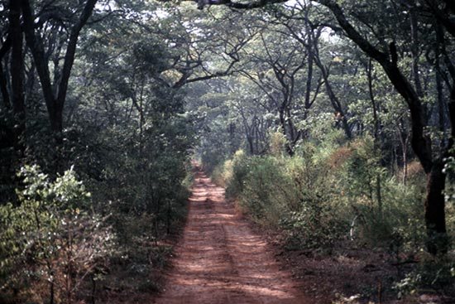
Photo 2. Lions in Moyhowosi Game Reserve
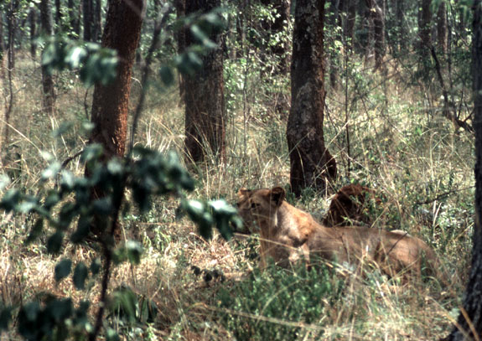
Photo 3. Rangers at Nkonje, Burigi Game Reserve
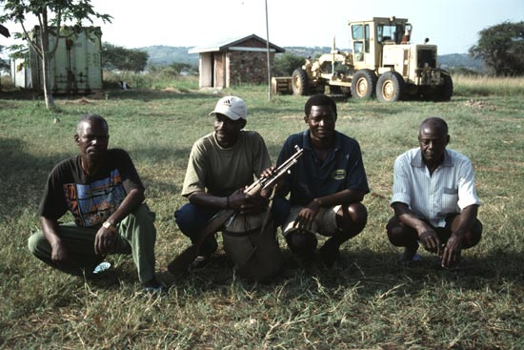

Photo 4. Rangers in Murongo Wildlife Division office, near Ibanda Game Reserve
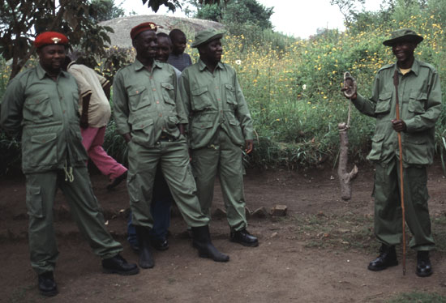

Photo 5. Snares collected by rangers from Ibanda and Rumanyika Game Reserves
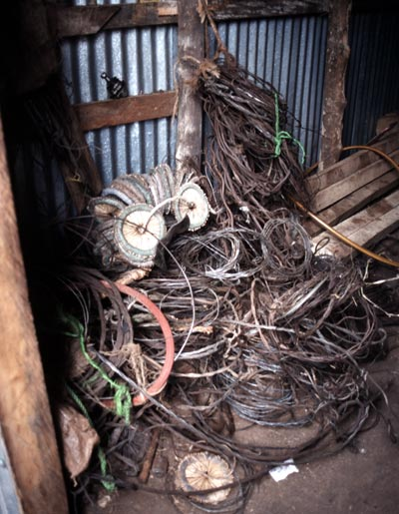
Photo 6. Project housing in Nkonje, Burigi Game Reserve
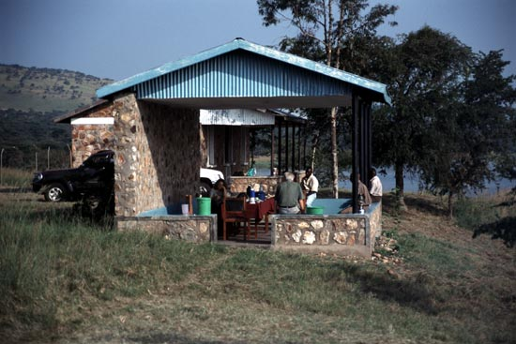
Photo 7. Individual cooking stove in use at household level
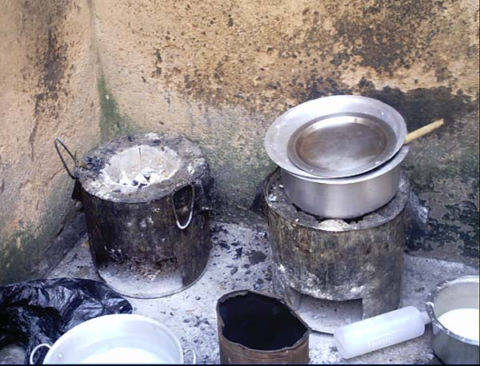

Photo 8. Refugees carrying firewood
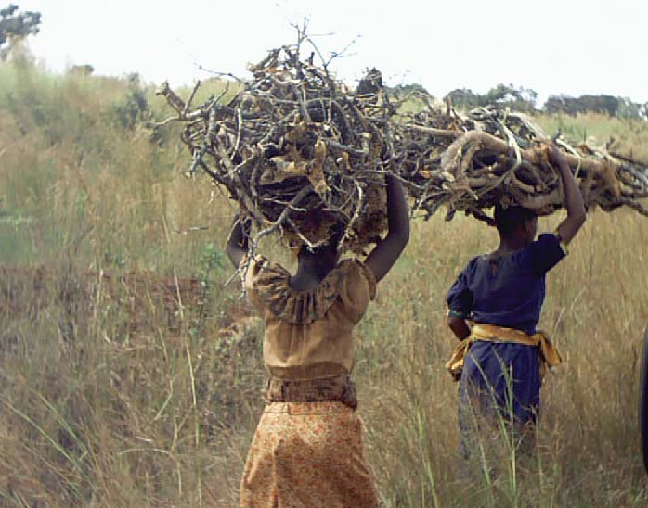
Photo 9. Institutional cooking stove at Baramba Girls School near Ngara
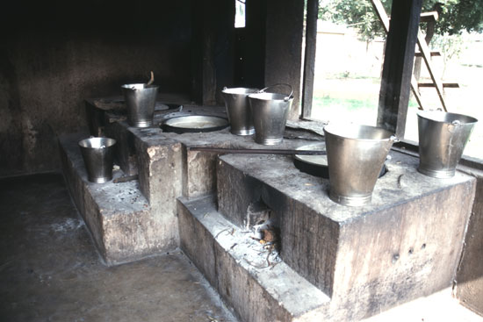

Photo 10. Traditional cooking stove
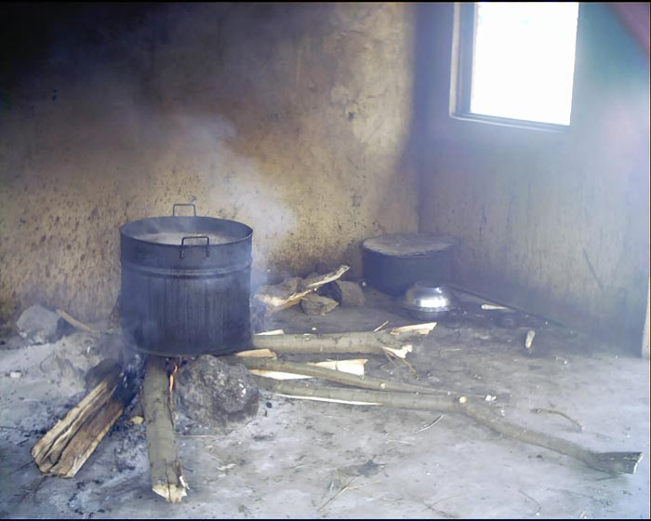
Photo 11. Woodlots at Baramba Girls School near Ngara
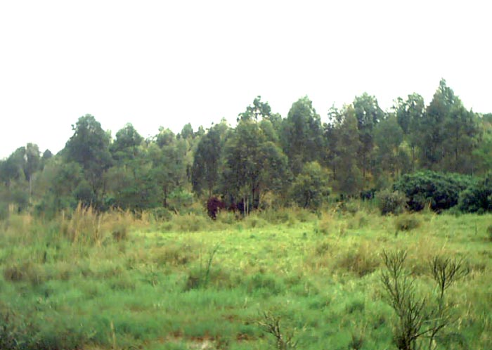

Photo 12. Incomplete market at Mabamba Village
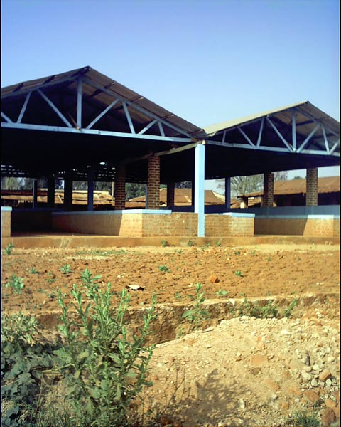
Photo 13. District Medical Officer's office, Kigoma
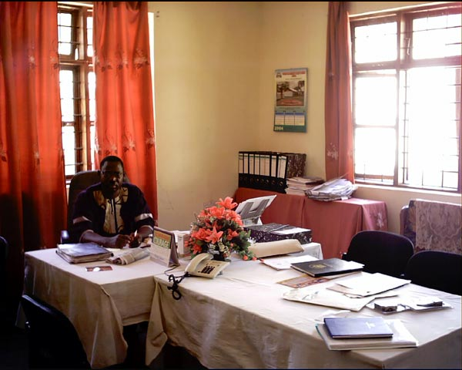

Photo 14. Classrooms built under the SPRAA project
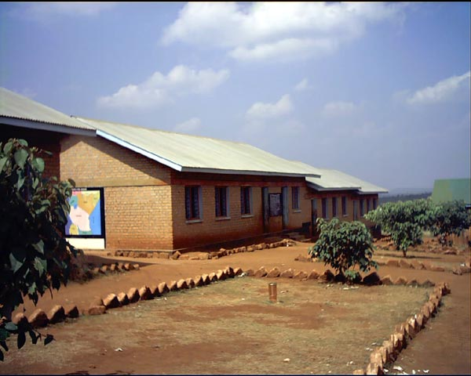
Photo 15. Inside view of completed hospital ward
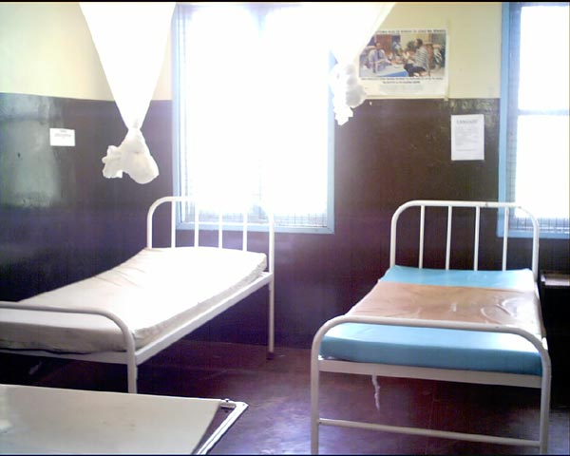

Photo 16. Completed and equipped labour ward
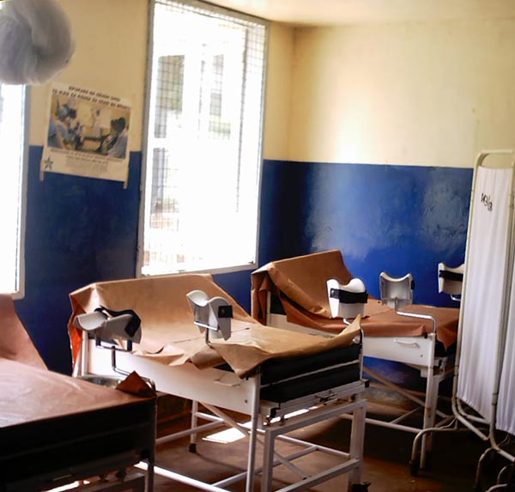
Photo 17. Children assisting in cracking open oil palm nuts, Bugamba Village
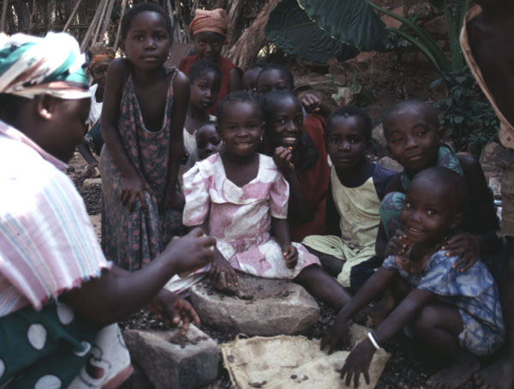

Photo 18. Tree nursery at Bugamba Village, Lake Tanganyika
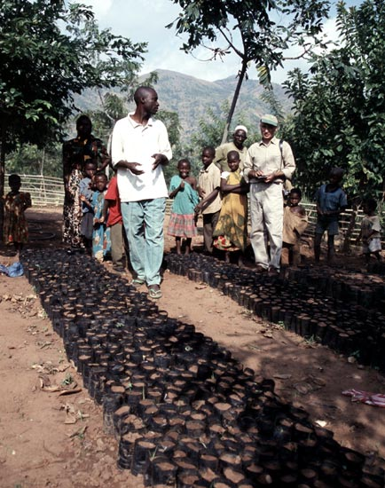
Photo 19. Mwanza Airport runway
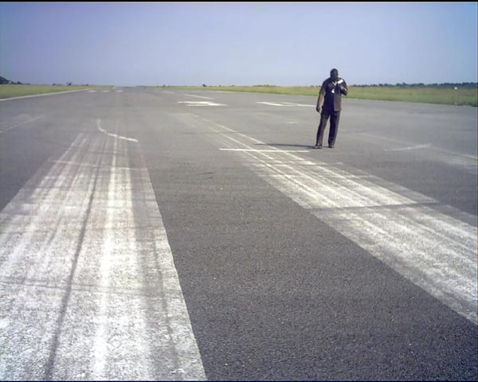

Photo 20. Mwanza Airport drainage system
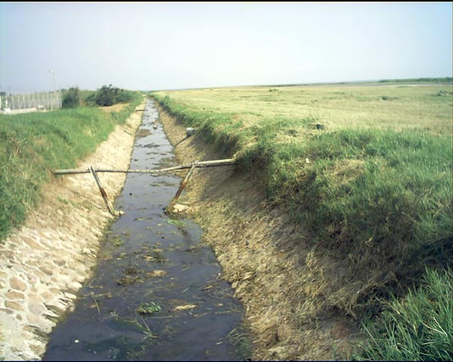
Photo 21. Damage to runway caused by turning aircraft


Photo 22. Deterioration of taxiway and apron, Mwanza Airport
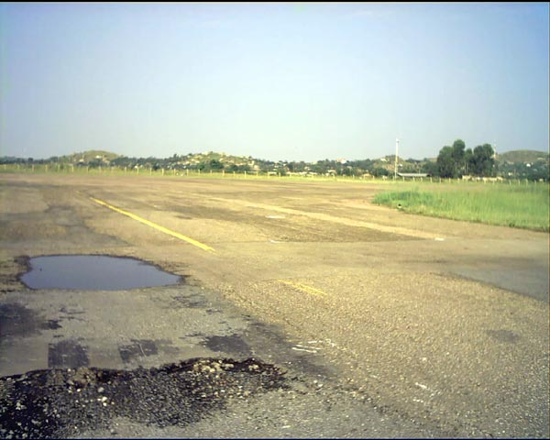
Photo 23. Unpaved apron at Mwanza Airport
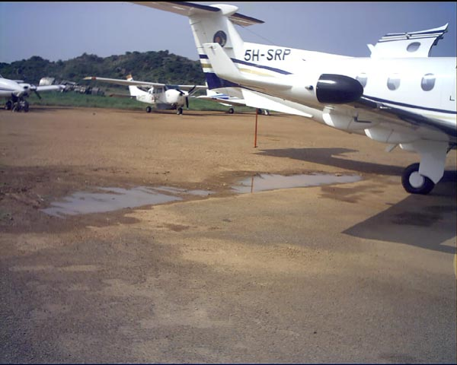

Photo 24. Road section rehabilitated by the project
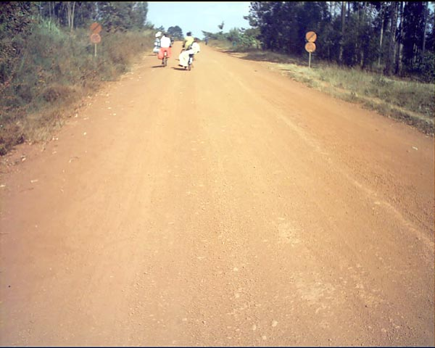
Photo 25. Narrow bridge that restricts traffic
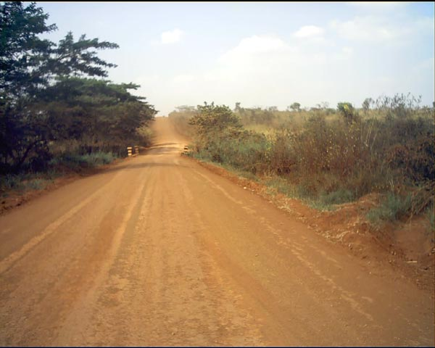

Photo 26. Road surface with gullies
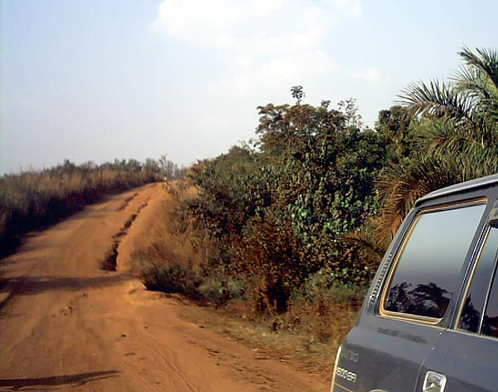
Photo 27. Road surface with potholes
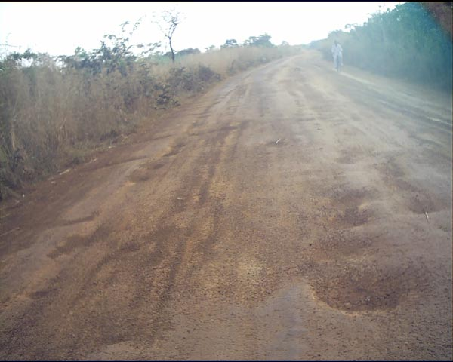

Photo 28. Bridge with guard rails missing
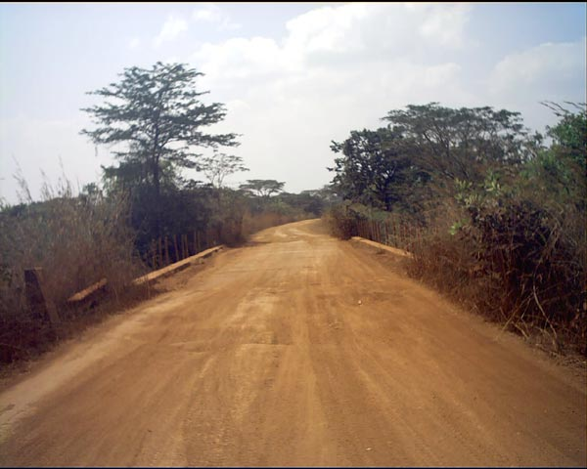
Photo 29. Signboard indicating construction of Muyobozi Bridge
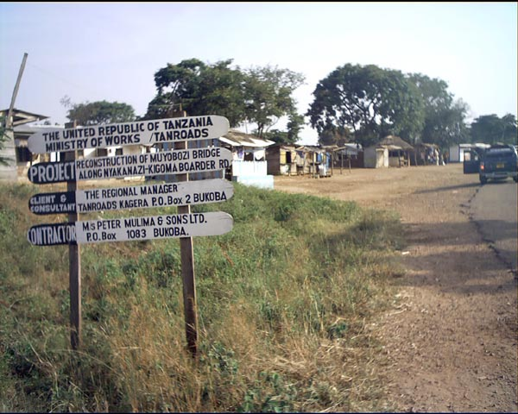

Photo 30. Ongoing work to repair culverts
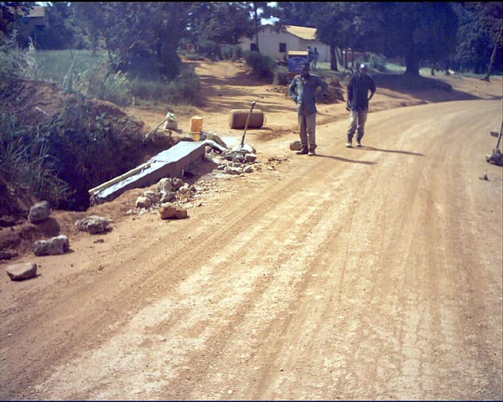
Photo 31. Narrow bridge on sharp curve; note absence of handrails
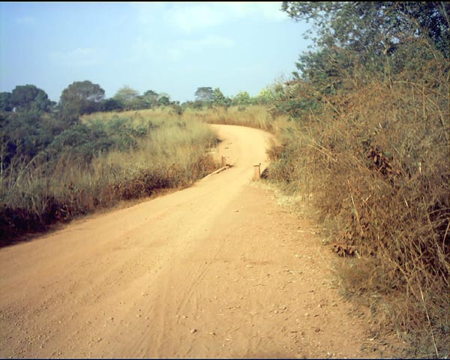

Appendices

Terms of Reference - Final Evaluation

SPECIAL PROGRAMME FOR REFUGEE AFFECTED AREAS (SPRAA)
7 ACP TA 098 - TANZANIA

- INTRODUCTION
SPRAA was launched in September 1997 with a €22m Financing Agreement between the Government of Tanzania and the European Commission, in the framework of the 7th European Development Fund. The programme focused on four areas of intervention:
- Transport infrastructure.
- Environment.
- Administration and socio-economic infrastructure.
- Programme management.

- OBJECTIVES OF THE STUDY

The study’s global objective is to assess if the project fulfilled its initial purpose, i.e. “maintain Tanzania’s capacity to accommodate refugees originating from the Great Lakes Region and her readiness to prepare for future influxes improved”, but to also assess the achievements of SPRAA and to make recommendations on the design for future programmes under relevance, efficiency, effectiveness and sustainability criteria.
More specifically, the main foci of the evaluation should concentrate on the result areas in the intervention logic.
- BACKGROUND
SPRAA was a follow-on from the EC-funded project ‘Special Rehabilitation Programme (SRP)’ for countries neighbouring Rwanda and was developed to increase Tanzania’s capacity to accommodate refugees from the Great Lakes Region and to improve readiness for future refugee influxes. SPRAA consisted of several sub-projects:
SPRAA Management Unit implemented by the Prime Minister’s Office (PMO)
PMO was responsible for the supervision of the implementation of SPRAA. Other responsibilities for PMO included the co-ordination of donor rehabilitation efforts.
Kagera Kigoma Game Reserve Rehabilitation Project (KKGRRP) implemented by the Wildlife Department
The project was initiated to control the depletion of wildlife in the game reserves of north-western Tanzania following massive influxes of refugees into these regions from Rwanda, Burundi and DRC. The major activities supported by this project were (1) strengthening reserve management; (2) protection of the wildlife resources through funding law enforcement operations; (3) development of management plans; and (4) encouraging community based conservation of the surrounding wildlife resources.
Kagera Environment Project (KEP), implemented by the Regional Forestry Office and GTZ
The aim of the project was to enable the communities of the districts in Biharamulo, Karagwe and Ngara to use their natural resources in a sustainable way. This concentrated on community forest management through land use planning and improving the capacity of the District Administration to plan and implement environment projects.
Palm Oil Production and Improvement of Local Processing Techniques implemented by the Jane Goodall Institute
This project aimed to increase local benefits to the Tanzanian population from the refugee presence in Kigoma region through improved production of palm oil (through the utilization of a hybrid) which could be sold to WFP for the refugee communities or sold on the local and export markets.
Lake Tanganyika Catchment Reforestation and Education Project (TACARE) implemented by the Jane Goodall Institute
TACARE involved the introduction of environmental and sustainable farming techniques as well as informal environmental education, village based savings and credit schemes and community development through village grants.
Small to Medium Social and Economic Projects for Kagera and Kigoma Regions implemented by International Red Cross
To tackle some of the problems faced by local communities as a result of refugee influxes, this project aimed at addressing social infrastructure and economic needs. Seven sub-projects comprised: construction of Ndela youth centre and hospital office in Kigoma; installation of communication equipment at Biharamulo; construction of Kibondo Primary School and expansion of Kibondo District Hospital; renovation of Nyarugusu primary school; and the refurbishment of three markets.
Review of Refugee Policies implemented by University of Dar es Salaam
During the influx of refugees into Tanzania in 1993-94, the way refugees were handled and the problems of co-ordination between various actors in the area of refugee management was poor, largely because there was no specific policy or practice on refugees. The aim of the project was to appraise current policy and provide recommendations for a more comprehensive Tanzanian policy on refugees.

Road Improvement Programme
The overall objective of this programme was to promote economic growth and integration as well as better living conditions in Kigoma and Kagera regions by improving accessibility in the area. This comprised of the rehabilitation of 335km of road in the Kigoma region and 258.2km in the Kagera region and the improvement of the capacity and safety at Mwanza Airport.
In Kigoma region, the roads included:
- Lot 1: Kigoma – Kasulu (92 Km)
- Lot 2: Kasulu – Kibondo (150 Km)
- Lot 3: Kibondo – Nyakanazi (93 Km)
Roads in Kagera region included Nyamirembe–Buzirayombo (39Km); Makurugusi–Bwanga (15Km); Bwanga–Buseresere (20.8Km); Chato junction–Chato ginnery (4.5Km); Lusahunga–Biharamulo (37.5Km); Biharamulo–Katoke (3Km); Katoke–Bwanga (66.8Km); Katoma–Bukwali (29.6Km); and Bukoba–Kabango Bay (42Km).
At Mwanza Airport, works included the repair of 3,300m of runway and a drainage system. Institutional support was provided and equipment was procured for the Airport Authority to foster safety and the sustainability of its services.

- ISSUES TO BE STUDIED/TASKS TO BE UNDERTAKEN

The evaluation study will make an assessment of the current situation in the project area, the impact of the project and provide recommendations with regard to the following issues:
- To review the relevance and quality of design of the project. To assess how well the project addressed the needs of the beneficiaries.
- To assess the effectiveness of the project, focussing on assessing if the planned benefits of the various components were delivered to the target groups.
- To assess the efficiency of the project activities undertaken in order to yield the project results, paying particular attention to means and costs, organisation and management, and participation of beneficiaries in project implementation.
- To assess the sustainability of project activities and outputs.
- To assess how the project contributed to poverty reduction.
- To draw the lessons learned. What policy, organisational and operational lessons can be drawn specifically in relation to the project? (e.g. for the Government and the EC); what pre-conditions might be recommended for similar future projects; what general development lessons might be drawn from the evaluation in relation to, for instance, policies, instruments, and sectoral, country or regional strategies?

- METHODOLOGY
The experts are required to:
- Conduct a briefing with the NAO, PMO and EC Delegation at the beginning of the mission;
- Hold discussions with the implementing organisations and key personnel within line ministries regarding the implementation of the SPRAA projects;
- Visit project sites in Kagera, Kigoma and Mwanza regions to assess achievements and constraints with project managers and other key stakeholders;
- Review relevant project documentation which will include, inter alia, progress and financial reports, monitoring and evaluation reports and any independent reports/studies where relevant.

- OUTPUTS
The consultant shall supply the following reports:
- Draft Final Report within two weeks after the end of the mission to Tanzania, to be submitted for comments and/or approval to the National Authorising Officer.
- Final Report within one week after receipt of comments and/or approval of the draft final report by the National Authorising Officer.
A debriefing exercise to the Delegation and the NAO will also take place at the end of the mission to Tanzania.
All reports shall be written in English. The final report will include:
- An executive summary, containing major findings and recommendations (max. 5 pages);
- The monitoring and evaluation methodology, assessment, conclusions and recommendations; and
- Annexes: the Terms of Reference, the consultant’s comments on these Terms of Reference (if any), the list of persons and documents consulted, a brief curriculum vitae of the consultants and other technical annexes as relevant.
The National Authorising Officer will communicate to the consultant its comments and/or approval of the draft final report within 4 weeks after its presentation.
The draft and final reports shall be submitted in 6 hard copies and one electronic version.

- EXPERTISE REQUIRED

The team will comprise a total of four experts:
- One Team Leader with a least 15 years of professional experience (category I) in the development sector in Africa with a strong background in Monitoring and Evaluation of EC-funded projects;
- One expert with at least 10 years of professional experience in environment/natural resources (category II). Experience of working in Africa for a donor organisation as well as monitoring and evaluation experience would be an advantage;
- One expert with at least 10 years of professional experience (category II) as a senior transport economist or civil engineer in the management, design and supervision of road and infrastructure developments projects in developing countries. This experience must include trunk and regional roads and backlog maintenance schemes. Experience with EDF works contracts and project management and procedures would be an advantage; and
- One expert with at least 10 years of professional experience in social and economic sectors (category II). Experience of working with refugee related projects in Africa as well as monitoring and evaluation would be an advantage.
All experts must have a relevant university degree, and preferably postgraduate qualifications in their field of their expertise and be fluent in English. EDF experience and command of Swahili would be a distinct advantage.

- WORK PLAN AND TIME SCHEDULE
The evaluation should take place during April/May 2004, and should be completed within a six week period. The four experts will be on assignment in Tanzania for a period of three weeks each. An additional provision has been made of 14 man-days at the Consultant’s head office to finalise the draft final and final reports, the time distribution for the experts will be as follows:

Expert | Days in Field | Days Reporting | Total
Category I (Team leader) | 21 | 5 | 26
Category II (Environment) | 21 | 3 | 24
Category II (Roads) | 21 | 3 | 24
Category II (Social) | 21 | 3 | 24
 | 84 | 14 | 98

The total cost of these services, including fees, per diems, air and local travel, reporting and office expenses should not exceed €80,000.

List of persons consulted

Dr. Anthony Carol Collins Senior Representative, Jane Goodall Institute (JGI), Tanzania
Dr. Dismas Vyagusa District Medical Officer, Kigoma District Council
Dr. Geoffrey Okumu Health Coordinator, International Rescues Committee (IRC)
Dr. Rolf Link Ex SPRAA – GTZ staff, GTZ FOPLS
Dr. Sifuni Ernest Mchome Senior Lecturer and Head Civil and Criminal Law Department, Faculty of Law, University of DSM
Eng L. Mujjungi Director Trunk Roads, MOW
Eng R. L. Byanyuma European Development Fund (EDF)-PSU, NAO’s Office.
Eng. A.G.M. Maregesi Ag. Senior. Maintenance Engineer, TANROADS, Kigoma
Eng. Augustino Phillip Senior Maintenance Engineer, TANROADS, Kagera
Eng. E. Mujwahuzu Ministry of Works, Dar es Salaam
Eng. I. A. Kirway Sen. Engineer Trunk Roads, MOW
Eng. J. J. Msukupakulia Ag. Director Maintanance, MOW
Eng. J. Kalupale Regional Manager, TANROADS, Kigoma
Eng. Joseph Nyamhanga Regional Manager, TANROADS, Kagera
Eng. Mariehellen Minja (Ms.) Programme Officer, Infrastructure, Delegation of the European Commission, European Union.
Eng. Prosper Tesha Director General ,Tanzania Airports Authority (TAA)
Eng. S.S. Suleiman Technical Director, TAA
Eng. V. Ndyamukama Director of Maintenance, TANROADS
Mr. Whycliffe K. Songwa Head, UNHCR Kigoma Office
Mr. A. A. Shao Regional Administrative Secretary (RAS), Kigoma
Mr. Abdu Edward Mgoma SACCOS Beneficiary, Bugamba Village
Mr. Adam B. Dongwe District planning Officer, Kigoma District Council
Mr. Adam Hassan Farmer, Bugamba Village, Kigoma
Mr. Adam Kenani Administrative Assistant, TACARE
Mr. Admirabillis Kafigiri Agriculture Coordinator, Ndela Youth Centre
Mr. Adolph Samaje SACCOS Beneficiary, Bugamba Village
Mr. Adrian Jackson Head-Roots & Shoots Department, TACARE
Mr. Adrophinus Leopold Councilor, Ndela Youth Centre
Mr. Amani Kingu Chatta Head, Agriculture Department Oilpalm Specialist, The Jane Goodall Institute TACARE Project
Mr. Amani Kingu Head, Agriculture Department, TACARE/JGI
Mr. Amanya Michael Ebye Country Director, International Rescue Committee, TZ Program (IRC)
Mr. Andrew Cauldwell Technical Advisor, Kagera & Kigoma Game Reserves Rehabilitation Project (KKGRRP)
Mr. Bakari Kingobi District Executive Director, Ngara District Council
Mr. Chrysantus Ache Representative, UNHCR, Tanzania
Mr. David Matovolwa Civil Engineering Technician Mwanza Airport
Mr. Deogratias Malongo Airport Manager, Mwanza Airport
Mr. Dominic Kweka Ag. Council Director, Kigoma District Council
Mr. E. M. Lutabingwa Project Manager, Burigi & Biharamulo Game Reserves
Mr. E. Mwaisala Former Coordination Unit of SPRAA, Prime Minister’s Office
Mr. Edward M. Lutabingwa Project Manager, Ibanda Rumanyika Orugundu Game Reserve Project
Mr. Elias Lyanga Road Inspector, TANROADS, Kagera
Mr. Elieskia Mugheni Forest Officer, Karagwe District.
Mr. Emmanuel R. Mtiti Project Manager, TACARE
Mr. F. J. Kapsara Project Manager, Burigi & Biharamulo Game Reserves
Mr. Felix Nyilema Head Teacher, Baramba Secondary School, Ngara
Mr. Frederick Mwinjabi Public Information Assistant, UNHCR
Mr. Fortunatus Kambarangwe RADESO, Ngara
Mr. George Kessy Former Fuel Efficient Stove Consultant, KEP/GTZ
Mr. Gervas Nyogole District Health Officer, Biharamulo District Council
Mr. Gideon Kibambae Incharge of Bagamba Village Dispensary
Mr. Hamis Ismail SACCOS Beneficiary, Bugamba Village/Headteacher
Mr. Hussein Hassan Secretary VEC, Bugamba
Mr. J.S.F. Mbwiliza Project Coordinator, WD and Project Manager Moyowosi and Kigosi GR
Mr. Jackson Madyalo District Natural Resource Officer, Biharamulo
Mr. Japhet Ndau Farmer, Bugamba Village, Kigoma
Mr. Joseph Mwasi Farmer, Murongo Village
Mr. Kulige O. Bongo Chairman, Bugamba Village
Mr. Moshi Matias SACCOS Beneficiary, Bugamba Village
Mr. Muhunzi Deputy Game Officer, Burigi Game Reserve.
Mr. Ndyamukama Director of Maintenance, TANROADS
Mr. Peter Mahushi District Education Officer, Ngara
Mr. Phillip Eleta District Forest Officer, Ngara
Mr. Razi Latif European Delegation
Mr. Robert Gingiri Youth Secretary, Ndela Youth Centre
Mr. William Mngalula District Executive Director (DED), Biharamulo
Ms Maagi Regional Assistant Secretary (RAS), Regional Forest Officer & Agriculture – Kagera
Ms. Aristides A. Kashula Head Forestry Section, TACARE
Ms. Beatrice Marwa Community Dev. Officer, TACARE
Ms. Domina Rugaiganisa District Reproductive and Child Health Coordinator, BDC.
Ms. Doto Madelina SACCOS Beneficiary, Bugamba Village
Ms. Edita William Teacher, Njia Panda Primary School (BENACO), Ngara
Ms. Hanifa Ramadhani SACCOS Beneficiary, Bugamba Village
Ms. Jenipher Mgarula District Nursing Officer, Biharamulo District Council
Ms. Joha Ramadhani Chairperson, Village Environmental Committee (VEC), Bugamba and SACCOS Beneficiary, Bugamba Village
Ms. Kilugala Anthony Forestry Assistant, TACARE
Ms. Letisia Antoni SACCOS Beneficiary, Bugamba Village
Ms. Maria Paris-Ketting Counsellor, Rural Development & Governance, Delegation of the European Commission, EUROPEAN UNION
Ms. Mary Mavanza Co-Manager, TACARE
Ms. Matrida Alois SACCOS Beneficiary, Bugamba Village
Ms. Modesitine Wisoni SACCOS Beneficiary, Bugamba Village
Ms. Moshi Sanze Agriculture Assistant, TACARE
Ms. Sinaraha Husein SACCOS Beneficiary, Bugamba Village
Ms. Situmahi Hamim Chairperson SACCOS/ Beneficiary, Bugamba Village.
Ms. Tabitha Rulanyaga Administration Assistant, JGI Tanzania
Ms. Zahara Amrani SACCOS Beneficiary, Bugamba Village.

Brief CVs of Evaluation Team

Dr. Martyn Murray: Team Leader and Natural Resources Expert;
Eng. Exaud Mushi: Civil/Highway Engineer (Roads);
Mr. Richard Minja: Forestry and Environmental Expert (Environment);
Dr. Flora Kessy: Socio-economist (Social).

Mwanza Airport Traffic Record from 1994 to 2003

MWANZA AIRPORT TRAFFIC RECORDS FROM 1994 TO 2003
Year | No. of Aircraft Movements | Total No. of Passengers | Cargo (Kgs) | Mails (Kgs)
1994 | 8,193 | 87,443 | 4,923,092 | 84,258
1995 | 8,867 | 99,545 | 2,851,734 | 109,826
1996 | 9,205 | 96,722 | 3,996,451 | 160,844
1997 | 9,422 | 93,311 | 10,055,990 | 118,919
1998 | 11,123 | 99,482 | 11,283,180 | 232,277
1999 | 9,612 | 87,708 | 4,333,101 | 122,715
2000 | 13,817 | 100,845 | 19,562,435 | 162,493
2001 | 14,629 | 119,695 | 21,063,048 | 165,928
2002 | 11,937 | 110,961 | 17,419,788 | 132,016
2003 | 13,699 | 137,847 | 12,311,091 | 148,533

Deliveries and Maternal Deaths for Burundians and Tanzanians - 2001 and 2002 (Kibondo District Hospital).

 |  | 2001 |  |  |  |  |  |  |  |  |  |  |  | 2002
 |  | Jan | Feb | Mar | Apr | May | Jun | Jul | Aug | Sep | Oct | Nov | Dec | Jan | Feb | Mar | Apr | May | Jun
Normal | BR | 9 | 19 | 21 | 16 | 21 | 9 | 11 | 8 | 11 | 19 | 13 | 13 | 12 | 11 | 15 | 17 | 23 | 23
deliveries | TZ | 93 | 58 | 83 | 56 | 85 | 79 | 116 | 96 | 81 | 63 | 88 | 78 | 83 | 80 | 97 | 83 | 98 | 70
Caesarean | BR | 14 | 13 | 21 | 14 | 13 | 19 | 24 | 11 | 19 | 25 | 23 | 22 | 26 | 28 | 35 | 34 | 22 | 29
section | TZ | 7 | 5 | 3 | 8 | 10 | 11 | 23 | 12 | 17 | 11 | 16 | 20 | 22 | 17 | 23 | 18 | 16 | 22
Vacuum | BR | 1 | 0 | 1 | 1 | 0 | 2 | 3 | 3 | 0 | 3 | 1 | 1 | 1 | 0 | 0 | 1 | 0 | 0
 | TZ | 0 | 1 | 1 | 0 | 0 | 2 | 1 | 0 | 0 | 1 | 1 | 4 | 1 | 0 | 0 | 1 | 0 | 0
Breech | BR | 0 | 0 | 0 | 1 | 0 | 3 | 1 | 0 | 0 | 0 | 0 | 1 | 3 | 3 | 0 | 1 | 2 | 1
deliveries | TZ | 3 | 0 | 2 | 0 | 1 | 1 | 3 | 0 | 1 | 4 | 1 | 1 | 1 | 1 | 1 | 3 | 0 | 3
Total | BR | 24 | 32 | 43 | 32 | 34 | 33 | 39 | 22 | 30 | 47 | 37 | 37 | 42 | 42 | 50 | 53 | 47 | 53
deliveries | TZ | 103 | 64 | 89 | 64 | 96 | 93 | 143 | 108 | 99 | 79 | 106 | 103 | 107 | 98 | 121 | 105 | 114 | 95
Blood | BR | 0 | 0 | 0 | 0 | 0 | 0 | 0 | 0 | 0 | 0 | 0 | 5 | 0 | 3 | 0 | 4 | 1 | 10
transfusions | TZ | 0 | 0 | 4 | 9 | 1 | 6 | 3 | 5 | 0 | 0 | 4 | 11 | 8 | 9 | 4 | 11 | 9 | 9
Maternal | BR | 0 | 0 | 1 | 0 | 1 | 0 | 0 | 0 | 0 | 0 | 0 | 0 | 0 | 0 | 1 | 1 | 0 | 1
deaths | TZ | 1 | 0 | 1 | 0 | 0 | 1 | 1 | 0 | 0 | 1 | 0 | 4 | 0 | 0 | 1 | 1 | 0 | 0

