MONGOLIA
DYNAMICS OF BIODIVERSITY LOSS AND PERMAFROST MELT IN LAKE HÖVSGÖL NATIONAL PARK, MONGOLIA
GEF Medium Size Project TF028988
MID-TERM REVIEW
FINAL REPORT

Martyn Murray
MGM Environmental Solutions Ltd

August 2004
Mongolia

Dynamics of Biodiversity Loss and Permafrost Melt in Lake Hövsgöl National Park, Mongolia

GEF Medium Size Project TF028988

Mid-Term Review
Final Report

by
Martyn Murray
August 2004

Hövsgöl GEF/WB Project
Geo-Ecology Institute-301, Baruun Selbe-13,
Ulaanbaatar 211238, Mongolia

Table of Contents

1. Introduction and Background 1
1.1 The Review 1
1.2 The Study Area 1
1.3 Project Objectives 2
1.4 Gradients and Ecological Transitions in the Project Area 3
2. Review of work undertaken, 2002-2004 5
2.1 Project History 5
2.2 Project Studies 5
Meteorology 5
Permafrost 6
Soil Morphology and Chemistry 7
Hydrology 8
Forest Regeneration 8
Forest Growth, Dynamics and Fire Study 10
Forest Insect Pests 11
Small Mammals 12
Birds 13
Steppe 14
Terrestrial Insects 16
Nomad Land-use and Livestock Grazing 16
Pasture Plant Map 17
Livestock Parasites, Condition and Disease 18
Water Chemistry 18
Diatoms 19
Aquatic Insects 19
Fish 21
Nomad Socio-Economics 21
Carbon Cycle 22
Database 24
GIS 25
3. Project Impacts 26
3.1 Immediate Local Impact 26
3.2 Sustainable Local Impact 27
3.3 Sustainable World Impact 27
4. A Conceptual Model 29
5. Ecosystem Management 31
5.1 Sustainable Use 31
Carrying Capacity of Steppe 31
Sustainable Use of the Forest 31
Sustainable Offtake of Large Mammals 31
Sustainable Offtake of Fish 33
5.2 Management 33
6. Conclusions and Recommendations 34
6.1 Review findings 34
Design and Implementation 34
Capacity Building 34
Scientific Impact 35
Management Impact 36
Communication and Security 38
Budget 39
6.2 Recommendations for Years 3, 4 and 5 40
Year 2004 40
Year 2005 40
Year 2006 41
Prioritising Research 42
7. References 44
8. Photos 45

List of Photos

Frontispiece: Moving camp in Turag Valley (courtesy of Ariuntsetseg)

Photo 1. Clearings on north-facing slope of Turag Valley (from Otor meadow) 46
Photo 2. Steppe on south-facing slope of Noyan Valley 46
Photo 3. Riparian habitat in Sevsuul Valley 47
Photo 4. View of the project camp and south-facing steppe from Dalbay River 47
Photo 5. Early morning mist over permafrost on north-facing slope in Dalbay Valley 48
Photo 6. Melting ice alongside a small tributary of the Dalbay River (mid-July) 48
Photo 7. Site of experiment on seed predation and germination, Dalbay Valley 49
Photo 8. Germination of larch seeds is monitored in 0.5x0.5m plots 49
Photo 9. Mature larch with old cones, Turag Valley 50
Photo 10. Measuring the growth of larch with a girth band, Sevsuul Valley 50
Photo 11. Fire hollowed trunk of mature larch tree in Sevsuul Valley 51
Photo 12. Date of major fires and age can be determined from tree rings 51
Photo 13. Areas of dying forest that burnt in 1997, north slope of Turag Valley 52
Photo 14. Impression of a large tree left by the 1997 fire in Sevsuul Valley 52
Photo 15. Edge of forest and steppe along the south-facing slope of Dalbay Valley 53
Photo 16. Larch seedlings on a shaded south-facing slope, Dalbay Valley 53
Photo 17. Flowers and grasses in the Otor pasture of Turag Valley (see Photo 1) 54
Photo 18. Biomass measurement on the upper south-facing slope of Noyan Valley 54
Photo 19. Livestock exclosures on south-facing slope of Dalbay Valley 55
Photo 20. Quadrats are clipped inside livestock exclosures to measure production 55
Photo 21. River Dalbay 56
Photo 22. Electro-fishing in River Dalbay 56
Photo 23. Monitoring river temperature 57
Photo 24. Minnows and young fish caught in River Dalbay 57

Annexes

- Training Topics Organized by Hovsgol_GEF Project
Acknowledgements

This report is based on the field visits, presentations, discussions and reports provided by the researchers of the Hövsgöl-GEF project and their advisors during my four weeks in Mongolia over the summer of 2004. Thanks to all of the project staff and advisors for helping with interpretation, meetings, reports, communications and logistics. The Project Assistant (B. Gantsetseg), Project Manager (B. Mendsaikhan), former Project Manager (E. Elbegzaya) and the Project’s socio-economist (Sh Saruul) provided much practical help and information as well as meeting every request during a very busy period.

I am grateful to the International Consultant (Clyde Goulden) for many thought-provoking discussions and for his unfailing hospitality during my stay in the project area. Many thanks also to Tony Whitten and Giovanna Dore for transporting me to the study site in splendid style and for providing an excellent introduction to the project. I am particularly grateful to Peter Zahler for extending me the hospitality of his apartment in Ulaanbaater throughout my time in the city. Warm thanks also to the project drivers for making my travels so enjoyable and to the cooks at Dalbay Valley for turning out at all hours of day and night to provide hot meals and drinks. Lastly I would like to thank the many other unnamed individuals who assisted me during the mission.

1. Introduction and Background

1.1 The Review
The mid-term review of the Hövsgöl-GEF project was initiated in May 2004 with the receipt of the project's 2002 and 2003 annual reports and other working documents. An Inception Report was produced on 18th June 2004. The reviewer arrived in Ulaanbaatar on 15th July attending meetings in the project office on the next day with the Project Assistant (B. Gantsetseg), the forest ecology researcher (M. Khishigjargal) and two senior Mongolian academics associated with the project (the hydrologist Dr. V. Tuvshinjargal, Science Secretary, Institute of Geography, MAS and the soil scientist O. Batkhishig, Head of the Soil Laboratory, Institute of Geography, MAS). From 17-19 July he accompanied Dr. A. Whitten (Senior Biodiversity Specialist, EASES) and Giovanna Dore (Operations Analyst, EASES), on the journey up to the Hövsgöl-GEF study area. A series of meetings was held with the Project Manager (Mendsaikhan), the International Consultant (Dr. C. Goulden) and 14 researchers. Inspections of field methods were held at individual study locations in five of the tributary valleys; meetings were also held with herders, including those with small and large numbers of livestock, and with representatives of the local NGO. A PowerPoint presentation of methods and current results was delivered by the research team on 20 July. The reviewer presented his initial observations on the project to the research team on 27 July, met with Tumasukh (Director of Hövsgöl National Park) in Hatgal on 28 July, and returned to Ulaanbaatar on 30 July. Meetings were held with Dr. J. Tsogtbaatar (Project Director, Institute of Geoecology) on 31 July, with T. Galbaatar, (Vice-President, Mongolian Academy of Sciences), J. Tsogtbaatar and C. Goulden on 3rd August, with Oyunchuluun (terrestrial insect researcher), Sanaa and Suvdtsetseg (aquatic insect researchers) on 4th August, with B. Elbegzaya (Programme Officer UNDP and formerly Project Manager of the Hövsgöl-GEF project) on 5th August and with C. Goulden on 9th August. The reviewer departed from Ulaanbaatar on 11th August 2004 and completed this report on 22nd August.

1.2 The Study Area
The Hövsgöl region is located in the transition zone between the Siberian taiga, the Steppe, and the Central Asian desert, the country is prone to shifts in geo-climatic zones caused by climate change. Lake Hövsgöl itself is a large and ancient lake located at the southern edge of the taiga forest and the boundary of continuous permafrost. It is pristine, cold and oligotrophic and contains many endemic species. The Hövsgöl basin receives more precipitation than in other Mongolian regions, averaging from 200-350 mm per year. About 85-90 percent of the annual precipitation falls as rain during the summer and 50-60% is in July and August. Average winter temperatures in the region are -16.5º C - 23.0º C with an extreme minimum of -47.7º C recorded in January 2000; average summer temperatures are 10.8º C - 11.8º C with and extreme maximum of 31.6º C recorded in July 2002. The region is experiencing major climate warming: annual temperatures have warmed by 1.86º C over the last 32 years at the south end of the lake (Hatgal) and by 2.8º C at the north end of the lake (Hanh).

Field studies are being conducted in six valleys that run in a predominantly east to west direction with rivers draining into Lake Hövsgöl's eastern shore. Characteristically the north-facing valley slopes are forested and the south-facing slopes are open steppe; the rivers are fringed by riparian shrub and forb communities (Photos 1-4). Permafrost is present on most north-facing slopes and in lower stream valleys, but is absent from south-facing slopes (Photos 5, 6). The Siberian larch (Larix siberica) dominates the forest composing more than 90% of trees (Photo 9); Siberian pine (Pinus siberica) is the next most dominant tree species. Willow scrub (Silex sp) is common in the riparian zone. Dominant grasses in the steppe include: Festuca lenensis, Koelena altaica and Poa attenuata. Dominants in the riparian zone include the sedges, Carex duriuscula and C. dichroa, and the forbs, Geranium pratense, Polygonum alopecuroides and Sanguisorba officinalis. Grazing impacts are heavy in the northern valleys of Turag and Shagnuul and light or absent in the southern valleys of Dalbay and Borsog. Large mammals that may be found in the study area include moose, red deer, Siberian roe deer, Siberian musk deer, wild boar, brown bear, Eurasian lynx, Pallas cat, wolf, red fox, corsac fox and dhole, but the wild ungulates at least apparently occur at low density.

Thanks to the active layer of permafrost the rivers have a continuous discharge throughout the year. Typically they are divided into an upper mountain section with high velocity, a slower middle section with increasing depth and a lower meandering section that connects to the lake. Storms can produce waves that hold back the river current, and temporary rock dams sometimes form. Grayling and lenok migrate up the rivers to spawn from May to July.

Until relatively recently the project area was kept unoccupied to conserve pastures for livestock herds being driven up to Russia. Now that this trade has ceased, some 39 herding families, many of which are related to one-another, have moved into the project area. Most families arrived around 1972 or subsequently. Their ability to move livestock is restricted by the Russian border in the north, the lake on the west and by unsuitable habitat on the hills in the east. Hence a major challenge for the project and the herding families is to find new ways of living within a restricted space without depleting natural resources.

1.3 Project Objectives

The overall objective of the project is to identify sustainable land use practices that will protect biodiversity, ecosystem function, and permafrost.

The specific objectives of the project as listed in the Project Brief are as follows:

- To identify the physical impacts of different intensities of pasture use and forest cutting on the dynamics of forest, steppe, riparian zones, and streams in tributary valleys of Lake Hövsgöl.
- To define how those impacts interact and are affecting the melting of permafrost, soil characteristics, and plant and animal biodiversity.
- To inventory climate change effects in ecosystems of HNP.
- To determine sustainable resource use patterns that will improve land management and also protect biodiversity, permafrost and soil/forest sequestration of carbon, and possibly lead to programs for the rehabilitation of certain areas.

A fifth objective is listed in the Aide Memoire of the First Supervision Mission (June 20 - July 5, 2002):

5. Calculation of benefits and costs of alternative land use practices, especially as related to pastoral nomads.

A number of questions that are central to achieving these objectives are also listed in the Project Brief:

- What are the physical impacts of alternative nomadic pasture uses, forest loss and climate change on the wetland, stream and lake ecosystems of HNP and how do they interact?
- Within forest, steppe, riparian zones and aquatic habitats, how are these impacts affecting permafrost melt, soil moisture, water chemistry and altering plant and animal diversity and ecosystem function?
- What land use practices have the greatest impacts within and outside the ecosystems where they occur, which have the least, and how can an understanding of these relationships lead to sustainable use of resources?
- Will altered land use practices lead to a recovery of damaged valleys, reducing ecological impacts among the ecosystems and slow the rate of permafrost melt in impacted valleys?

The first two questions are challenging: a full answer to the second question for instance would require a comprehensive knowledge of the ecosystem at the depth usually associated with an Integrated Ecosystem Study (IES). Typically an IES would track energy and nutrient fluxes between soils, the herbaceous layer and trees, herbivores, and decomposers. An IES might begin with a baseline description of the soils and vegetation, and follow this with the identification and investigation of key processes in the ecosystem. For the Hövsgöl-GEF project, prioritisation would need to be given to the ecological processes that incorporate: permafrost thaw; soil moisture; soil nutrients, forest regeneration; grazing impacts and river pollution. In the final phase of an IES, the ideas generated would be extended elsewhere. A timeframe of about 10 to 15 years might be reasonably expected for a major IES. As the Hövsgöl-GEF project has a timeframe of only 5 years, it is having to move fast. Two areas that may prove difficult in consequence are: (a) the smooth integration of individual project results within a whole ecosystem framework; and (b) the investigation of those processes with multiple unknown steps that require sequential research projects.

The loss of boreal forest that lies at the root of the project was thought to derive at least in part from unsustainable land-use practices brought on by socio-economic changes that disrupted traditional nomadic use of pastures. The project's objectives do not appear to address this problem directly. Nevertheless during implementation, a Nomadic Social Study specialist was contracted and the first socio-economic survey (reported in Chapter 21, 2003 Annual Report) indicates that limited nomadic movement of herds may be a bigger problem than stocking rate per se. Ongoing socio-economic work will hopefully provide a better understanding of the constraints bearing on land-use practices of livestock herders, and may point to livestock husbandry and marketing inputs that would assist herders willing to adopt sustainable practices.

1.4 Gradients and Ecological Transitions in the Project Area
Over the past thirty years much attention in ecology has been focussed on transitions between stable states that can vary markedly in vegetation biomass, productivity, and species diversity. Transitions may be a natural part of the landscape in response to gradients in moisture, temperature or soil character, but they are also associated with overgrazing, overhunting of keystone species, anthropogenic forest fires, introductions of exotic species, and pollution. Avoiding the transition of diverse and productive habitats to their impoverished counterparts is equally important in land development and species conservation.

The study area of six east-to-west valleys has several large-scale ecological gradients: (i) the incidence of solar radiation (dependent on aspect - north-facing slopes receiving less radiation than south-facing slopes); (ii) altitude (lakeside pastures are colder and more moist in summer, upper valleys are colder in winter); and (iii) livestock grazing pressure (more intense in the northern valleys). These gradients in energy flux, moisture and grazing pressure affect the productivity of soils and vegetation, and ultimately the chemistry and biota of rivers and lake.

At least four kinds of ecological transition are found or could potentially occur in the project's study area: (a) permafrost to permafrost free areas; (b) forest to steppe; (c) healthy to degraded steppe; and (d) oligotrophic to eutrophic/polluted rivers. The project is seeking to understand how land use practices affect these ecological transitions as well as tracking the major energy pathways within habitats. Preliminary findings suggest that a key determinant of productivity and biodiversity in the valleys is the link between vegetation cover, permafrost and soil moisture.

The project is also seeking to identify sustainable options for land-use that will protect biodiversity. This task is made more challenging by the political and geographic landscape on the eastern side of Lake Hövsgöl, which restricts livestock movement. Herders have adapted by changing their traditional nomadic lifestyle to a more settled way of life confined within valleys or between adjacent valleys.

2. Review of work undertaken, 2002-2004

2.1 Project History

The project was delayed from its intended start in 2001, effectively commencing in April 2002 with the recruitment of the Project and Financial Managers. Procurement of equipment and supplies followed shortly thereafter. Research positions were advertised and the research team recruited from a field of 90 interviewees in May/June. The first field season commenced in June 2002. A logistics officer was hired to help set up the camp. In 2003 and 2004, the typical period of research was from mid May to the end of August. Several researchers also visited the project area in November, December and March. The meteorologist visits every two months throughout the year to download information from the dataloggers. The project's database was developed with the aid of a consultant from the National Technical University in the second year. It is now managed by the project's meteorologist.

The project produces weekly, monthly and annual reports for the World Bank and the Project's steering committee which is chaired by T. Galbaatar and has representatives from the Ministry of Nature and the Environment, Ministry of Finance, the Pedagogical University and the Project itself. The World Bank reviews the project on site on an annual basis. This mid-term review covers all aspects of the project and is the first independent review to be conducted.

2.2 Project Studies

Meteorology (B. Nandintsetseg M.Sc.)
The meterological study aims to identify general climate cycles and long-term climatic trends in the region and to describe and monitor short-term climatic conditions in each valley. It also seeks to identify the occurrence of wintertime thermal inversions in the project area. Climate information within the Hövsgöl basin is being gathered from meteorological stations at Hatgal (1963-2003), Hanh (1971-2003) and Murun (1940-2003). Analysis reveals that the date at which the ambient temperature passes 10º C is being reached earlier in the year than previously, shifting from 12 June in 1996 to 14th May in 2004 at Hatgal; the main period of precipitation still commences in July.

Climate information within the project area is being collected at two permanent meteorological monitoring stations (Campbell Meteorological Stations) with automatic data loggers that were erected in Dalbay and Turag Valleys, and from four mini-stations that require observers placed in the other 4 valleys. Solar radiation, air temperature, ground temperature, soil temperature, relative humidity, soil moisture, wind speed and direction, and barometric pressure are recorded at 2-hourly intervals. The data reveal that temperature, precipitation and relative humidity are similar in the six valleys. There are obvious signs of climate change - soil drying and permafrost thaw - but the period of pasture growth has not tracked the rising temperature in early summer. Loss of soil and plant moisture from evapotranspiration may prevent pastures responding to warmer conditions early in the year. Plans for the future are to continue meteorological measurements, analyse evidence for inversions in Dalbay Valley, and request longer-term datasets from Russia to assist in the investigation of climate cycles.

Commentary
The evidence for climate warming is impressive. Purchase of remote sensing NDVI data would enable the project to monitor the advent of growing conditions in the region. Climate and hence the ecology of the project area could be affected by shorter cycles driven by periodic sunspot activity or possibly El Niño events in the Pacific. Longer-term datasets from Russia may help to distinguish such cycles. Nandintsetseg will have an opportunity to learn analytical techniques from climatologists during a forthcoming visit to Alaska.

Permafrost (Sharkhuu, B. Etzelmuuler, E. Heggam & V. Romanovsky; presentation by C. Goulden.)
Permafrost studies in the project area are seeking to monitor the dynamics of the southern boundary of continuous permafrost, and to investigate conditions for maintaining permafrost along the edge of the boreal forest. The depth to the permafrost surface or its active layer is measured with bore holes and thermistors (or simply by inserting a column of water). Temperature in surface soils is obtained from dataloggers place in a variety of topographic settings.

Permafrost is widespread in the study site, especially in the upper and middle sections of the river valleys. Its thickness is between 5 to 20 m in the valley bottoms, thicker in north facing, forested slopes, thinner in southerly expositions. South-facing slopes without forest contain no permafrost. Permafrost in the study area is warm (-0.5º C - 1.5º C) and there are numerous pingos (raised frozen areas), icings and areas of solifluction (where ground has slipped under wet conditions).

The active layer provides the mains source of water in the rivers throughout the spring, summer and autumn. The active layer of permafrost at the end of May on the forested north- lower slope was 15 cm deep, twenty days later it was 30-40 centimetres deep (Batkhishig, pers. comm.). In summer, the depth of the active layer varies from 1.4 metres in Borsog to 4.8 metres in Turag apparently in relation to livestock grazing pressure. Trees, bushes and herbaceous cover provide protection but solar radiation penetrates deeply where overgrazing has occurred, causing the frost to melt. Conversely permafrost increases soil moisture, which enhances plant productivity. Where permafrost nears the soil surface on an incline, water percolating downhill also comes to the surface providing a high soil moisture content and dense grassland.

Plans for future work include the construction of more profiles of the surface and subsurface soil conditions in valleys.

Commentary
These findings point to a complex relationship between atmospheric parameters, topography, hydrological conditions, plant cover, soil moisture, soil temperature and permafrost. This interactive system can be perturbed by events that affect vegetation cover including grazing, fire, forest insect pests and anthropogenic deforestation. In surveying permafrost, the team might consider investigating conditions on south-facing slopes that have retained forest, perhaps contrasting areas with and without a dense herbaceous layer so as to distinguish between the shade provided by trees and the insulation provided by herbaceous vegetation. An experimental approach might be worth considering.

Soil Morphology and Chemistry (O. Batkhishig)
The objectives of the soil study were (a) to provide an overview of soil forming conditions, (b) to undertake chemical analysis of the soils, (c) to compare the soil characteristics of the six valleys, and (d) to relate soil chemical characteristics to moisture and temperature measurements. Soil samples were collected from each valley along a transverse transect at four points: south-facing upper steppe, south-facing lower steppe, riparian zone, north-facing lower steppe (Figure 1). The boundary of each stratum is defined by soil moisture differences.

South-facing upper steppe
South lower steppe
North-facing lower steppe
Riparian zone
S
N

Figure1. Schematic profile of valleys showing soil sample locations.

A description and analysis of soils is provided in the 2003 Annual report. In general the steppe soils (such as those in Noyon and Dalbay valleys) are light in texture, being close to a sandy loam or silty-loam. The riparian zone soils are alluvial with a heavier texture. Borsog valley soils have a very high content of organic carbon (16.33-32.08%) compared with Dalbay valley (2.34-9.58%); they are categorised as organic peat-muck soil (Hostosol) created in waterlogged conditions. The soil organic carbon content of Noyon valley (12.3%) is 3 times more than in Sevsuul valley. The average moisture content (42.5%) is 2 times higher. The moisture content difference is not connected with permafrost but to differences in soil properties. The organic carbon content of soils in Shagnuul valley ranges from 1.77-6.74%; this is the lowest value in the 6 valleys. Moisture content in steppe areas of Shagnuul is 17.9-16.6%, whereas in riparian zones it reaches 46%. Turag valley has similar soil characteristics to Shagnuul but chloride (Cl) is higher. Soil temperature is also higher.

Soil phosphorus (P₂O₅) content is high in all valleys; potassium (K₂O) is particularly high in Sevsuul valley. The salinity of soils is generally low and dominated by bicarbonate (HCO₃⁻) and calcium (Ca). The abundance of soil organic carbons was related to the soil moisture condition (r² = 0.799); it was little affected by soil temperature.

Commentary
One interesting result of the soil chemical analysis is the difference in the total nitrogen content of soils on grazed south-facing slopes and ungrazed north-facing slopes (Table 1).

Valley | South Lower | South Upper | North Lower
Turag | 0.345 | 0.254 | 0.687
Shagnuul | 0.209 | 0.280 | 0.863
Noyon | 0.238 | 0.116 | 1.135
Sevsuul | 0.165 | 0.154 | 0.354
Dalbay | 0.215 | 0.130 | 0.658
Borsog | 0.785 | 0.396 | 1.254

Table 1. Nitrogen content (%) of soils in the steppe zone of the project area.

On average the south-facing lower slopes have less than half the nitrogen content of their north-facing counterparts whilst the south-facing upper slope of Noyan has only about one-tenth the nitrogen content of the north-facing lower slope. Given the possibility of nitrogen limitation in the system (see commentary on the Carbon Cycle Study, below), it would be worthwhile conducting a more detailed investigation of soil nitrogen on the grazed slopes to determine whether nitrogen is limiting primary production, especially where dung is being intensively harvested.

As Batkhishig point out, further work on the dissolved organic carbon in soils is also needed so that the organic carbon flux to Hövsgöl lake in summer can be determined. The formation of peat-muck soils also requires further study as peaty soils are one of the biggest accumulators of carbon and constitute and important global carbon sink.

Hydrology (D. Tuvshinjargal)
The objectives of the hydrological study in 2002 were to establish water monitoring stations, to collect and summarize all hydrological data, and to determine baseline characteristics in the six valleys on the eastern shore of Hövsgöl lake. The main goal for 2003 was to define the relationship between the river level and the discharge rate into the lake for the 6 streams.
River discharges were estimated from water velocity and river cross sectional areas. River levels were monitored at stations in each river by an observer.

A detailed hydrological description of the Borsog and Dalbay Valleys was completed in 2002. It is concluded that the water regime of the two rivers is affected by drought conditions in the watershed during the summer. In winter, the Borsog and Dalbay Rivers are apparently fed by underground water. In 2003, good correlations were obtained between river level and rate of discharge in the Turag , Borsog and Dalbay Rivers.

Forest Regeneration (M. Khishigjargal)
The successful regeneration of larch forests requires a healthy seed supply, the right seed bed conditions and moderate weather. The purpose of the forest regeneration study is (a) to investigate the pattern of seed production and germination, (b) to make a quantitative description of age structure, height class and spatial distribution of seedlings, and (c) to determine the growth processes, survivorship rate and major causes of mortality in seedlings, saplings and young trees. In each valley a transect line was established on the north-facing slope from the edge of the forest to the top of the hill. The transects vary in length from 700m to 1200m. Twelve plots, each with 5.6m radius, are sited along the transect line using random tables. Data are gathered on all seeds, saplings, and young and old trees in the plots.

Borsog valley has the highest density of adult trees in association with a low density of seedlings. In general, there are few saplings where adult tree density is high possibly due to shading.

The forest floor consists of a patchwork of grass, moss, litter (dead needles and grass) and bare soil. Most seedlings are found on moss which has a high moisture content, followed by litter. The number of seeds per cone is lowest in Turag Valley but, in the lab, these seeds have the highest germination rate, possibly because of reduced insect attack.

Both larch trees and a ground cover of moss are indicators of permafrost. This relationship is being investigated in more detail through an experiment in which 500 seeds were planted in 50 small plots that varied according to substrate and canopy cover (Photos 7, 8). Germination rate and seedling survival are now being monitored over a two-year period together with soil temperature, moisture and the overhead Leaf Area Index (LAI). It was reported during this mission that seed predation (possibly by the vole, Clethrionomys) has destroyed over 90% of seeds prior to germination in sites with grass, moss and litter substrates, but only 40% of seeds in sites covered by shrubs.

Future plans include replanting the experimental plots with larch seeds and extending the study to investigate the seed bank and seed predation.

Commentary
Other studies (for instance, bruchid beetle infestation of Acacia tortilis seeds) have reported up to 100% loss of seeds as a result of seed predators. The larch regeneration study has shown that the forest cycle includes a key initial stage of seed predation. This could usefully be investigated by experiment, perhaps in collaboration with the small mammal researcher (Tsogt) and involving different seed densities and plant cover. It might also be possible to make nocturnal observations of foraging behaviour by Clethrionomys using a nightscope.

Shortly before the end of this mission, Khishigjargal devised a new set of experiments in which larch seeds will be sown this month (August) at different densities with some plots protected from small mammals with wire mesh. A different strategy may be needed to investigate the survival of seedlings. Rather than replanting, it may be more efficient to mark several hundred one-year old seedlings in the forest and monitor their subsequent growth and survival.

The relationship between fire and larch seed germination should also be investigated. Larch trees are fire-adapted and dendrochronology confirms that some trees withstand multiple fires (Photo 12). Other fire-adapted trees and shrubs have seeds that germinate in response to the raised temperature of a fire, thereby taking advantage of the bare nutrient-rich soils that the fire leaves behind. The situation at Hövsgöl is not straightforward, however. On the one hand, the drying of the forest floor following a fire and the loss of moss cover may prevent germination. On the other hand the lack of competition from other plants in the herbaceous layer, the decrease in shading, and the return of nutrients to the soil, all might favour germination, given adequate soil moisture.

Casual observation during this mission indicated that larch can colonise south-facing slopes in the absence of livestock grazing. In such circumstances, the adult tree density is relatively low but there are many young saplings and sapling growth rate is high (Kishigjargal pers. comm.). Along several forest-steppe ecotones (for instance, at the top of south-facing slopes in Dalbay, Noyon and Shagnuul valleys, where livestock are present, photo 15) the reviewer noted that few seedlings occurred near to the edge of the forest, but numerous seedlings (2 - 5+ years old) occurred in patches some 20 - 40 metres deep into the forest (Photo 16). This might indicate that forest generation on south-facing slopes is especially sensitive to livestock grazing along the fringes. It is also possible that permafrost may return during the colonisation of south-facing slopes by forest. Perhaps the simplest way to test these ideas would be to create an exclosure on a south-facing slope that included an area of forest at the top and stretched well down the slope to incorporate steppe grassland. Presence and growth of larch seedlings could then be monitored inside and outside the exclosure over a long time period.

Forest Growth, Dynamics and Fire Study (B. Oyunsanaa)
This study set out to determine how tree cohorts form in the Lake Hövsgöl watershed, how forest fires are distributed amongst the six valleys, and whether the valley forests differ in age structure and tree growth as a result of anthropogenic fires whose frequency is related to nomadic pasture use. The principal methodology comprises: (a) measurement of the basal area and radial growth of trees (with girth bands) in the same slope transects used by the forest regeneration study (Photos 9, 10); (b) the analysis of dendrochronology using both core samples and discs (Photo 12); and (c) the determination of Leaf Area Index (LAI). In this way the age structure of forest trees can be determined in different valleys, tree growth rate can estimated as a measure of carbon accumulation, and the date and extent of forest fires can be established. Seven slopes are being studied in the six valleys. A total of 5177 trees and 1467 saplings have been counted and measured. Some 840 core samples and 84 disk samples were obtained.

The cohort structure of the forest is patchy with distinctive differences between valleys: relatively old trees predominate in Shagnuul and Turag Valleys. Growth rates and long-term fire dynamics were determined over the last 410 years. Basal area increments in growth are higher on south-facing versus north-facing slopes in the period 1700 to 2000AD, except in the interval 1850 to 1920. Fire scars (Photo 11) are clearly visible in the core and disc samples enabling years of major fires in each valley to be established. For instance, in Borsog Valley “major fires” (covering more than 21 ha) occurred in 1987, 1937, 1924, 1903, and 1867. In Dalbay, Sevsuul, Noyon, Shagnuul and Turag, “major fires” occurred in 1997, 1893, 1867, 1811, and 1806 (Photo 13). Fires have occurred most frequently in Turag and Borsog valleys and least commonly in Sevsuul valley. Trees in Turag and Shagnuul Valleys are still dying from the effects of the 1997 fire. Damage to forest trees in general appears to be due primarily to fire rather than tree cutting or insect damage.

Future plans include the gathering of more core and disk samples, and more girth measurements. In addition to continuing with the valley transects, next year Oyunsanaa intends to: (a) investigate the recent distribution of natural and human-set fires, hopefully with the aid of satellite imagery; (b) calculate forest cover in watersheds; and (c) establish some new forest transects. In the following year, he intends to analyse the long-term dynamics of forest structure including the growth in tree size and the pattern of tree density. He also plans to complete and analysis of the factors causing tree mortality (fire, gypsy moths and cutting).

Commentary
The study is progressing well and gathering a large amount of interesting data which bodes well for future publication. Oyunsanaa has a sound knowledge and understanding of the dendrochronology techniques and associated statistical analyses but his knowledge of forest dynamics and the underlying processes is patchy. If possible he should take a course in forest dynamics, or at least be provided with appropriate reading. Oyunsanaa should be encouraged to pursue his interest in the "dying forests" of Turag and Shagnuul. The study would most usefully be undertaken jointly with Khishigjargal who can report on the lack of regeneration in fire-affected forest. A comparison of pine and larch trees would also be interesting and might reveal why larch dominate these valley forests. If pine trees are more vulnerable to fire than larch, it should be possible to show differences in mortality rate in recently burnt areas. Alternatively larch could be more efficient at scavenging nitrogen in N-deficient habitats.

Forest Insect Pests (T. Baigal-Amar, P.W. Schaefer)
Two major populations of forest pest insects were discovered affecting the larch forest during the summer of 2002, Zeiraphera diniana Gm, the larch bud moth, and Lymantria dispar asiatica, the Asian gypsy moth. The distribution of the larvae is significantly different on the south and north facing slopes of the mountain forest. Zeiraphera diniana is primarily found on north-facing slopes and Lymantria dispar occurs primarily on south-facing slopes. Outbreaks of larch bud moth and gypsy moth can cause damage to extensive areas of forest, opening the way to secondary attacks by larch bark beetles. This study is focussing on the effect of climate change on outbreaks of Asian gypsy moth and investigating the impact of outbreaks on growth and survival of saplings and mature larch trees; it is also gathering information on associated infection by bark beetles. The principal methods involve gathering historical information on any past outbreaks, visually estimating the extent of defoliation and tree health (6 stages of tree health are categorised) in current or recent outbreaks, and logging environmental conditions at the site of outbreaks.

Gypsy moths have not been observed by local people over the past 30 years, however outbreaks in 2002 and 2003 caused defoliation of 137 and 274 hectares of trees respectively in the project area. Borsog Valley (2002) and Turag Valleys (2003) suffered the highest areas of defoliation. One gypsy moth lays approximately 300 eggs in a silken pouch on rocks. Larvae disperse downwind for up to a kilometre, being carried by a thread of silk. By comparing moth emergence with ambient temperature at four sites in Hövsgöl basin over two years, it was concluded that an average air temperature of 13º C is required for moth development. Warming of the climate over the past 32 years may therefore have greatly increased the risk of outbreaks in the region. The adult sex ratio was highly skewed towards females (96.3% of moths attracted to light). Females that were collected were found to lay unfertilised eggs.

Larch saplings half-defoliated in 2002 suffered reduced growth in 2003. Damaged trees were colonised by bark beetles, which may have further reduced their survival.

Future plans include: (a) following up on the relationship between gypsy moth outbreaks and average summer temperature; (b) an investigation of dendrochronology to determine whether the history of gypsy moth attacks is recorded in the pattern of tree rings; and (c) an investigation of bark beetle infestation and the health of host trees.

Commentary
The project has identified an important potential control mechanism on gypsy moth outbreaks relating to average summer temperatures. The skewed sex ratio may also be important. If the dendrochronology investigation reveals a method of reading the history of gypsy moth outbreaks this will open up new areas of research.

One problem facing the bark beetle study concerns the question of what is cause and what is effect. Do bark beetles cause further damage to trees that have been defoliated by gypsy moths or are they merely attracted to the damaged trees and cause them no harm? It might be possible to answer that question through experimental defoliation and insecticide treatments of larch saplings to determine whether bark beetles are causal agents of mortality. But rather than diversifying into the study of another organism, possibly only a secondary cause of tree mortality, it is recommended that Baigal-Amar continue to focus on gypsy moths, travelling outside the project area, as necessary, to gather further information on the relationship between summer climate, moth outbreaks, development and sex ratio. She should also follow up on the dendrochronology study.

Small Mammals (S. Tsogt)
The purpose of the small mammal study is: (a) to determine the distribution and long-term cycles of the common species; (b) to investigate diet and impacts of small mammal feeding on the vegetation; (c) to investigate the importance of small mammals in the diet of predators; and (d) to determine the impact of grazing on small mammal populations. The main method depends on trapping small mammals in grids containing 100 Sherman live traps and in pitfall traps placed in steppe, riverine and forest zones.

Eleven small mammals species have been collected including three shrews, five voles, a hamster, a mouse and the Siberian chipmunk (Tamias sibirica). Species diversity was significantly higher in the forest zone. The number of animals trapped declined in 2003; the result is consistent with studies in other parts of Mongolia. Steppe species were most abundant in Turag in 2002 and in Dalbay in 2003. Riparian species were most abundant in Borog in 2002 and in Dalbay and Sevsuul in 2003. Forest species were most abundant in Borog and Turag in 2003. The number of small mammal species increases with an increase in livestock numbers in the steppe zone. In contrast, the number of small mammals and species diversity in the riparian zone decreases as the livestock number increases (but no statistical evidence for this conclusion is given).

Future plans include continued monitoring of small mammals, dietary studies, and studies of predator diets.

Commentary
Tsogt considers that five days trapping in each valley per month does not provide him with enough time at any one location. He would prefer to concentrate on Dalbay, Seevul and Turag. This should be given serious consideration. He does mark trapped animals by clipping toes and has tried the Jolly-Seber mark-recapture method to estimate population size but considers that it overestimates actual numbers. He also has a collection of pellets and scats (from wolves and red fox) from each valley awaiting examination, and he has been collecting seed and other plant samples from cheek pouches and stomachs which will be analysed in collaboration with Dr. Tserenkhand of the Institute of Biology.

Tsogt has a good grasp of his methodology and appropriate use of statistics but limited understanding of small mammal ecology and population dynamics. Ideally he should take a course in small mammal population biology and ecology, or at least ask John Dunnam (international associate at the University of New Mexico) for a reading list and ask his mentor Professor Batsaikhan to visit the project site.

There are many questions that could potentially be asked of a small mammals study. What is the effect of annual climatic variations on breeding success? Do numbers and breeding success of predators (wolves, red fox, mustelids, owls, hawks or eagles) follow small mammal eruption cycles? But perhaps the most pertinent investigations for the project would be to investigate: (a) the impact of intensive steppe grazing by livestock on the abundance and breeding success of small mammals by comparing populations in grazed and ungrazed steppe on south-facing slopes (perhaps using summer and winter grazing pastures in the same valleys); and (b) the impact of small mammals on the larch seed bank, and vice versa the impact of the size of larch seed crops on the breeding of small mammals. Tsogt observed that the numbers of the grey-sided vole (Clethrionomys rufocanus) and the Siberian chipmunk were correlated with the abundance of larch seeds last autumn. It would be useful if Tsogt and Khishigjargal could devise an experimental research programme to determine the proportion of larch seeds predated by small mammals, according to the size of the seed crop and the population density of small mammals. Tsogt should also consider whether he can relate his data on the population density of small mammals to particular features of the habitat, such as biomass of green matter or necromass.

At the end of the 2004 field season, Tsogt should be encouraged to write up his work in more detail before preparing a research plan for 2005. This should be reviewed by Dunnam and Batsaikhan.

Birds (B. Batdemberel)
The purpose of the bird study is: (a) to investigate the distribution, density, breeding, migration and habitat selection of birds in the project area; (b) to assess the extent of grazing and other human-related impacts; and (c) to make detailed studies of rare and endangered species and predatory species. Methodology includes visual identification and counting of birds along 2 kilometre transects (one traversing the valley, two others situated in grazed and ungrazed habitats along the valley), counting nests, mist netting and ringing (banding). A total of 115 bird species of 15 orders and 45 genera have been recorded in the project area. This makes up about 50 % of the birds recorded in the basin of Lake Hövsgöl. Among them are 105 breeding species, five possible breeding species, 81 migratory species, and 34 residents. Among these, the black stork, white-tailed eagle, Pallas’ fish eagle, whooper swan, Baikal teal, and osprey are listed in the Mongolian Red Book. Species richness is highest in the riparian zone, including the river outflows, and lowest in the steppe. The main breeding and moulting habitat of many migratory species thus overlaps with the areas used by herders in summer. However, the use of wetland areas for nesting varied in 2002 and 2003 apparently depending on the level of summer precipitation. Plans for the future include further observations on human impacts on rare and important species.

Commentary
Batdemberel has gathered some interesting additional data that were not presented at the July Dalbay meeting. These include data on (a) the disturbance caused by livestock to nesting migratory birds (number of failed nests in different areas), and (b) on the diet of predatory birds (from pellets and observations of food brought to the nest). He also has ideas about managing bird tourism in the wetland areas. He should be encouraged to work with his mentor, Dr. Tseven Mgadeg and colleagues, to write up these aspects of his work.

Steppe (Ariuntsetseg)
Field surveys recorded over 250 species of vascular plants belonging to 103 genera and 45 families. The most species-rich families are the sedges and grasses. Species number and species composition are dependent upon soil moisture content and altitude. Turag and Shagnuul Valleys have a higher diversity of species than Dalbay and Borsog, particularly of xerophytic species. Under conditions of low grazing pressure, a small number of species can become dominant; grazing then increases diversity. Heavy grazing however reduces plant cover allowing a greater evaporation of moisture which dries the soil. Livestock grazing on south-facing slopes and in the riparian zone is leading to degradation of pastureland in valleys with many livestock.

The purpose of the steppe study is to identify impacts of grazing on plant communities and soil in the project area and to investigate the effects of climate change. Methods are twofold: (a) measurement of pasture biomass along transects; and (b) measurement of pasture biomass within experimental exclosures.

Transects have been established across each valley and seven 0.5m x 0.5m framed quadrats are selected at random in the lower steppe of the north-facing slopes, in upper and lower steppe of south facing slopes, and in the riparian zone (Photos 17, 18). Information collected from the clipped quadrats includes plant biomass by species, plant diversity, necromass (i.e. litter), below ground plant biomass, canopy cover, soil moisture and temperature, and organic C and N content. A total of 265 vascular plant species were recorded in the project area in 2003. Necromass is much higher in the least grazed valleys (Borsog and Dalbay) and grass biomass and plant cover are lower in the most grazed valleys (Shagnuul and Turag). Species composition of the pasture varies depending on grazing pressure: perennial grasses are more common in less grazed slopes whilst forbs and annual grasses are more common on grazed slopes. Forbs such as Artemesia spp. dominate on the south-facing lower slopes of Turag giving a higher overall plant biomass than is found on the equivalent slopes in Dalbay. Soil N and C is lower in the most heavily grazed valleys where there is intensive collection of animal dung. Soil moisture is also lower in these valleys. Necromass may be insulating the soil and slowing evaporation of moisture.

Productivity is measured within fenced exclosures (Photos 19, 20). Experiments designed to test to investigate whether the level of soil moisture and amount of necromass affect the production of plant biomass are also being conducted within a livestock exclosure. Treatment consists of various combinations of watering and necromass cover. Soil temperature is found to be higher in plots with less necromass which has obvious implications for permafrost degradation. Contrary to expectation, grass biomass within exclosures placed on a south-facing slope in Dalbay Valley was seven times lower than that outside the exclosure where yaks frequently graze at night.

Commentary
The unexpected results from the exclosure experiments at Dalbay may indicate that the soils on south-facing slopes are exhausted of plant nutrients. For instance it is known that CaCO₃ is leached from the grazed steppe on south-facing slopes (Batkhishig, pers. comm.) and it is possible that N and other nutrients are limiting growth in the absence of animal dung and urine. To test for this effect, it is recommended that in 2005 an additional experiment is undertaken in which plots within exclosures are provided with a weekly application of animal dung (as discussed with Ariuntsetseg) and compared with those without such application.

The significance and potential importance of steppe litter in Mongolia was highlighted by Murray (1999):

"The answers to many problems with plant and crop growth is allowing, assisting or making water penetrate the soil, recharging the soil profile with available water, and conserving water presence in the soil. If the soils are too silty then surface caps form during rainstorms (and this effect can be exacerbated by the ash from fires) and these limit moisture penetration. If on the other hand the soil is too sandy, and without organic matter or structure, then water will drain rapidly downwards and be lost from the shallow root zone.

Plant litter in and on the surface of the soil acts like a “mulch” to trap rainwater and allow it to slowly infiltrate into the soil. It will also absorb the energy of rain drops and thus reduce the risk of surface capping. It has other beneficial effects, maintaining a more even soil temperature, preventing erosion and controlling plants with a weedy lifestyle. Thus, if litter is allowed to accumulate it can improve the soil’s ability to retain moisture and increase productivity. Obviously however, dry litter is also a very combustible material. By destroying litter, a rangeland fire may reduce the productivity of the pasture, and it may then take several years for a healthy layer of litter to regenerate. This could explain why fires are perceived to be especially damaging in Mongolia.

We tentatively conclude that it is possible that the eastern steppe is more sensitive to fire and over-grazing by livestock than are many pastures found in moister savannas elsewhere."

In view of the potential significance of necromass in Mongolian pastureland, it is recommended that a new experiment be initiated to test for the cumulative effect of several years of litter. A method was outlined during this mission in which all necromass is initially removed from two plots of about 20m by 20m. In one plot all necromass is removed in each subsequent year as well. In the other plot necromass is allowed to accumulate. The experiment should ideally be continued over 4 or 5 years, with quadrats clipped each year from both plots. Ground should be cleared of vegetation along the outer perimeter fence each year to protect against fire as well as grazing. Further methodological details were discussed on site. The eventual aim is to plot the annual increment in live biomass attributed to the necromass against the weight of the necromass itself.

The steppe studies need to provide the overall project with information on primary productivity. It is therefore important to know the date at which peak production occurs. It is recommended that a further series of quadrats (7 quadrats on the south-facing slope and seven quadrats in the riverine zone) is clipped at approximately weekly intervals from May through August to investigate the seasonal variation in production. These measurements will provide information on: (a) the peak biomass period; (b) the biomass that is carried over from the previous year; and (c) the influence of summers with long or short periods of growing temperature (>10º C) or with above and below average rainfall.

The opportunity was taken during the mission to discuss two rapid techniques for estimating plant biomass and cover: the point quadrat method and the canopy height method. The latter might provide a useful method for measuring pastures in different locations, for instance in the Otor areas or in forests in the lower valley. The average canopy height estimates would need to be calibrated against biomass measures taken from clipped plots.

Terrestrial Insects (Oyunchuluum)
This study aimed to investigate the distribution, species richness and abundance of Tipulids (crane flies) and Orthoptera (grasshoppers) in riparian and steppe habitats to determine whether they are affected by human and livestock impacts. Insects were collected using Malaise traps along the forest edge and riparian zone, and by aerial sweeping in the riparian zone. Fifty crane fly species were collected of which 15 were new for Hövsgöl and 8 new for Mongolia. Species richness was highest in the riparian habitats of Borsog and Dalbay valleys
which have a high plant biomass and high soil moisture content. By contrast, grasshoppers were most abundant in Turag and Shagnuul Valleys, and on south-facing slopes, where plant biomass and soil moisture are lowest. These results may be related on the one hand to livestock disturbances of insect microhabitats and on the other to the influence of grazing on soil moisture (grasshopper eggs may be especially prone to fungal attack on moist soils). Tipulids appear to be good indicators of undisturbed habitats with high soil moisture; Orthoptera appear to be good indicators of livestock grazing. Future plans include a study of the diet of the two groups.

Commentary
A multivariate statistical analysis would help to narrow down the specific features of the riparian habitat that are associated with high or low species richness. Future work should also look at oviposition sites which may be sensitive to soil compaction, temperature and moisture content. In addition to diet, oviposition sites and anti-predator strategies are important components of niche separation in terrestrial insects. Grasshoppers may also be strongly affected by grass fires.

Nomad Land-use and Livestock Grazing (A. Bayasgalan)
This study sets out to: (a) define grazing impacts on watersheds; (b) estimate carrying capacity; and (c) develop pasture management guidelines. Methods include herder interviews, herd follows, and counting bite rates. The number of livestock has been ascertained for each valley in 2002 and 2003 showing highest numbers in Shagnuul and Turag, and lowest numbers in Borsog. Goats predominate (which relates to the high cost of cashmere), followed by cattle and sheep. Family number is highest in Turag, especially in winter when families from Shagnuul move to Turag. Bite rates have been recorded for different species at different times of day. The results show that available food is highest in the riparian zone. Five dominant genera used widely by livestock are: Artemisia, Potentilla, Carex, Festuca and Leymus. Summer grazing preference by habitat is measured by following livestock herds and noting their location every two hours but no data from these observations were presented. Winter grazing does not appear to have been quantified. Plant nutritional quality has not been assessed. Future plans include the estimation of carrying capacity by combining Munkhbayer's information on the size and character of plants in different mapped habitats with the forage requirements of each livestock species. These estimations will be worked out for the grazing area that is available to each herding family. As Munkhbayer points out, the condition of pastures varies from year to year and so estimations of carrying capacity will need to take account of annual fluctuations in productivity.

Commentary
Existing plans for estimating carrying capacity will need to be revisited to ensure that they yield reliable quantitative estimations. Data on livestock numbers in different valleys should be recast as standard livestock units per unit area of steppe. It should be noted that bite rate, without associated information on bite size, does not provide a measure of daily intake. However, it does provide some indication of the density of available food on different pastures.

This research programme needs to be expanded to include investigations of: (a) the relative damage to pastures and forest caused by different livestock species; and (b) the proportion of primary productivity consumed in different habitats. The first of these requires close observation of food plant selection by individual animals using a check-sheet method. It would be useful to follow animals that are moving into the forest edge to monitor any feeding on larch seedlings and small saplings. The observations should be repeated in winter. Information on cropping height of plants (height of plant left above the ground after a bite is taken) could be gathered at the same time.

The second investigation is more problematic. Exclosures can be used to compare the standing crop of green biomass in grazed and ungrazed areas; the difference provides a measure of consumption. However Ariuntsetseg has found lower than expected levels of green biomass within exclosures suggesting that the soils may be nutrient deficient and require animal fertilisation for growth. Hence the method may only be suitable over a short time span. One possible technique would be to lay out 20 mini (0.5m by 0.5m) cages in a different location each week, at the end of the week clipping within the enclosed quadrats and in a randomly chosen quadrats outside. Then add the differences week by week. Another method is to estimate food consumption of each species from standard tables of intake, then measure the time herds of known size spend in different habitats per 24 hours, correcting for the amount of time actually spent feeding, then estimate the biomass of pasture removed from those habitats. Potential methods should be discussed with Ariuntsetseg.

Pasture Plant Map (Dr. S. Munkhbayar)
This study was instigated recently to assist in the determination of steppe carrying capacity. The objectives are: (a) to define pasture conditions in the major summer and winter grazing areas, and "haying areas"; (b) to prepare a pasture map; and (c) to prepare a photographic booklet for herders that illustrates edible and inedible pasture plants and different conditions of pasture. The methodology relies on a qualitative assessment of the cover and botanical composition of geobotanical areas. Visual assessments are made by ground inspection or sometimes from horseback and usually about 20 species are recorded. Mapping is performed with the aid of GPS readings and altitudes using a 1:100,000 scale. The qualitative data appear to be thoroughly recorded and will provide a useful index of pasture condition (according to the presence of palatable and unpalatable plants) over the entire area available to livestock. Future plans include completing the pasture quality assessment, completing the mapping (the third valley was being mapped at the time of this mission), and making recommendations for pasture quality improvement.

Commentary
Munkhbayer's approach has the great advantage of being extensive but suffers from a lack of precision, especially in terms of the quantitative estimation of annual production, nutritional quality of plants and the proportion of production consumed. The photographic booklet on edible and inedible plants and on pasture condition should be especially helpful in implementing the project's conservation goals. The booklet should include diagrammatic plans that illustrate the preferred system of pasture management to be adopted by herders, together with information on how herders should respond to drought conditions or severe winter weather.

Livestock Parasites, Condition and Disease (REU student, James McGowan)
This study aims to evaluate the general health of livestock in the project area, the incidence of disease (including brucellosis), the parasite burden, and the influence of herd size on health. Body condition was determined by a fat index based on tactile assessment; disease was surveyed by interviewing herders; and parasites were surveyed from egg counts in faecal samples. In general, the body condition of goats was rated as poor, possibly because they had just finished kidding but the condition of sheep and cattle was found to be satisfactory. A comparison of abortions in first and second pregnancies indicates that brucellosis is not affecting herd structure in the study area. The highest parasite burdens are found in Turag and Shagnuul valleys. This is potentially significant as animals with a high strongid parasite burden may have to increase their daily energy intake by one third. (Indeed one herder informed the reviewer that their animals were not fattening this year despite relatively good quality pastures brought on by heavy rains.) Body condition was not correlated with parasite burden, indicating perhaps that many animals successfully compensate for parasites by increasing food intake, however infected lambs, young and old animals may be unable to compensate and succumb as a result of infection. This could explain why some herders are prepared to pay for parasite treatment.

Parasite burden increases dramatically in large herds of 600 or more sheep units. Large herds may consequently use pastures less efficiently than small ones. Future plans include: (a) further work on the relationship between herd size, parasite load, animal intake and steppe carrying capacity; (b) an investigation into the relationship between winter severity, survival of parasite eggs and parasite burden; and (c) an investigation into the effectiveness of local parasite treatments.

Commentary
McGowan has made good progress this summer. He will be writing up his results and preparing research proposals for next year. In addition to the investigations outlined above, the relationship between parasite burden, reproduction and infant mortality could also be examined. The project as a whole would be particularly interested in an assessment of the additional grazing per animal required as a result of parasite infection, or conversely, on the likely loss of revenue resulting from reduced livestock reproduction and growth.

Water Chemistry (P. Tamiraa)
Water quality is being monitored in the six study streams to test the hypotheses that (a) heavy livestock grazing will increase suspended sediments, salinity and ammonia, and (b) permafrost thaw will decrease dissolved organic matter and increase mineral content. Steams in the project area carry brown water because of the high content of humic acids derived from the organic-rich permafrost soils. Chloride content is low in all streams as is typical for continental areas far from the oceans. Salinity, ammonia and phosphate levels are also low. pH is higher in the lower streams than in the upper and middle sections. The water chemistry of Turag and Shagnuul rivers is different from that in the others. Turag has a high PO₄ concentration. A significant positive correlation was found between livestock number (across valleys) and salinity in streams as predicted, and an inverse correlation between salinity and dissolved organic matter (DOM).

Hövsgöl has low chloride levels relative to other lakes of the world but levels in the watershed are now rising. Future plans include the use of boreholes to investigate the chemistry of ground water, an investigation of the sources of ammonia entering the streams, and an analysis of water chemistry against water temperature, rainfall and soil conditions.

Commentary
The study is producing excellent data of relevance to all the aquatic habitat researchers.

Diatoms (Ts. Bokhchuluun M.Sc.)
Diatoms grow on stones (epilithic) and plants (epiphytic) in the streams and are principally made from silica oxide and fatty acids. They are a major food of aquatic invertebrates and possibly spiny loach. The objectives of the study are: (a) to determine species composition of diatoms in the streams; (b) to calculate their relative abundance; (c) to investigate diatom abundance in relation to water chemistry; and (d) to evaluate the use of indicator species. Diatoms were collected from sand, mud, rocks and plants and slides prepared using standard techniques. Some 213 species were identified of which one genus and 42 species were new to Mongolia. The composition of diatoms in Sevsuul was markedly different from the other five streams, possibly because of the sandier substrate. Achnanthidium minutissimum may prove useful as an indicator of water quality with a significantly higher abundance in Turug.

 | Representation of A. minutissimum in rocky habitats
Valley | Upper | Middle | Lower
Turug | 0.48 | 0.46 | 0.52
Sevsuul | 0 | 0.01 | 0
Borsog | 0.02 | 0.01 | 0
Dalbay | 0.06 | 0.02 | 0.07
Noyan | 0 | 0.1 | 0
Shagnuul | 0 | 0.01 | 0

The abundance of several diatom species shows variation with pH, electro-conductivity, temperature, sulphate, nitrate, Fe, chlorophyl, DOM and other parameters of water quality. However correlations with livestock number and salinity failed to reach significance. Taxa richness is significantly and positively related to temperature and water hardness. Future plans include an investigation of specific human impacts on diatom survival, an investigation of the high species richness in Sevsuul, and an investigation of the relatively high levels of species richness in the upper and middle reaches of the streams.

Commentary
The study is producing excellent results. The identification of indicator species is encouraging and justifies further investigations of human impacts on diatom survival.

Aquatic Insects (Ch. Suvdtsetseg and E. Sanaa)
This study aims to evaluate the impacts of human activities on the abundance and species richness of three aquatic insect groups: Ephemeroptera (May Flies), Plecoptera (Stone Flies) and Trichoptera (Caddis Flies). Two methodological approaches have been adopted: (a) use of the United States Environment Protection Agency (USEPA) Rapid Bio-Assessment protocol to assess the water quality in different valley streams; and (b) direct comparison of aquatic insect abundance and species richness with water quality data collected in the study area. Larvae and adult insects were sampled from three sites in each of the six streams using kick nets, D-frame nets, sweep nets and Malaise traps. Larvae were identified to genus level and adults to species level.

A total of 48 genera were identified including 10 stonefly species, 22 Mayflies and 29 caddisflies of which 4 were new to Mongolia and one was a new species for science. Taxa richness and abundance varied between streams but the pattern was different for each insect group. There is some indication that steams where livestock are concentrated have greater changes in the aquatic insect communities, but further work is required to understand these effects. When the insects are divided into feeding groups, predators predominate in the lower streams, shredders in the upper streams, and filter feeders and scrapers in the middle sections.

The USEPA biotic index (based on the presence and abundance of aquatic insects) was calculated for each stream and found to fall within the excellent category in all cases. It can be concluded that the benthic macro-invertebrate communities of the six streams in the project area are not showing serious signs of disturbance at this time. But on rivers where livestock and families are concentrated (actually on the Sevsuul, Shagnuul and Turag River), definite changes in the aquatic insects communities have already occurred.

May fly abundance is significantly and inversely related to pH and water hardness, and positively related to NH₄ and NO₃. Malaise trap data for adult May flies shows increased taxa richness and abundance at higher air temperatures. Future plans are to continue with the current set of methods and observations.

Commentary
The USEPA biotic index is a rapid bio-assessment protocol that is designed to provide information on water bodies subject to anthropogenic pollutants including sub-lethal doses of toxins. It utilises measures of a stream’s benthic community to categorise its biological condition. Because it focuses on what is at risk, the index can serve many kinds of environmental and regulatory programmes. For instance, the states of California, Florida, Ohio, and North Carolina use bio-assessment criteria to manage and protect water quality. Bio-assessment can discriminate between natural and human caused changes in water or habitat quality but its principal use is not found in diagnosis but in monitoring: it provides an overall expression of the ecological health of a river or stream that is familiar to a wide range of stakeholders.

The Hövsgöl-GEF project has established that the biotic indices of all its streams fall into the excellent category although the benthic invertebrate communities were found to have been affected by the different intensities of grazing in the tributary valleys. In seeking to isolate indicator species and taxa that are associated with the intensity of livestock use and degree of permafrost melt, the project has commenced an investigation into the relationship between taxa presence and abundance, the impact of livestock on wetland habitats and the physical and chemical attributes of streams. It is unlikely that summary variables, such as the USEPA biotic index which incorporates data on multiple invertebrate species into a single statistic, will add significantly to this investigation.

It is recommended that the project shift its emphasis from the bio-assessment approach towards a direct multivariate analysis of insect taxa richness and abundance and its relation to habitat use, water quality and temperature measurements. Data should be presented initially by week to determine the different dates of insect emergence in each valley. The causation of such differences can be investigated by seeking specific thresholds in water temperature that cue emergence. A multivariate statistical approach is required to analyse the extensive and excellent data being collected. Both researchers would benefit from training in stream ecology and from advice in statistical modelling.

Suvdtsetseg and Sanaa work for four months of the year on the Selenge River project (NSF granted) helping with systematic and biogeographic work. They are present in the Hövsgöl-GEF project site during June and August only. In 2003, but not 2004, other researchers undertook sampling for them in July. The project needs to consider how to assist this study with data collection in July 2005.

Fish (B. Mendsaikhan with A. Dulmaa and B. Batbayar)
Fish are sensitive to water quality and may therefore be affected by climate change and pasture use. This study is monitoring the effects of water chemistry on spawning success, the survival and growth of young fishes and diet; it is also investigating the impact on the fish population of harvesting during the spawning season. Fish were caught with gill nets in the lower river sections and by electro-fishing in the middle and upper sections (Photos 21-24).

Nine species, representing seven families of fishes were collected in the six streams. These are: one species of Salmonidae, two sub-species of Thymallidae, two species of Cyprinidae, one species of Lotidae, one species of Cobitidae, one species of Balitoridae and one species of Percidae. Brachmystrax lenok (Asian trout or lenok) and Thymallus arcticus arcticus (Arctic grayling) were found to stay near the deep pools and feed in smooth water, where food is plentiful. Lota lota (burbot) and Cobitus taenia (loach) feed on bottom animals staying near to stone shelters and sandy stream bottoms.

The abundance of all nine fish species has been estimated in the six streams. In addition, the growth, biomass and diet of Asian trout and grayling in different streams have been quantified. There is some indication that the timing of spawning is affected by water temperature. Future plans include relating diet of juveniles and adults to the abundance of aquatic insects (dipteran larvae); relating juvenile survival to water temperature, estimating the productivity of rivers and repeating the spawning studies.

Commentary
The study has yielded some excellent data. The relationship between spawning date and water temperature should be further investigated as it may be a principal means of reproductive isolation between the Arctic and Hövsgöl Graylings. The study should begin to focus on the need to supply the project with information on a sustainable fish offtake. Mendsaikhan may require assistance from a fish population biologist as she will need to construct a population model that integrates information on spawning, mortality and growth.

Nomad Socio-Economics (Saruul Sh)
This study aims to describe and quantify the lifestyle of the nomadic population, their animal husbandry, pasture usage and livelihood sources, and to seek ways by which to improve their quality of life whilst attempting to reduce negative impacts on the environment. The study has concentrated so far on gathering data on: the human population; livestock number, movement and migration; income and expenses; gene chronology; and local community and institutional aspects. Comprehensive information is now available on herder families in the six valleys, including their educational level, number of livestock per household and per valley, and seasonal locations and movements of families and their herds. The study has also produced a detailed gene chronology for families living on the eastern shore of Lake Hövsgöl.

Among the many interesting findings of this study, it may be noted that herders do not undertake large scale nomadic movements but merely move from winter to summer camps that are separated by 4 - 5 kilometres (see Frontispiece). This means that the same pastures are often constantly in use increasing soil erosion in some foothill areas. (One herder, the bag leader, informed the reviewer that due to the deterioration of pasture, some herders are now camping in the winter pastures during the summertime.) The income from livestock sources of the 39 families living in the project area in 2003 came from cashmere (28%), horse and cattle pelts (24%), selling of horses (24%), selling cattle (15%), with lesser amounts from selling sheep, goats, milk and other products. Annual income was under $1000, often much less, except for two herders with herd sizes at around the 1000 mark. Much of their small income is spent on essential items such as food, clothing, hospital and school expenses. The main limitation on income relates to the restricted access to markets. Herders supplement their livelihoods through hunting, cutting wood for construction and fuel, and by fishing.

Saruul has concluded that the best method for increasing the herders' incomes, and protecting them from the effects of dzud or drought years, and other risks imposed by the harsh and unpredictable climate, is to establish a cooperative. She has succeeded in facilitating the establishment of an NGO and helping with the formulation of its goals. One of the problems discussed at an NGO meeting is the high cost of transport. It is seldom worthwhile for buyers to travel from Muron to the project area to purchase cashmere or other products from a single herder. Recently Saruul took two representatives to Muron to discuss joint marketing of their products at a scale that would be viable despite the high cost of transport.

Future plans include capacity building within the NGO to improve its ability to self-organise and prepare financial programmes. A handbook will be prepared to teach herders how to write project proposals and apply for financial support for small business enterprises. Further socio-economic work will be aimed at learning from local people and teaching them how to obtain sustainable harvests and use of their limited natural resources.

Commentary
The study has yielded a great variety of useful and interesting data on the history, lifestyles and socio-economics of herding families in the project area and on the constraints that they face. In facilitating the formation of an NGO, the first step has been taken in preparing the way for improved livelihoods and sustainable resource management. The motivation of herders to accept recommended changes in their lifestyles (to bring about sustainability in their use of pastures, forest products, fish and wildlife) will depend critically on the project's success in improving their livelihoods. Accordingly, various alternative marketing and value-added options for their products should be investigated, transport difficulties should be addressed, and enquiries made into the possibility of introducing ecotourism. Consultations with experts in pastoralism and community development in Mongolia (for instance from the Centre of Nomadic Pastoralism Studies, GTZ, WWF, the World Bank and the Steppe Forward Programme) should assist Saruul to devise an effective strategy for raising the institutional capacity of the East Hövsgöl NGO. The project will have to deliver tangible benefits to the herders soon, if it is not to lose their trust.

Carbon Cycle (Otgonsuren)
The main goal of the Carbon Cycle study is to determine how grazing and fire affect the cycling of carbon and the release of carbon dioxide into the atmosphere. To achieve this, the study is concentrating on three objectives: (a) to measure carbon allocation in the major carbon pathways; (b) to determine how different rates of decomposition in different habitats affect vegetation cover; and (c) to measure rates of soil respiration in areas of former forest fires. The main methods employed are measures of respiration with a digital soil respirometer and measures of decomposition based on weights of dried material placed in litterbags in the field. Decomposition is being measured in the forest of the north-facing slope of Dalbay Valley and on both slopes of Borsog Valley. Hobo dataloggers on both slopes provide information on temperature and relative humidity.

The CO₂ evolution in the steppe zone of Dalbay valley was 0.71 g (CO₂) m⁻² h⁻¹ whilst that in Turag which is heavily grazed was 0.52 g (CO₂) m⁻² h⁻¹ almost 40% lower. Green biomass and necromass in Turag were 40% and 25% of that in Dalbay, respectively. Useful carbon allocation diagrams have been prepared for Turag and Dalbay Valleys. Respiration rates (measured with vegetation present) were higher in Shagnuul and Turag Valleys (0.80, 0.70 g (CO₂) m⁻² h⁻¹ , respectively) compared with the other four valleys (range of 0.51 - 0.59 g (CO₂) m⁻² h⁻¹).

Soil respiration is significantly higher in the forest zone of Shagnuul Valley. The fires of 1997 affected these forests but not so severely as in other valleys. Shagnuul has a relatively dense and old forest.

The rate of decomposition of larch litter is approximately twice as fast on south-facing slopes as on north-facing slopes and is correlated with ambient temperature. Measurement of the decomposition rate of dominant forbs, grasses and sedges in the south-facing steppe zone of Dalbay Valley are in progress, utilising a livestock exclosure.

Commentary
The carbon cycle of an ecosystem is a large and complex subject. Otgonsuren is making good progress in understanding the subject and in gathering relevant data. At this crucial stage in the study, she would benefit from training and support from an experienced ecosystem's scientist.

The rate of CO₂ generation by the soil (soil respiration) is an integrated measure of respiration by roots, soil fauna and soil microbes. When measured above the litter layer, as here, it equals the net primary production by the system when at a steady state (plus carbon losses from the roots not reflected in growth). The soil respiration data indicate that primary production of the steppe zone has been negatively affected by the livestock grazing pressure in Shagnuul and Turag valleys. This is an important result that is worth repeating.

The seasonal pattern of soil respiration in forest and steppe habits should reveal how the ecosystem responds to rising temperature and soil moisture levels. It is suggested that measurements are taken at weekly or ten-day intervals in one valley. This would help to integrate Otgonsuren's study with the information on climate warming.

Primary production may be limited by the rate at which nutrients can be assembled into organic molecules; alternatively it may be limited by the rate at which nutrients are released into the system and made available for uptake by plants (Scholes & Walker 1993). The process of decomposition of plant litter (and mineralisation of soil organic matter) releases energy and nutrients back into the ecosystem. It is affected by the moisture content and temperature of the litter and by the particular chemical constituents of the litter, some of which may retard decomposition.

The high rate of decomposition in forests on south-facing slopes suggests that productivity may be higher in south-facing forest; this would fit with observations of faster growth of larch saplings and a higher biomass of larch needles (collected in litter traps) on south-facing slopes (Khishigjargal, pers. comm.). As the Borsog valley runs southeast to northwest, the south-facing forest is not entirely typical. It may retain permafrost and have higher soil-moisture content. Future measurements of decomposition should be accompanied by both soil moisture and temperature measures to help distinguish their relative influence on the carbon cycle.

The decomposition pathway may be diverted through the ruminant's digestive system or through the effects of fire (Photo 14). Only part of the carbon and nitrogen in litter is oxidised by fire depending on the fire’s temperature and the quantity of litter that is protected below ground (McNaughton et al, 1998). It would therefore be useful to measure the proportion of the litter layer which is consumed by fire, as well as the frequency and extent of fires, so that the fraction of litterfall which is oxidised by fire can be estimated. The proportion of litter consumed by a fire will probably depend on its temperature. It is possible to estimate the temperature of fires from the colour of ash using a grey scale, as whiter ash signifies a greater oxidation of carbon (Stronach & McNaughton 1989). Burning trials could be undertaken to establish whether frequent fires deplete soil carbon content or the system nitrogen pool.

As regards the steppe, it will be useful to estimate the proportion of primary production that is consumed by livestock (see Nomadic Land-Use and Livestock Grazing Study, above) and that collected as dung by herders, and ultimately volatalised by fire. Nutrients may be especially limiting on heavily grazed south-facing slopes, making the estimation of decomposition rate all the more critical. It is reasonable to suppose that the decomposition rate of plants that are not favoured as food items by livestock (perhaps because they are slow to digest) may also be slow to decompose. At present Otgonsuren is measuring decomposition on Dalbay south-facing slopes and proposing to do the same for Turag. It would be interesting to compare these values with the decomposition rate in steppe on a north-facing slope in Turag.

Due to the number of additional measures that could be made and the limited human resources, it is recommended that Otgonsuren write up her results this winter and devise a programme of work for 2005 and 2006 with the aid of an experienced ecosystem's ecologist. She will need to assess whether additional resources are required.

Database (B. Nandintsetseg)
The ecology database is intended to provide a comprehensive listing of observations of the ecological and social studies on the eastern shore of Lake Hövsgöl within an integrated and interactive management system. The database was created in Microsoft Access and Structured Query Language. Data have been collected from 21 individual research projects (over the period 2002, 2003) and from meteorological stations and other repositories of relevant information in the Hövsgöl basin. Information is available on studies (accessed via research themes, such as forest research, steppe grassland studies, etc), remote sensing imagery, publications, grey literature (proposals, reports etc.), research equipment and project administration. The database provides the user with a comprehensive and accessible exposition of the project and its environment. The presentation is excellent and once mounted on the web, it will provide national and international scientists with detailed information on the scope and nature of the ongoing research programme. Complex meteorological information is easy to access enabling researchers to select relevant data for their analyses. The database will be further developed after the 2004 field season.

Commentary
Nandintsetseg clearly has no difficulty in managing and extending the project's database and is providing a valuable service to the project and researchers. It should be noted that the database in its present form is not an ecosystem research tool in that it does not attempt to relate one study to another. The project has yet to develop a common conceptual model of the ecosystem (see Section 4).

GIS (A. Bayasgalan and M. Munguntuya)
A GIS of the project area was developed in 2002 and 2003. Data were collected on the following: the movement of nomadic settlements, the results of meteorological monitoring data, soil moisture, soil temperature, measurements of steppe vegetation including below ground plant biomass, necromass, mosses, shrubs, and forbs. Defoliated areas of the forest by the gypsy moths were mapped. Location maps were also prepared for Malaise traps and hydrochemical measurement points. Data were put into Excel, then brought into Map-info and ArcView in order to visualize them on the Map. Field data were also included in different Excel fields and used to create thematic maps. Three-dimensional topographic maps were created for the six valley areas and for the whole area surrounding Lake Hövsgöl.

Commentary
It was not possible to examine the GIS during the mission as the project currently has no GIS operators and is consequently unable to use the facility. Apparently the GIS does not yet have a library of layered information that can be assembled according to user need. Given the potential for incorporating geographical information into an ecosystem model (see section 4), and the utility of GIS in ecosystem management (see section 5), the project should make efforts to continue with its GIS development.

3. Project Impacts

3.1 Immediate Local Impact

(Immediate local impact covers performance impacts such as number of graduate students, number of masters and doctoral theses, number of contact hours of teaching and supervision.)

The Project receives professional support from 11 national advisors (mentors), 22 international academics and the international consultant, Dr. Clyde Goulden. The mentors are senior academics from the Mongolian Academy of Science, the National University of Mongolia, the Technical University and the Pedagogical University. They include experts in: botany, diatoms, fish biology, GIS, hydrology, insect ecology, ornithology, permafrost social nomadic studies and soil studies. The international academics are from Germany, Norway, Russia, Taiwan, Switzerland and USA. They include experts in: biostatistics, decomposition, insect taxonomy, limnology, meteorology, nomad studies, permafrost and rangeland management.

The project supports some 20 graduate and postgraduate researchers, many of whom were previously taught by their local mentors who also assisted in the selection of candidates. In some cases, mentors are actively involved in the studies and spend time with the researchers in Ulaanbaatar and in the field. In other cases, contact since the initial selection appears to have been minimal. The researchers are responsible for contacting their mentors and requesting assistance. The level of supervision from international scientists is also variable with some working alongside researchers in the field on an annual basis and others so far communicating only via e-mail.

There is abundant evidence of team spirit and high morale amongst the researchers who appear to recognise that failure by one will negatively affect the team. Consequently an ethos of interdependency and cooperation has developed. The researchers have experienced occasional difficulties arising from conflicts between the different scientific approaches in the west and in Mongolia. These do not appear to have seriously impeded their progress; the researchers have been able to rationalise the two approaches and maintain positive working relationships on both sides. The project's English-speaking programme has been aided by Peace Corps volunteers.

In the winter 2002/03 the Project Manager arranged a series of guest lectures in a variety of relevant areas from scientific networking to pastoralist studies (Annex 1). The International Consultant provided support in project design, in clarifying research questions and in preparing reading assignments. He and the Project Manager also arranged technical support in database management and GIS.

Researchers have been well supported by the project in scientific methodology and with training in a diverse range of scientific disciplines. Many now have a thorough understanding of the research design and methods employed in their studies and are familiar with the sophisticated instrumentation that is a feature of the Project. There are, however, gaps in understanding, especially in areas of ecosystem's research, functional ecology, herbivory, mammalogy, population modelling and rangeland management. Whilst GPS is used routinely, the GIS is not currently in use as an everyday research tool. The project has benefited considerably from the short-term visits by international academics but would gain even more from longer inputs, especially from experts in biostatistics, population modelling and integrated ecosystem's research.

3.2 Sustainable Local Impact

(Sustainable local impact considers the research ability and other employment skills gained by the researchers. It also covers contributions made by the project to the management of the Hövsgöl National Park.)

The project takes seriously the need to develop capacity in its staff. Considerable progress has been made during the first two years, with numerous lectures, courses and periods of supervised fieldwork. The international consultant facilitates the research programme, finds suitable academic contacts, and plays a key role in maintaining research momentum He also monitors the quality of data collection, and checks that researchers have a clear understanding of their projects. He insists that researchers keep using the English language on a regular basis and encourages them to write up their results. This year he has asked the researchers to begin focussing on the preparation of scientific papers.

Four Master's theses have been completed by project staff in 2003 and 2004; thirteen research documents have been prepared for presentation at meetings or publication in national scientific journals (Annex 2)

The impact of training delivered by the project, and the degree to which it is sustained, will depend on employment opportunities for researchers at the end of the Project. Prospects will be substantially higher for those researchers who have published their work or had papers accepted by international peer-reviewed journals. One of the main benefits that would derive from a fifth year of Project support is the opportunity it would give researchers to produce and submit papers of the requisite standard.

As regards its contribution to management of Hövsgöl National Park, the project is gathering data on pasture and forest regeneration and on growth in fish populations that will provide it with the means of setting sustainable limits on natural resource use. It is also making progress with institutional development of herding familes. In due course, it should be in a position to contribute to a management plan for the Hövsgöl National Park.

3.3 Sustainable World Impact

(Sustainable world impact covers the progress being made by the project against its objectives, and its likely contribution to ecosystems science and management.)

The project is making sound progress towards its objective of understanding the dynamics of the major habitats (steppe, forest, riparian and stream). Four significant scientific papers are presently in preparation: (a) on steppe plant ecology (Ariuntsetseg); (b) on the interrelationships between permafrost and plant cover (Goulden et al); (c) on the dying forests of Turag and Shagnuul following the 1997 fires (Oyunsanaa); and (d) on a socio-environmental commentary of the project area (Goulden). Several other studies have achieved or are approaching international standards in their design, data collection methodology and analysis. The next major step for the project is to formulate a conceptual model of the ecosystem. If progress continues at the present rate, then by 2006, the project should have a fair understanding of the processes underlying ecosystem dynamics and the maintenance of biodiversity. It is anticipated that much of the work currently being undertaken will appear in peer-reviewed international journals in due course. By that time, the project should also be able to submit a paper describing the path and pattern of energy flow through the major habitats.

Initial results suggest that regeneration of forest and steppe habitats are especially sensitive to disturbance by grazing and fire and may take many years to recover, whilst the biodiversity of aquatic habitats is highly sensitive to the intensity of livestock grazing in steppe pastures. If these preliminary observations are born out by further study, the project will likely make a substantial contribution to the global understanding of ecosystem science and management. Again, the caveat is that the project receives sufficient support to continue for five years.

4. A Conceptual Model

The Project has two general aims: (a) to elucidate the ecosystem dynamics of the major habitats of the tributary valleys of Lake Hövsgöl including the role of permafrost melt and nomadic pasture use; (b) to identify sustainable resource use patterns that will improve land management and protect biodiversity. In addition it has recognised the need for active participation of pastoral nomads in the improved plans for management.

Project activities began with the definition of issues that needed to be addressed (grazing, forest cutting, permafrost, plant cover and aquatic resources) followed by the baseline characterisation and monitoring of environmental conditions in the six watersheds. The Project is currently composed of some twenty-two studies, as follows:

1. Geography and Geographic Information System.
2. Meteorology and Climate Change
3. Soil Morphology and Chemistry
4. Hydrology
5. Water Chemistry and Water Quality of Streams
6. Permafrost Distribution: Bore Hole Studies
7. Permafrost Distribution: Tomography Studies
8. Forest Growth Dynamics and Fires
9. Seedling Survival and Distribution
10. Decomposition of Leaf and Grass Litter
11. Forest Pest Insects.
12. Steppe Plant Biodiversity and Distribution
13. Steppe Plant Ecology
14. Steppe Insects
15. Stream Algae
16. Stream Insects and Biological Water Quality
17. Fishes
18. Birds
19. Small Mammals
20. Large Mammals and Domestic Herds
21. Nomadic Studies
22. Database Management.

In its first three seasons the project has been successful in establishing many critical baselines and has begun to unravel some of the important ecological processes operating within the major habitats of the tributary valleys. It is now at a point where it needs to proceed with the integration of its research programme at the ecosystem level.

The first step in relating one study to another is to formulate a common conceptual model. As the model develops, data transfer between studies is required and this can be supported by a dedicated database that stores semi-worked data (as opposed to raw data) that can be easily incorporated within a cross-disciplinary framework.

Several interactive modelling platforms, such as Stella or AME (University of Edinburgh), provide excellent tools for developing conceptual ecosystem models. An effective way to proceed is to convene an ecosystem modelling workshop involving all researchers. A proven workshop methodology was devised by the University of British Columbia in the 1970s for construction of simulation models for use in fisheries; this system was further developed at three workshops in which the reviewer participated and/or facilitated (comprising the Serengeti ecosystem, Tanzania; the rainforest and agro-forestry ecosystems, Sumatra; and the Forth estuary ecosystem, UK). Participants are taking through a stepwise model construction process, which includes the identification of issues, indicators of system performance, management actions to consider, spatial and temporal resolution, and identification of model components or submodels. The most critical step is the construction of an information flow table or “looking outwards table” which guides participants into constructing submodels that provide information required by other submodels. Clearly, such a process represents many compromises as each individual researcher frequently has detailed knowledge of one component of the system. However, the purpose is not to look in detail at any researcher’s knowledge and data, but rather to foster communication amongst researchers and also between researchers and managers. Several other devices help ensure that the model is simple enough to be understood by all participants, and that it addresses the key interdisciplinary connections that are often missed in individual research programmes.

The process of model construction encourages communication between researchers, idea generation and synthesis. It becomes clear to participants that data from their submodels need to be provided in a summary form and transformed into common units. The purpose of the modelling workshop is not to produce a model that generates quantitative descriptions of the ecosystem; the output is intended primarily for research co-ordination and possible future policy evaluation. However, it may well highlight areas where further research is required.

5. Ecosystem Management

One of the project's objectives is to identify sustainable resource use patterns that will improve land management and protect biodiversity. Accordingly the project aims to provide scientific advice on the limits to human use of the ecosystem. It could usefully fulfil this obligation and add to its outputs by making a contribution to the Protected Areas Administration’s next management plan for the Hövsgöl National Park, particularly as regards a section on the sustainable use of natural resources in the tributary valleys of the eastern shore. It also has a responsibility to work with herders to improve their livelihoods whilst motivating them to accept changes that provide sustainability in their use of natural resources.

5.1 Sustainable Use

Carrying Capacity of Steppe
The project is undertaking several studies on the steppe, including the classification and mapping of pasture quality, a study of pasture composition and productivity, and surveys of livestock grazing and parasite burden. The challenge now is to integrate the extensive and intensive data with information on annual variability to provide advice on carrying capacity and sustainable systems of livestock management.

Sustainable Use of the Forest
The Project is gathering information on several agents that may have significant impacts on forest structure. These include the following investigations: the role of seed predators and soil moisture on germination; the influence of aspect, soil character and grazing pressure on seedling growth and survival; and the effects of fire, insect pests and tree-cutting on sapling and adult tree survival. In integrating these studies to understand forest dynamics within the study area, the project should seek also to produce management guidelines on grazing livestock in forested areas, limiting anthropogenic fires, and cutting larch and pine trees for timber and firewood.

Sustainable Offtake of Large Mammals
Rangers of the park administration follow the following laws and regulations on wildlife conservation in their work.
1. Law on hunting, adopted in 10 April 1995.
2. Law on hunting reserve-use payments, and on hunting and trapping authorization fees, adopted in 22 May 1995.
However, regulations governing the hunting of large mammals in Hövsgöl National Park have little practical significance in remote locations where people's livelihoods may depend on hunting and the control of wolves. The project has been unable to gather quantitative information on large mammal densities or on hunting effort. Casual observations indicate that hunting does occur - rifle shots are heard by researchers in the field and cartridges can be found on the steppe - but herders are unwilling to admit openly to hunting. On the other hand, several researchers who spend much time riding in and between the six tributary valleys report that they have never observed anyone actually hunting. The situation may differ in winter when conditions are more favourable for hunting (animals can be tracked in the snow and carcasses are preserved by the low ambient temperatures), but the project only undertakes limited field work in winter.

During this mission, no deer, wild boar or other large mammals were observed in the pasturing areas. One of the reasons why Bayasgalan switched from a study of large mammals to the study of livestock grazing was because of the lack of wildlife sightings. Nevertheless, moose droppings can be observed in the valleys and deer and wild boar have occasionally been observed by researchers. Dr. Munkhbayer observed brown bear tracks on one occasion. Possibly large mammals are present in forests on the north-facing slopes coming down into the riparian zone at night. They may even be relatively abundant in remote areas such as to the south of Borsog Valley. Wolves are reported to be common and a serious pest of sheep, goats, foals and calves (James McGowan, pers. comm.). The reviewer noticed one foal that had recently been attacked and suffered a torn haunch.

It is also possible that wolves are preventing the recovery of deer and other large ungulates in the study area. It has been shown both theoretically and empirically that prey animals are especially susceptible to population reduction where their major predator has some other primary source of food available. This allows the predator to persist at high density even whilst its prey has been reduced to a low density. It may generate a type II functional response in which prey species decline rapidly to extinction or a type III functional response in which prey become trapped at low density in a “predator pit” (Sinclair et al 1998). That is why Australian marsupials are vulnerable to introduced foxes (Vulpes vulpes) which have rabbits (Oryctolagus cuniculus) as their primary prey, and why local populations of caribou (Rangifer tarundus) are vulnerable to wolves (Canis lupus) that have moose (Alces alces) as their primary prey (Seip 1992; Schaefer et al 1999). If deer and wild boar in the Hövsgöl-GEF study area have been over-hunted in the past by herders to the point that their populations were reduced to low density, and if wolves were still able to persist at high density by switching their diet from deer to a combination of small mammals and livestock, then the conditions would be created by which wolves might prevent the recovery of wild ungulates.

More information is required on hunting effort in winter and summer and on the interaction between herders, wolves and large ungulates. Surveys should aim to gather the following data: (a) the population density of wild ungulates in tributary valleys and in the more remote areas; (b) the hunting effort by residents and outsiders (i.e. number of hours or days spent hunting per month, cartridges used, success rate, etc); (c) the total offtake of fish, game birds, large mammals (from marmots and hares upwards) by age and class; (d) market and consumer surveys amongst herders in the project area and in Hatgal and Muron, to include information by wildlife species, age and class (e.g. infant, juvenile, adult, milking and moulting marmot skins) and by price and product (wild meat, skins, fur, hard antler, antler velvet and other specialist products) and the importance of this source of income in the local subsistence and cash economies of large and small herders; and (e) losses from wolf predation and its economic significance to large and small herders in the project area.

One of the most effective ways of reducing livestock predation on African ranches is by maintaining a healthy population of wild prey animals, including antelope, equids and suids. A recovery in the numbers of deer, wild boar and marmots in the Hövsgöl-GEF project area might protect herders from livestock losses. The project should also consider how husbandry practises could be improved to protect livestock from wolves. In the absence of systematic information on large mammal populations in the project area, it will be necessary to be conservative in their management. It is unlikely that any hunting of large mammals can be justified at present. On the other hand, wild boar in particular have the potential for rapid population growth rates, so that limited hunting might be possible after a few years of effective protection.

The project should consider whether requisite surveys could be undertaken with the aid of short-term inputs from an experienced mammalogist and social scientist. The ESBP report on a hunting survey in Dornod province should be consulted (Scharf & Enkhbold 2002). The explicit cooperation of the PAA should also be sought to ensure accuracy in the data collected.

Sustainable Offtake of Fish
The project has already gathered useful information on the abundance and reproduction of fish and is currently investigating annual growth. In order to estimate the sustainable offtake of fish from the tributary stream it will be necessary to develop a population model. Information will also be required on the current offtake of fish by herders and outsiders.

5.2 Management

A management plan that fully covers the Lake Hövsgöl basin was developed for a five-year period (1998-2003), and approved by Order No. 14 of January 27, 1999 of the Minister of Nature and Environment. The objectives of the management plan are to identify the future orientation and main goals for the park within the laws and regulations on nature conservation, and to plan and implement a complete set of activities to achieve these goals, based on an analysis made of the current situation of nature conservation, research and investigation, tourism and economic activities in the Hövsgöl National Park.

The Hövsgöl National Park is in the process of being proposed as a World Heritage Site, one of whose requirements is a fully elaborated management plan. Whilst the preparation of such a plan is clearly beyond the scope of the Hovsgol-GEF project, it could nevertheless make an important contribution by preparing a section on sustainable resource use and management of the eastern shore of Lake Hövsgöl. Throughout the world, there is often a lamentable lack of communication between ecologists and national park administrators in park management, however in Mongolia, the Eastern Steppe's Biodiversity Project has established a valuable precedent by working closely with the PAA in gazetting a number of protected areas and in writing management plans. The Project might consider whether it would benefit from extending its collaboration with PAA in a joint endeavour to develop the existing GIS of the project area and surroundings.

6. Conclusions and Recommendations

6.1 Review findings

Design and Implementation
The objectives of the Hövsgöl-GEF project are especially challenging in that they call firstly for an integrated understanding of the ecology of the Hövsgöl watershed, and secondly for the application of scientific information to the identification of limits on use and offtake that will ensure sustainable management of natural resources in the watershed. Thus the project has major objectives in both pure and applied science. Beyond that the project also has a role to play in facilitating sound management of the region in order to ensure protection of the six tributary valleys.

The project has an elegant overall design that incorporates multiple investigations of ecological parameters under different intensities of land-use and in topographically distinct habitats with long-term monitoring of climate, vegetation and permafrost. Localised gradients in grazing pressure, altitude and solar radiation provide exceptional opportunities for ecological study. The number of researchers chosen is sufficient to stimulate cooperation and synergy at the project level. Some 20 or more studies have been initiated covering meteorology, permafrost, forest and steppe dynamics, water chemistry stream and wetland ecology and nomad socio-economics. In general, the studies are well designed: they have clear statements of objectives, they contain suitable null and alternative hypotheses, they show statistical acuity in the design of experiments and observations, and they have adopted sound scientific methodology. The instrumentation provided is of particularly high standard, in some cases allowing automated and/or rapid measurements which increase data resolution and free researchers from time-consuming manual methods. A minority of studies have been less carefully thought through and would benefit from fewer and more specific objectives, and/or redesign of methods. Some suggestions for individual studies are given in Section 2.

The project mobilised quickly in its first year of operations. Most studies are now in their third summer field season; many of these are making excellent progress and will shortly reach a stage where initial results can be written up for peer-reviewed publication. A pattern is beginning to emerge of sensitive steppe and forested habitats in which disturbance that might perturb ecosystem processes in moister and warmer locations for a short period only may set back regeneration for many years. For instance, the steppe may require a steady accumulation of litter (necromass) over four or more years, in order to generate a natural mulch that retains soil moisture and supports productivity; the larch forest may require shade from the canopy to generate moss and damp litter on which larch seeds can germinate. Fire or overgrazing may set back regeneration by years or possibly decades.

Capacity Building
The project initially hired 23 graduate and postgraduate researchers and now, in its third year, has 20 young Mongolian researchers who are all receiving training in field research, scientific methodology and the English language. A number of these show considerable promise and would make suitable PhD candidates. National mentors and international academics provide valuable learning opportunities, for example in biostatistics, decomposition and ecology of plants, meteorology, nomadic studies, permafrost studies and systematics (see section 3). Nevertheless the coverage is uneven. Key areas that would benefit from increased international contact and collaboration are: ecosystem's research, functional ecology, herbivory and livestock grazing, mammalogy and population modelling. At present there is no formal framework for monitoring and supervising individual studies. To some extent the level of help provided depends on the interest and motivation of the researchers, but in addition it depends on the particular expertise of the advisors. It is recommended that a more formal system of supervision be established in consultation with the researchers to ensure that all receive adequate assistance, preferably whilst working in the field as well as when studying in Ulaanbaatar.

The UB office library requires expansion, for instance there is a need for texts that cover general, forest and stream ecology, herbivory, mammalogy, rangeland management and social-economics.

The MAS will eventually be in a position to consider finding academic jobs for 3 or 4 researchers that have proved their ability to undertake scientific research of high quality (Galbaatar, pers. comm.). However the project will need to provide career’s advice to researchers in its fourth and fifth years.

Scientific Impact
In its third year, the project is rightly encouraging its researchers to review their work with a view to publication. Some of the individual studies are well-founded and already achieving results of sufficient standard to merit submission to international peer-reviewed journals (section 2). Viewed as a whole, and when set against the project’s major objectives, there is some imbalance in the research effort with a disproportionate investment in aquatic stream studies and insufficient resources allocated to forest, steppe, combined ecosystem and social studies. Given the limited resources at its disposal, the project should consider scaling down its investment in aquatic stream studies in order that it can increase its investment in terrestrial studies. Where possible it should maintain aquatic studies that aim: (a) to establish indicators of pollution caused by overgrazing; (b) to monitor the health and diversity of the aquatic food chain; or (c) to establish quotas that would ensure sustainable offtake of fish. The project as a whole is weak in its studies of birds and mammals. This might be partially rectified by seeking collaboration with international experts and/or by bringing in short-term consultants, such as from the RSPB in UK, on a zero-fee basis.

The individual studies are currently grouped according to trophic levels but by and large are conducted in isolation from one-another. The project has reached a point where it urgently needs to integrate its scientific studies within an overall investigation of ecosystem dynamics. Important processes governing soil moisture and nutrient availability in the tributary valleys require studies that follow the path and pattern of energy flow and the cycles of nutrients between trophic levels. Integration could begin with the development of a conceptual model (Section 4) which will inevitably highlight ecological processes and anthropogenic impacts that link trophic levels (such as: grazing, fire, predation, hunting and decomposition).

It is unclear whether the ecosystem is limited by the rate at which organic molecules are assembled, in which case inadequate soil moisture or possibly low soil temperatures might directly limit primary production, or whether it is limited by the supply of nutrients being made available by decomposition. In the latter case, the supply of soil nitrogen or other nutrient might be limiting growth. Consider first the rate of assembly of organic molecules. In the steppe habitat, one important process governing primary production may be the formation of litter (necromass) and its roles in water conservation and protection of permafrost. Fire and grazing remove or reduce necromass. In the forest, regeneration may be limited by formation of moss under the forest canopy and its ability to retain water. The presence of moss may also be associated with permafrost. Again fire reduces soil moisture. Consider now the rate of nutrient supply. On the steppe, there is preliminary evidence that nitrogen and other nutrients are scarce on south-facing slopes. Dung is collected as a fuel from these pastures and subject to pyrogenic volatilisation which may be depleting the system of nitrogen. The growth of larch might also be limited by nutrients even although it is known to be an efficient scavenger of nitrogen. Forest fires cause pyrogenic volatilisation of nitrogen over large areas which could significantly deplete soils of much needed nutrients. It is also possible that steppe and forest might alternate between water and nutrient limitation.

Determining the path and pattern of the carbon cycle at Hövsgöl could lead to management recommendations concerning fire frequency and dung collection that might have wide implications in understanding and managing productivity throughout Mongolia.

In considering its potential scientific impacts, the project has to balance the need to support long-term objectives, such as the investigation of climate change in forest, steppe and wetland habitats, with the need to produce short-term results that can be written into peer-reviewed scientific papers. At present the project is focussing on its short-term studies. In addition to integrating its scientific programme, it needs to formulate plans that will support both short and long-term objective. For example, an exclosure could be established on the forest-steppe ecotone of the south-facing slope to monitor long-term regeneration of forest in the absence of livestock grazing. Meanwhile, experiments and observations on seed predation and seedling survival would provide complementary data that might be published after a single season. A similar approach could be taken with studies involving permafrost, soil moisture and plant cover.

Management Impact
In order to meet its objective of determining sustainable use of natural resources, the project should direct its individual studies towards finding safe limits and systems of resource use (see Section 5), particularly as regards grazing, timber extraction, harvesting of fish and hunting, but also with respect to the collection of rare plants and other wild products. Individual recommendations are given in Section 2.

Herding families in the project area are especially vulnerable to hardships imposed by the rapid national change from a centralised to a market economy. Not only have factories closed that once purchased wool, hide, bones and other products, but the herders are far removed from the Aimag and have to meet heavy costs in transporting products to markets. Lacking ‘know-how’, and being handicapped by a diminished income, they are unable to capitalise small-scale enterprises and transport systems to replace the defunct centralised system. They also lack knowledge to negotiate prices for their products effectively, and there is no government help available to improve marketing skills. One outcome of these events may be increased pressure on natural resources.

The project’s socio-economic study has provided the groundwork for improving livelihoods and developing sustainable resource-use practises. It has also facilitated the establishment of an NGO to represent the interests of herders in the six tributary valleys, and is now investigating marketing options and ways to solve transport difficulties. The project should fully support these endeavours and those aimed at promoting micro-enterprise developments and ecotourism. In providing this assistance, it opens up the possibility of engaging with herders to increase their understanding of the need for sustainable land-use practises and the conservation of wild animals and plants. Conversely if the expectations for real help are not met by the project, this opportunity will be lost. Presently the project recruits local labour in the form of rangers, meteorological station guards, research assistants, grooms, cooks and a driver. It also purchases meat and milk from herders. Whilst it is constrained by its budget in the level of support it can offer, it is recommended that the project finds additional, more substantive, ways of supporting herding families.

The Bag leader in Turag Valley mentioned that herders would benefit from learning techniques for tanning horse hide and for manufacturing better quality butter. There are of course many other possible means of raising the value of raw products that might be beneficial to herders in the project area. An example of micro-enterprise development in Mongolia, with a strong emphasis on self-sustainability, is provided by the work of the Mongolian Association of Business Women from Vulnerable Groups who have set up a group of clubs, each with a self-appointed committee of five (See Murray, 1999). The committees organised working groups who supplied homemade products, such as camel hair coats and knitted goods, which could be sent to a shop in Ulaan Baatar or directly to buyers overseas. At the beginning, international volunteers (UK VSOs) set the standards required for all products, assisted with control of money (ensuring it was returned to people who produced the goods), and helped with selling. The project might help develop, for example, products and markets for sheep’s wool (such as felt gloves, boots, hats and ger lining, woolen trousers and sheepskin dels), animal hides, less perishable milk products (such as milk powder and hard cheese), other livestock products such as horse tail hair, bone and parts used in traditional medicines. Assistance might also be provided for producing high quality cashmere that could be marketed directly in Ulaanbaatar, and advice could be given on the costs and benefits of improving the quality of cashmere with new breeds of goat.

The project should also investigate the setting up of a small scale community ecotourism business. It might be possible to link up directly with a tour company operating out of Hatgal or alternatively to advertise on the internet and undercut the prices charged by tour operators. In addition to their need for improved communication and transport links (see section on Security, below), one herder mentioned to the reviewer that she would welcome the opportunity to sell milk and meat directly to tourists, and could provide horses; fishing by tourists would not be acceptable (because of religious beliefs). Another herder mentioned that he would enjoy the opportunity for cultural exchanges. Although herders claim to understand tourism from their visits to Hatgal, it is important that the herders and NGO are made fully aware of both its advantages and disadvantages. The Bag leader informed the reviewer that herders would wish to undertake business with tourists on an individual rather than a collective level. However, some aspects of tourism would be better dealt with at an NGO level.

Several other donor and NGO agencies are considering or undertaking parallel business enterprise and ecotourism initiatives in Mongolia. The project should liaise with representatives of the World Bank, WWF, GTZ, FAO and others to see if joint or collaborative approaches would be beneficial to all.

As part of its drive towards sustainable use of natural resources, the project could become more actively involved in supporting the Protected Areas Administration in its development of a management plan for the Hövsgöl National Park. As mentioned previously (Section 5), the project does not have the resources to take on a major part of the preparation of such a plan, but it could offer limited help focussed on the management of the eastern shore. Bearing this caveat in mind, it is recommended that the Hövsgöl-GEF project forge closer ties with PAA and seek feasible and mutually beneficial means by which to liaise and cooperate. MAS is considering establishing a research station in Hatgal (T. Galbaatar, pers. comm.). As one possibility that might be considered, the project could equip the station with a GIS that could be shared with PAA.

Communication and Security
Families living in the project area have virtually no access to public services. They have a low educational level (more than 50% only up to 4th grade only) and lack emergency, preventative and routine medical services. Consequently they are exposed to considerable hardship and suffering. During this mission, the reviewer was introduced to one herder living in Turag Valley who had suffered a fall from his horse two weeks earlier in which he broke both legs and an arm. Unfortunately one of the legs had a compound fracture with an exposed bone and was already showing signs of infection. The project made arrangements to have a boat sent up from Hatgal, and offered to cover medical expenses and arrange the necessary insurance to permit treatment in the hospital at Muron, but in the end the herder could not be persuaded to leave, probably because his condition had deteriorated too far. Earlier in the mission, the reviewer encountered a student in Hatgal with a broken ankle being transported from a summer training camp in Dalbay (belonging to the Steppe Forward Programme) to the hospital in Muron. These incidents illustrated all too graphically the risks that are present for anyone living in this remote area where communications, transport and basic emergency services are very limited.

At present there is no radio link or telecommunication service for herding families and no transport, save for two jeeps owned by the two largest herders. When asked if tourists might not be an unwelcome intrusion into family life, one herder informed the reviewer that he was keen to encourage tourism because it would improve communication and transport to Hatgal. A boat link to Hatgal in the summer would be of great social benefit to them.

Staff security in the remote project area is a matter of concern. Communications are restricted to one radio set in the main camp at Dalbay Valley and the personal satellite telephone belonging to the International Consultant which is only available when he is in the field. Transport is provided by two vehicles, a Russian-made jeep and campervan. The road from Hatgal to the camp at Dalbay is appalling and has taken its toll on both vehicles. During this mission, the van broke down at night on the road from Turag to Dalbay and the project had to call on help from the Darwin Initiative’s Steppe Forward programme which fortunately was conducting a summer field course nearby. It had to call on the Steppe Forward programme again to transport researchers to Hatgal near the end of this mission.

During the winter, snowfall can make the road from Dalbay to Hatgal even more difficult and vehicles use Lake Hövsgöl which is frozen over as a convenient shortcut. There are particular locations in the lake where cracks and ridges form in the ice and these have to be avoided. The dangerous period is in April when the lake has begun to thaw but when vehicles, including the project vehicles, are still tempted to take the lake route. Recently a vehicle carrying a sick passenger and several herders took this chance and unfortunately went through the ice. None of the passengers survived.

About 80% of the researchers in the Hövsgöl-GEF programme are young women at least two of which have been or are conducting fieldwork whilst in late-term pregnancy. At any given time, many of the researchers are away from the main camp working in one of the other five valleys. In Turag, the project now rents a cabin but elsewhere relies on camping. The usual means of transport is by horseback. When possible, at least two researchers will work together, or one researcher will have a groom for company. But sometimes a single female researcher will undertake studies by herself, camping on her own. Researchers have been given some instruction in safety, including trekking by horse, making fires and first aid. However they possess no means of communication and do not carry any self-defence equipment.

Fortunately the project has not experienced any accidents, serious injuries or illnesses over the past three years, but in the opinion of this reviewer the researchers at Hövsgöl are exposed to considerable risk and have insufficient emergency resources to cope should the need arise.

It is recommended that as a minimum, the project make provisions to purchase two more radio sets to be installed in the project vehicles and three hand satellite telephones, one to be kept at Dalbay and the others to be issued to researchers when working elsewhere in the project area. All researchers should be trained in the use of this communication equipment. In addition, the first aid boxes used in the field should be thoroughly examined and re-equipped as necessary. These should be kept at Dalbay, Turag and in both vehicles. Each should contain instructions in Mongol and English on first aid procedures and on the use of different medicines. All researchers should be required to take a refresher course in first aid from a fully qualified instructor. A new code of rules concerning field work should be written and signed by all researchers and other employees. This should stipulate the periods and conditions under which the frozen lake may and may not be used for transport to and from Dalbay. It should stipulate that women researchers are not be left to work without a companion in remote valleys. These rules should be strictly enforced by the Project Manager. Consideration should also be given to issuing women researchers with an antipersonnel agent such as capsicum (chilli pepper) spray. Whilst violent crimes are uncommon in Mongolia, a few simple precautions such as these reduce associated risks. In addition to these measures, the project is strongly encouraged to find the funds needed to purchase and maintain a sturdy boat and engine for use in the summer months. The boat should be viewed not just as a convenient source of transport but as part of the project’s security equipment. It would also provide an emergency service for herding families and contribute to the project’s socio-economic support for the local community.

Budget
It was not possible to conduct an audit of the Hövsgöl-GEF project as part of the mid-term review, however various concerns about the budget were raised during the mission. The current financial difficulties are understood by all concerned: the most serious of these affect the ability of the project to function in its fifth year (2006). This problem is addressed below (Section 6.2). There is some concern that the project may be adversely affected in other ways by constraints in its budget. Concern was expressed about the level of staff salaries which are reported to be below those provided by equivalent international projects. However the International Consultant mentioned that salaries are still well above those received by national scientists. Certainly the equipment provided to researchers is of a high standard. Perhaps the biggest additional concern is over provisions for communication and transport in the field. Insufficient telephone and radio communications and the reliance on just two aging vehicles means that researchers are insufficiently protected against mishaps in the field.

6.2 Recommendations for Years 3, 4 and 5

A few key project activities and targets are listed under year of input below, followed by a section that prioritises research in years 4 and 5 depending on the duration of financial support.

Year 2004
Preparation of Research Plans
A range of recommendations for individual studies and for the project as a whole are included in this review in Sections 2-6. Some of the most far-reaching recommendations are the integration and tailoring of individual studies to provide a stronger ecosystem approach, and the expansion of the applied programme to address the need for sustainable use of natural resources. The most pressing concern for the project at present must be the level of funding that will be made available in its fourth and fifth years. It is to be hoped that this matter can be resolved in the current year. Once the level of funding has been clarified by the donor organisation, it will be necessary for the senior project advisors and steering committee to plan a research programme for the remainder of the project period that optimises the use of funds. Individual researchers should then revise their studies to meet the needs of the overall project, aiming to produce research plans that indicate their objectives, methods, resource requirements and timeframe.

Publication
When not in the field, researchers should be encouraged to make every effort to write up existing results for publication in peer-reviewed scientific journals. Ultimately this will contribute to the career development of researchers and assist the project in attracting financial support for longer term research.

Year 2005
Ecosystem Modelling Workshop
It is recommended that an ecosystem modelling workshop be held prior to commencing the 2005 summer field season. A proposed framework for the workshop is outlined in Section 4. A site dedicated to the continuing development of the ecosystem model should be established within the project’s overall database.

Individual Studies
The core meteorology and water chemistry studies should continue with some expansion in the meteorological work to investigate longer term cycles and trends. The research into steppe productivity and carrying capacity should be expanded as outlined in Section 2. In addition to the two assistants allocated to Ariuntsetseg, one senior assistant and two junior assistants should be recruited to form a second team capable of clipping and measuring plots independently. The nomadic land-use study should integrate more closely with the steppe study and parasite study to estimate carrying capacity. The efficacy of the extensive pasture assessments and the mapping of pasture use and quality should be carefully assessed.

Priority should also be given to expanding the forest dynamics and carbon cycle studies as outlined in Sections 2 & 5. Aquatic studies should focus on establishing indicators of pollution caused by overgrazing, on monitoring the health and diversity of the aquatic food chain, and on establishing quotas that would ensure sustainable offtake of fish. The small mammals study should be more closely integrated with the forest regeneration study.

Long-term Monitoring
Any remaining baseline conditions and equipment needed for long-term monitoring, such as the establishment of exclosures and boreholes, should be put in place.

Socio-economic Studies
The nomadic social study should obtain from other researchers their estimates of sustainable offtake and use of steppe, forest and aquatic resources and make a preliminary assessment of the likely impact of introducing sustainable use practices on the livelihoods of herding families. It should also prepare a programme of amelioration based on adding value to raw materials and improved transport and marketing of products. A study of hunting should be conducted to assess the extent and level of hunting on different species and their importance in the household economy (Section 5.1).

Contribution to the Management Plan for HNP
There is an opportunity for the project to integrate more closely with the Protected Areas Administration to the benefit of both. Assuming PAA is amenable, the Project should contribute a section on management of the eastern shore that could be included in the PAA’s revised management plan for the national park. As mentioned above, the MAS is considering the possibility of establishing a research station at Hatgal. The project should investigate whether it could rent an office and establish a GIS facility that could be shared with the PAA.

Publication
By the end of the 2005 summer field season, all projects should have gathered sufficient data for publication. The project will need to provide researchers with further training and assistance in preparing their study results for publication in the autumn.

Year 2006
Targets
Assuming that funding permits, the project should finalise its programme of observations and experiments paying close attention to any major gaps in the energy path and pattern identified by the ecosystem model. It should aim to provide a definitive answer to the question of whether soil moisture or nitrogen (or other nutrient) is limiting energy exchanges in the forest and steppe habitats and how permafrost, above-ground vegetation, necromass, fire and offtake of animal dung are affecting productivity and regeneration. It should be able to elaborate on the processes governing forest regeneration. It should also be able to elaborate on the transitions between steppe and forest, degraded and healthy steppe, permafrost and thaw, and biodiversity rich versus impoverished aquatic habitats. The longer-term perspectives on climate change and its impact on permafrost melt, ecosystem dynamics and biodiversity should have been clarified. On the applied side, the project should be able to justify recommended limits on stocking rate, hunting quotas, fish offtake and harvesting of natural resources, and provide scientific advice on the management of fire and timber extraction. The herding families should have started to benefit from schemes for adding value to their raw materials and from improved marketing and have accepted the need for adopting sustainable forms of land-use. A significant contribution on the management of the eastern shore of Hövsgöl National Park should have been submitted to the PAA.

Publication
By the end of its fifth year, the bulk of the project’s research effort should be published, in press, or in an advanced stage of preparation for publication. Finally the project in its fourth and fifth years should have been actively seeking support for continuation of its programme of long-term scientific monitoring. By extending these studies, the project should be able to test the model of ecosystem dynamics generated in its first five years, and at the same time enable several researchers to undertake doctoral and post-doctoral studies.

Prioritising Research
If the project is to be limited to four seasons, then in 2005 priority should be given to completing all experiments on forest and steppe dynamics and to establishing indicators of human grazing impacts on wetland biodiversity. Priority should also be given to formulating a grazing plan, calculating hunting quotas, estimating sustainable limits for offtake of timber and fish, and establishing preferred limits on the frequency of forest fires. Social studies should concentrate on raising the capacity of the NGO to improve marketing of livestock products. The modelling workshop is still worthwhile as a heuristic exercise on integrating studies within an ecosystem framework but establishment of long-term experiments, such as the five-year necromass investigation and the forest regeneration exclosure on a south-facing slope could be dropped.

A four-year project should make a substantial contribution to science in Mongolia through publication of results obtained from several individual studies, but it is unlikely to fully meet its main objectives. The integrated understanding of ecosystem dynamics and the underlying role of permafrost and soil moisture and nutrient characteristics will almost certainly require a longer period of study and project development. The project's influence on engendering sustainable resource use practices through its partnership with herding families and the Protected Areas Administration will also be limited. There is an added risk that publication of some scientific results will be jeopardised as researchers begin to leave the project during the fourth year to take up employment elsewhere. Consequently the project's investment in raising the scientific capacity of the next generation of biologists may fall short of that intended, as the level of training in researchers may not merit their immediate recruitment by national research institutions. The international value of the Hövsgöl project in monitoring long-term effects of global warming along the Boreal-Steppe ecotone will clearly be put at risk.

If the project is able to run for five years on a restricted budget then priority should be given to the core studies investigating the energy path and pattern in forest and steppe habitats and the critical threats to aquatic biodiversity resulting from human activities. A major effort should be made to improve the welfare of local herders and to persuade them to adopt sustainable land-use practices. If the project is fully funded in its fifth year then a wider range of studies can be supported including a forest bird survey, expanded studies of small mammal breeding and predation, and expanded studies on aquatic invertebrates. On the social side, the development of ecotourism can be supported. Emphasis should be given to writing up results for publication. The results of a fully-supported project will attract interest from a range of scientific disciplines, including: global warming, boreal and steppe ecology, ecosystem dynamics, nomadic pastoralism and natural resources management. Every effort should be made to document the work of the project as a whole in book and film formats.

Integrated ecosystem projects can be expected to run for ten or more years whilst continuing to deliver profound insights into ecosystem dynamics. An extended timeframe for studies at Hövsgöl would benefit our understanding of global warming effects and provide some of the current researchers with the opportunity to establish an international reputation in their fields. For these reasons, MAS is interested in seeing the current project continue beyond five years and would give active consideration to supporting elements of the programme (Galbaater pers. comm.). Equally, the replacement of unsustainable land-use practices by sustainable patterns of resource use that are economically viable will benefit from a longer period of project support.

Obtaining support for a second five-year term of funding at Hövsgöl will not be an easy task but the prospects would be substantially improved by tangible evidence of success in the first term, in the form of peer-reviewed publications and papers in press. As mentioned above, publication will be severely curtailed if the current programme is terminated after four seasons of work. Accordingly the reviewer recommends that every effort is made by the donor to support the project for the full five years, and by so doing maximise its returns in scientific understanding to date, increase the opportunity for others to build on that scientific base in future, and take full advantage of the investment made in raising the scientific capacity of a new generation of researchers in Mongolia.

7. References

McNaughton, S.J., Stronach, N.R.H. & Georgiadis, N.J. (1998). Combustion in natural fires and global emissions budgets. Ecol. Appl. 8 (2): 464-468.

Murray, M.G. (1999). Grassland Ecology, Rangeland Management and Biodiversity Conservation. ESBP report.

Schaefer, J.A., Veitch, A.M., Harrington, F.H., Brown, W.K., Theberge, J.B. & Luttich, S.N. (1999). Demography of a decline of the Red Wine Mountains Caribou Herd. Journal of Wildlife Management 63, 580-587.

Scharf, K. & Enkhbold, S. (2002). Hunting in Eastern Mongolia. ESBP report.

Scholes, R.J. & Walker, B.H. (1993). An African Savanna: Synthesis of the Nylsvley Study. Cambridge University Press, Cambridge, UK.

Seip, D.R. (1992). Factors limiting woodland caribou populations and their interrelationships with wolves and moose in southeastern British-Columbia. Canadian Journal of Zoology 70, 1494-1503.

Sinclair, A.R.E., Pech, R.P., Dickman, C.R., Hik, D., Mahon, P. & Newsome, A.E. (1998). Predicting effects of predation on conservation of endangered prey. Conservation Biology 12, 564-575.

Stronach, N.R.H., McNaughton, S.J. (1989). Grassland fire dynamics in the Serengeti ecosystem, and a potential method of retrospectively estimating fire energy. Journal of Applied Ecology 26 (3): 1025-1033.

8. Photos

Photo 1. Clearings on north-facing slope of Turag Valley (from Otor meadow)
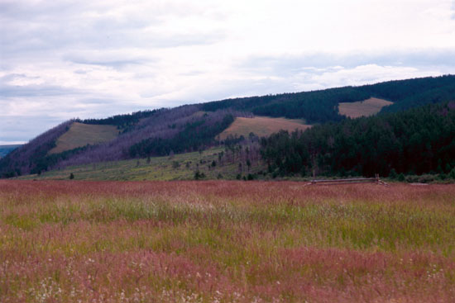

Photo 2. Steppe on south-facing slope of Noyan Valley
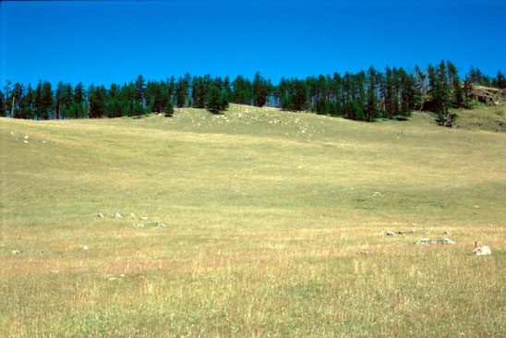

Photo 3. Riparian habitat in Sevsuul Valley
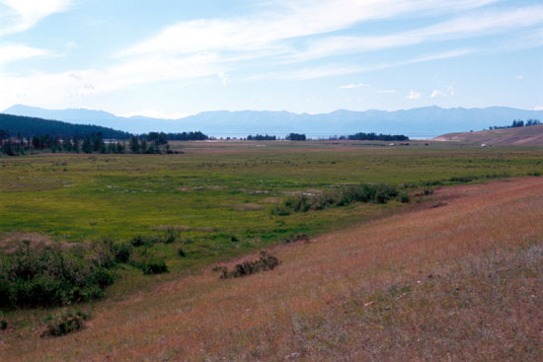

Photo 4. View of the project camp and south-facing steppe from Dalbay River
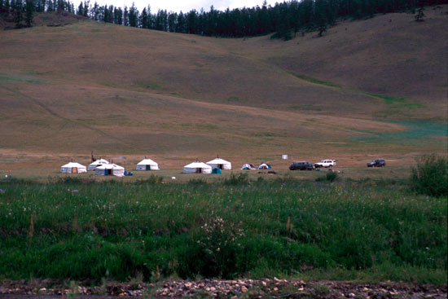

Photo 5. Early morning mist over permafrost on north-facing slope in Dalbay Valley
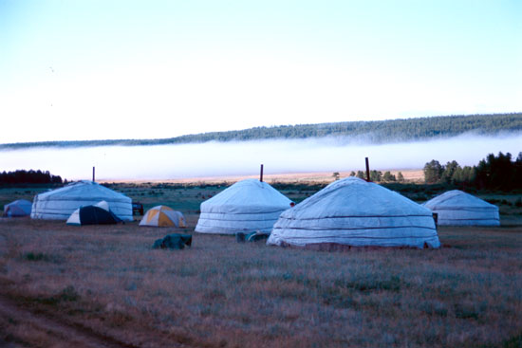

Photo 6. Melting ice alongside a small tributary of the Dalbay River (mid-July)
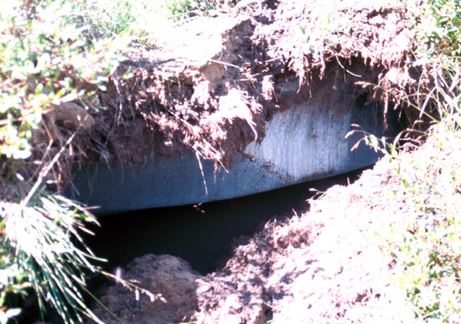

Photo 7. Site of experiment on seed predation and germination, Dalbay Valley
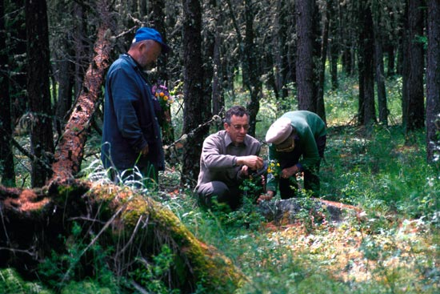

Photo 8. Germination of larch seeds is monitored in 0.5x0.5m plots 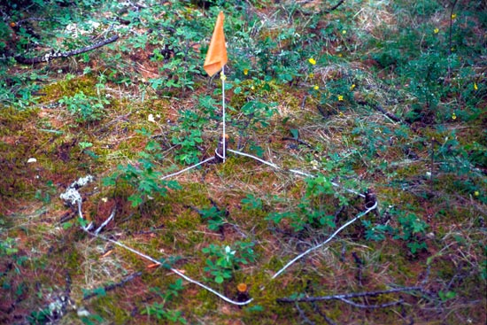
Photo 9. Mature larch with old cones, Turag Valley
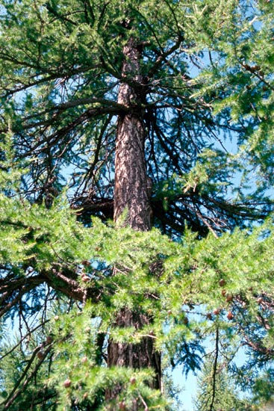

Photo 10. Measuring the growth of larch with a girth band, Sevsuul Valley
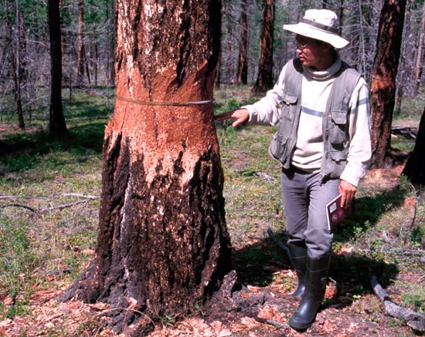
Photo 11. Fire hollowed trunk of mature larch tree in Sevsuul Valley
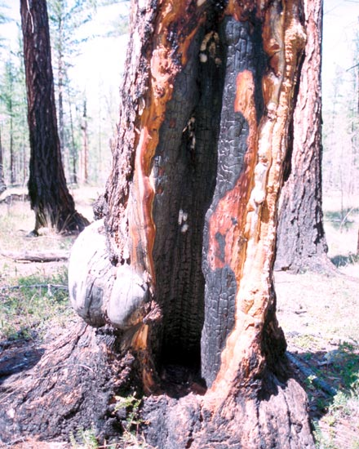

Photo 12. Date of major fires and age can be determined from tree rings
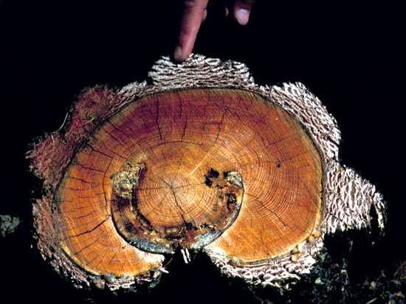
Photo 13. Areas of dying forest that burnt in 1997, north slope of Turag Valley
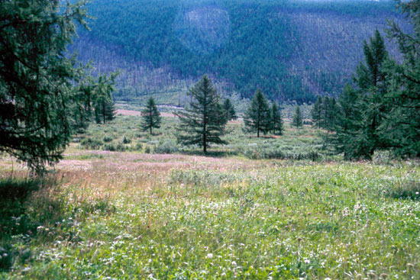

Photo 14. Impression of a large tree left by the 1997 fire in Sevsuul Valley
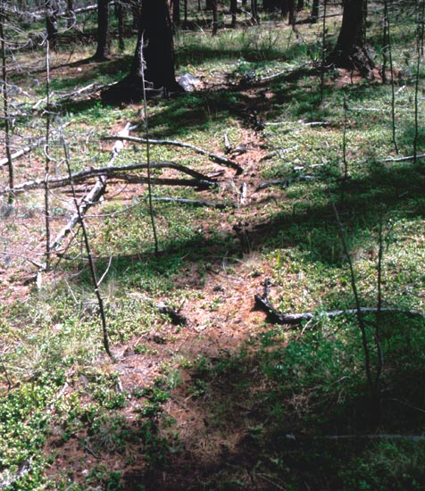

Photo 15. Edge of forest and steppe along the south-facing slope of Dalbay Valley
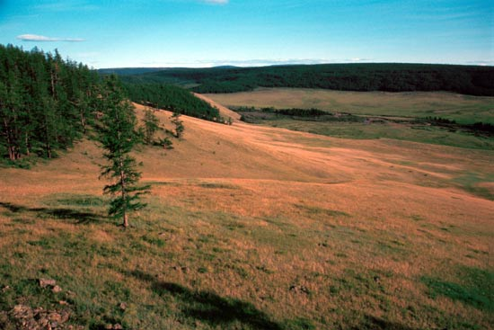

Photo 16. Larch seedlings on a shaded south-facing slope, Dalbay Valley 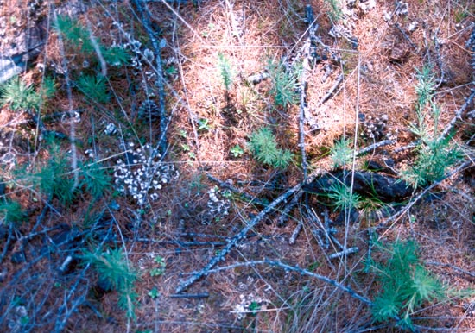

Photo 17. Flowers and grasses in the Otor pasture of Turag Valley (see Photo 1)
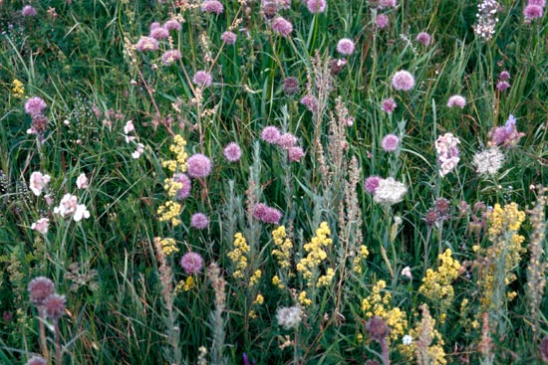

Photo 18. Biomass measurement on the upper south-facing slope of Noyan Valley
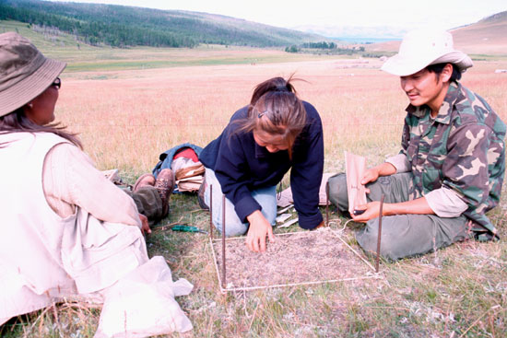

Photo 19. Livestock exclosures on south-facing slope of Dalbay Valley
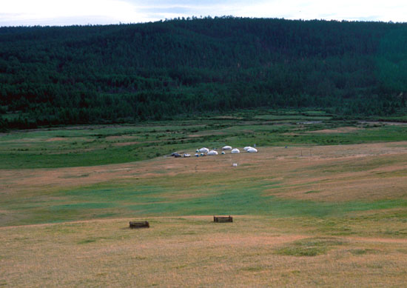

Photo 20. Quadrats are clipped inside livestock exclosures to measure production
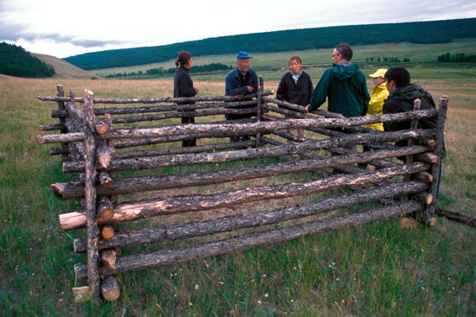

Photo 21. River Dalbay
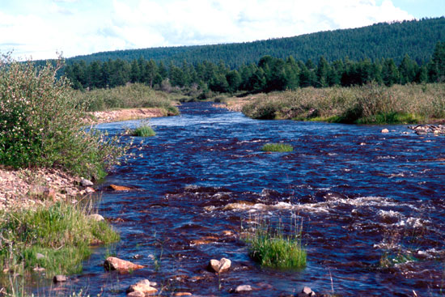

Photo 22. Electro-fishing in River Dalbay
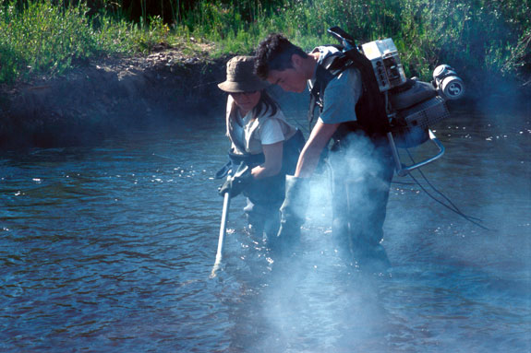

Photo 23. Monitoring river temperature
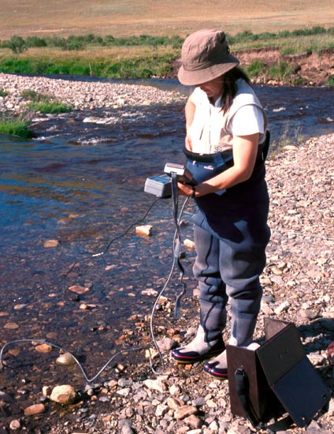

Photo 24. Minnows and young fish caught in River Dalbay
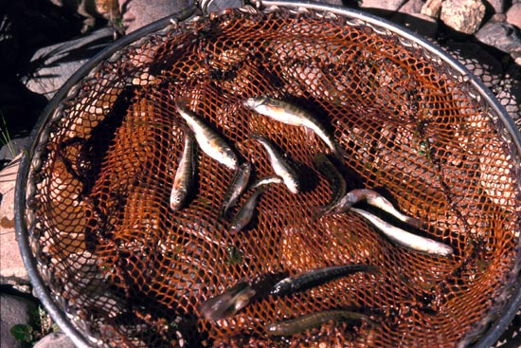

ANNEXES

ANNEX 1.

Training Topics Organized by Hovsgol_GEF Project

 |  | Training topic organized by Hovsgol_GEF Project
No | Training topic | Name | Country | Begining Date | Ending Date
1 | Permafrost study | Bernd Etzelmuller | Norway | 22/08/2002 | 05/09/2002
2 | Permafrost study | Eva Heggem | Norway | 22/08/2002 | 05/09/2002
3 | Permafrost study | Regula Frauenfelder | Switzerland | 22/08/2002 | 05/09/2022
4 | Permafrost study | Vladimir Romanovsky | Russia | 22/08/2002 | 05/09/2002
5 | Soil Properties | Hsia | Taiwan | 05/07/2002 | 10/07/2002
6 | Aquatic Insects | Tom morse | USA | 05/08/2002 | 15/08/2002
7 | Terristrial Insects | Jon Gelhaus | USA | 05/08/2002 | 15/08/2002
8 | Statistics | Peter petraitus | USA | 01/08/2002 | 08/08/2002
9 | Forest ecology | Steven Hamburg | USA | 02/07/2002 | 08/07/2002
10 | Database design | Davaasuren | Mongolia | 05/03/2003 | 01/04/2003
11 | Algology | Soninkhishig | Mongolia | 10/02/2003 | 10/02/2003
12 | Mammalogy | Batsaikhan | Mongolia | 05/03/2003 | 05/03/2003
13 | Plant Taxonomy | Tserendash | Mongolia | 10/04/2003 | 10/04/2003
14 | Climate change | Natsagdorj | Mongolia | 02/05/2003 | 02/05/2003
15 | English Language | Rose | USA | 28/06/2002 | 15/07/2003
16 | Biostatistics | Peter Petraites and Boldgiv | USA, Mongolia | 01/06/2003 | 10/06/2003
17 | SOP- Workshop | All Consultants | Mongolia | 18/05/2003 | 18/05/2003
18 | 2003- Research Results | All Consultants | Mongolia | 04/05/2004 | 04/05/2004

